STARTS and TURNS SWIM CLINIC
Learn about the dynamics and fundamentals of starts, turns and underwater kicking

Moreton Hall School, Oswestry
Saturday 28 July 2018

Led by GB international swimming coach, Paul Remmonds will guide swimmers through skills, drills and practices that have helped to produce a World Champion, Olympians, European and Commonwealth finalists.

Paul is a specialist in the biomechanics of swimming. He has coached on British Swimming Teams including the World Short Course Championships (2004) and has vast experience with British and English Junior teams including being Head Coach at the European Youth Olympics.

Schedule:
Registration
Starts & Underwater Kick Workshop
Pre-Pool (Starts Focus)
Starts & Underwater Kick Swim Session
Lunch
Turns & Finishing Workshop
Pre-Pool (Turns Focus)
Turns & Finishing Swim Session

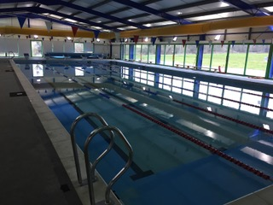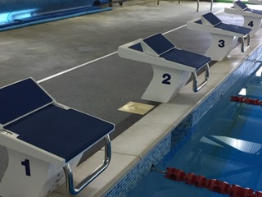
_____________________________________________________________________________________________
Find Skills4Podium on Facebook Follow Skills4Podium on Twitter

