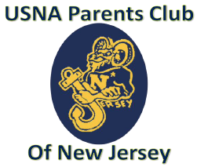 | Join USNA Parents’ Club of New Jersey.  Striving to support the brigade of midshipmen, fostering the budding roots of the Navy family, and sharing our experiences and joys with peers and families associated with USNA.  The club executes as many as 16 different events during the calendar year which provide opportunities for sharing and growing in our excellence of support for YOUR midshipmen kids. Please join us in supporting your family and the Navy family.

Membership Form

Parent Information
First Name(s): | Last Name(s):
Address:
Phone #1: | Phone #2:
Email 1: | Email 2:

Midshipman/ Alumni Information
First Name: | Last Name:
Company number: | MIDN email:
USNA Graduating Year: Major:
Rank: Service assignment:

DUES:  $100 for Lifetime Membership  Please make checks payable to:  USNA Parents’ Club of NJ | Mail check and form to:  Kimberly Trafford  22 McKinley Avenue  West Caldwell, NJ 07006

