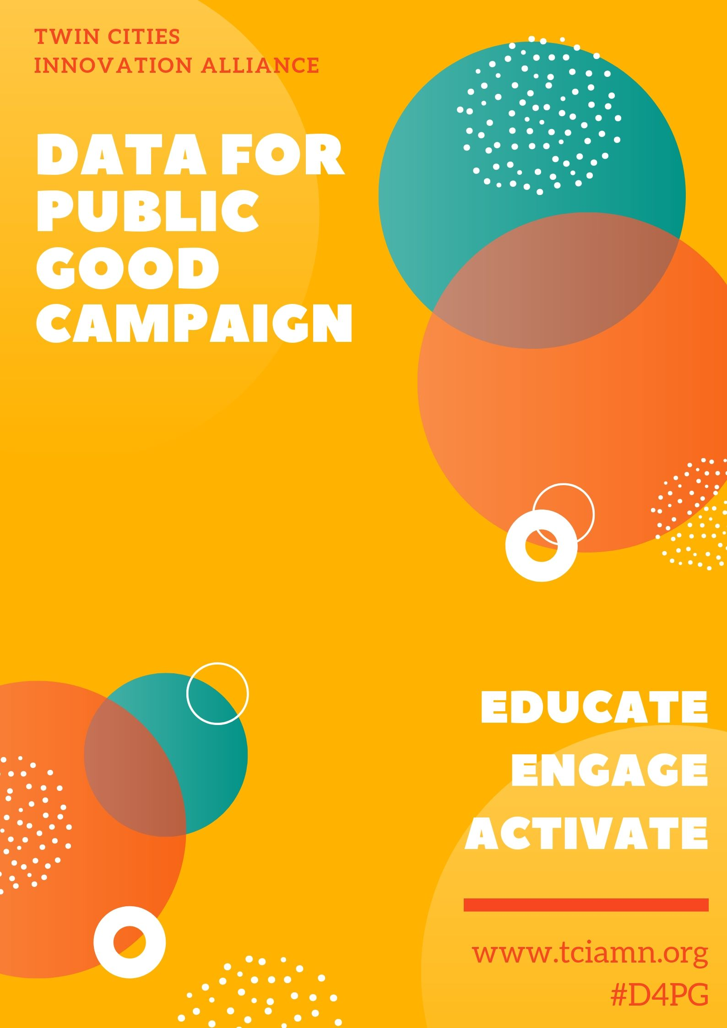
We live in an information age where data is currency and the driver of our digital economy, where individuals, communities, government systems are both the purveyors and end users of big data, whether we are aware of it or not, whether we agree to it or not. This trend is expanding across sectors and is surfacing in school districts across the country, presenting ethical dilemmas for education and educational ecosystems.

As we collectively navigate this technological transition outcomes will not be the same for everyone. Our data is collected and analyzed across sectors and systems at a tsunamic pace with a compounding ripple effect and little to no transparency. The use of big data, predictive analytics and algorithms is fundamentally changing our society and democracy, without our full knowledge or consent.

The United States constitution upholds the protection of privacy, this is a fundamental right. Constitutional conversations about protections of privacy are sadly lacking and limited to academic, legal and journalistic silos, these conversations are happening as if the people and the data are separate; the people are reduced to data; and at the same time commoditized.

Globally, as government systems move towards smart technologies and SMART Cities emerge, big data is fuel for designing efficient, effective and responsive systems with humans at the center across education, transportation, governance, health, building/architecture, energy, infrastructure, mobility, and technology. At the core of new technologies, any design, any innovation has to be about serving all people, and all people with equity and inclusion.

It is essential that our local, regional, national and international governing bodies keep pace with policies that establish a basis and expectation of trust that data and privacy is used for the common good, informed and determined by the people. Big data, new technologies, and new analytical approaches, if applied responsibly, and in co-design with those most impacted have tremendous potential to be used for the public good.

We are at a crucial moment as a nation and globally, revisiting the role of government in protecting privacy and safeguarding data, while ensuring trust with individuals and communities is paramount to our democracy.

Also, of necessity is a parallel process that deepens opportunities for individuals and communities to actively engage in learning about and defining how big data and predictive tools will be used for public good for the next fifty years and beyond. For this very reason the Data for Public Good Campaign (D4PG) begins now – with us!

“You are only afforded privacy where there is an expectation of privacy” Aasim Shabazz, Co- Founder of the Twin Cities Innovation Alliance

The D4PG campaign aims to increase public education and engagement about the use of big data, predictive analytics and algorithms, raise awareness about the expanded use of big data in decision-making, and build collective capacity for youth, parents, advocates, academics, educators, policy makers, system leaders, computer scientists, and data scientists to work together to identify principles, shape policies, and establish accountability and reporting standards in education while elevating the ethical use of data.

"We need more public awareness of algorithms, data mining and analytics” Kathy O’Neil tech writer and data scientist

The Twin Cities Innovation Alliance’s (TCIA) vision for the D4PG campaign was born out of necessity, as the emerging trend of big data, predictive analytics and algorithms became center stage in Ramsey County, MN. In 2018 a cross system data sharing and joint powers agreement (JPA) between Ramsey County (child protection, health and human services, county prosecutor’s office), St. Paul (law enforcement, housing) and St. Paul Public Schools was unanimously approved by their elected bodies.

“You’ll never be able to stop three systems with a mandate and momentum, once they have approved the JPA-it can’t be undone” Community Member, Fall 2018

This well intended but problematic JPA was designed to create efficiencies and eliminate redundancies in services across systems, while better identifying and supporting students at risk for interactions with the juvenile justice system through the application of predictive analytics. The JPA was described as an innovation, in reality, what they created was an algorithm to bake in bias through the application of predictive analytics, while structurally excluding the participation of community stakeholders in the new entity created to oversee the data agreement. Essentially providing expansive data to law enforcement, system enforcers and third-party contractors, while structurally excluding community representation. The approved data sharing agreement was developed without prohibition on what data is collected and what it will be used for, presently and in the future. Paving the path for further criminalization of Black and Brown children, youth and families and establishing a cradle to prison algorithm.

“I have to believe my past does not predict my future” St. Paul Youth

The Twin Cities Innovation Alliance along with the Coalition to Stop the Cradle to Prison Algorithm were successful in dissolving the JPA in 2019. At the same time, we recognized that our work wasn’t over, we are at the forefront of a movement to engage stakeholders in a broader conversation about big data and technology in education.

Across TCIA’s advocacy, we developed and leveraged networks of individuals and organizations who helped to identify resources and research, collaborate on strategy, and discuss policy, all which we now intend to share during the roll out of TCIA’s D4PG campaign. The engaged and invested response we received from community and the resulting dissolution of the local JPA affirmed that TCIA’s work was not only groundbreaking but should be elevated nationally. TCIA’s work will be used as a roadmap and playbook to support communities across the country.

“What you have taken on here in St. Paul is 10-15 yeas ahead of the majority of places across the country and where you have succeeded provides a roadmap for others and should be replicated”. Yeshimabeit Milnar, Co-Founder Data for Black Lives

