To: MASTER MV...................................................... Terminal Voyage: V-

Please return the following information to your appointed agent and the terminal via email shipping@dbct.com.au at least 10 days prior to arrival at the Port.

It is a requirement that all vessels entering the Port of Hay Point be compliant with all applicable International Maritime Organisation (IMO) Environmental Regulations and be able to demonstrate that the vessel does not pose a threat to the environment.

Please ensure that all the Terminal prefilled information (printed in blue font) is verified as valid and correct.
If any prefilled information is changed - write by hand or edit with red font.

Please refer page (4) for Cargo Nomination Advice.
Please review the Vessel Loading Sequence Preparatory Guideline (GD0020) before answering section 1. ‘Loading Plan’ below.

The Initial ETA to Hay Point anchorage is to be advised upon receipt of this questionnaire. Daily updates are required starting 10 days before arrival.
- Initial ETA (time & date): __________________________________________________
- Master’s name: _________________________________________________________
- Voyage number for departure from DBCT, Hay Point: ___________________________

Loading Plan
INSTRUCTION: Please advise required cargo, stowage by holds, loading order and the quantity to be loaded each pour prepared on IMO BLU code format.

1.1 Please advise the berthing displacement:
INSTRUCTION: Berthing displacement CANNOT exceed 110,000MT.

1.2 Please advise the sailing displacement: ...……….……………………………………….

1.3 Please advise the MINIMUM time required for deballasting including stripping (in hours):
INSTRUCTION: Where necessary, only include the minimum stripping time which is required to pump out while alongside the berth at DBCT.

1.4 Basis average loading rate of 7000-6100mtph (5600mtph for geared vessels), please advise if you require the terminal to stop loading for deballasting and/or stripping prior to the completion of loading (Yes/No):
INSTRUCTION: Calculate available time for deballasting to the Trimming Draft Check only (not full cargo request).

1.5 Stoppage time (if applicable) required for deballasting and/or stripping (in hours):
INSTRUCTION: If temporarily stopping the loading operation, indicate on the loading sequence plan after which loading step and for how many hours you require the terminal to stop loading for deballasting. Kindly note that regardless of the total time taken for deballasting, the stoppage time to loading for deballasting requirements will be recorded on the Working Log (time sheet) as 'Deballasting at vessel's request'. Please accurately declare the minimum required time only. Retaining ballast on finish is an option. As best practice, this assists the Terminal in developing the most optimal and best expedited schedule of shipping movements at the Port of Hay Point. Your active cooperation is appreciated.

1.6 Distance from the water line to the top of the hatch coaming of the first hold to be loaded (in metres):
1.7 Berthing Drafts |  |  |  | 1.8 Departure Drafts (including deflection)
FWD | AFT | MID |  | FWD | AFT | MID

INSTRUCTION: Harbour Master requires that the berthing AND departure trim by stern does not exceed 2.5m and propeller to be fully (100%) immersed for berthing and sailing.

Vessel may load to tropical draft (either only cargo or cargo with retained ballast) subject to tide availability within Great Barrier Reef. Summer draft restrictions apply immediately outside the Reef from 1st December to 31st March (South Pacific Seasonal Tropical Area Zone).

Vessel Specifications
2.1 Hatch dimensions (in metres) |  |  | 2.2 Distance between hatch centres in metres  (review illustration below for guidance)
Hatch | Length | Width
1 |  |  | Hatch 1 centre to hatch 2 centre:
2 |  |  | Hatch 2 centre to hatch 3 centre:
3 |  |  | Hatch 3 centre to hatch 4 centre:
4 |  |  | Hatch 4 centre to hatch 5 centre:
5 |  |  | Hatch 5 centre to hatch 6 centre:
6 |  |  | Hatch 6 centre to hatch 7 centre:
7 |  |  | Hatch 7 centre to hatch 8 centre:
8 |  |  | Hatch 8 centre to hatch 9 centre:
9

2.3 Please advise the Aft Extreme to the last (aftmost) hatch centre distance (in metres, NOT frame distance):

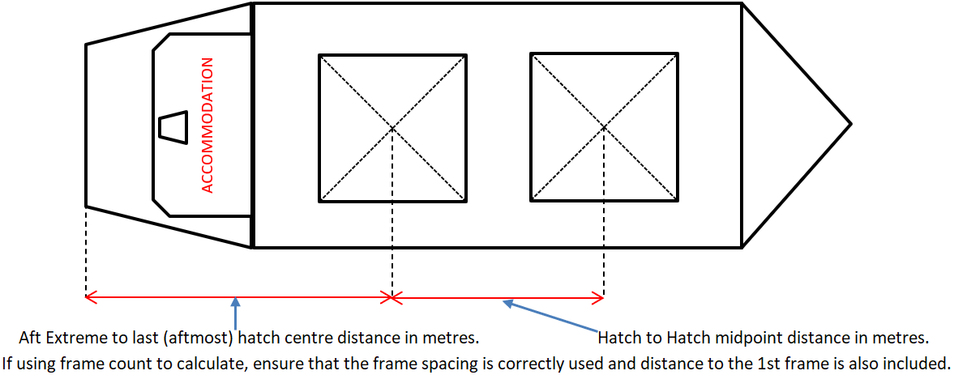

2.4 Cubic capacity of each cargo hold in m³  (incl. hatchway/coaming volume) | 2.5 Maximum individual loading hold weight limit (Vessel construction limits in TOTAL xxxxxMT NOT xxMT/m²) | 2.6 Maximum adjacent (combined) loading holds weight limit (Vessel construction limits in TOTAL xxxxxMT NOT xxMT/m²)*
Hold 1: | Hold 1: | Hold 1 and 2:
Hold 2: | Hold 2: | Hold 2 and 3:
Hold 3: | Hold 3: | Hold 3 and 4:
Hold 4: | Hold 4: | Hold 4 and 5:
Hold 5: | Hold 5: | Hold 5 and 6:
Hold 6: | Hold 6: | Hold 6 and 7:
Hold 7: | Hold 7: | Hold 7 and 8:
Hold 8: | Hold 8: | Hold 8 and 9:
Hold 9: | Hold 9: | *if available or applicable

Summer DWT |  | GRT |  | NRT
LOA |  | Beam |  | Summer Draft
Summer TPC |  | Constant |  | IMO #
Call Sign |  | Flag State
Port of Registry |  |  | Telephone
Email

2.7 Please advise minimum distance between deck obstructions, i.e., cranes, light masts, etc. (in metres, NOT frame distance):

2.8 Length of the cargo box (forward coaming 1st hatch to aft coaming last hatch (in metres, NOT frame distance):

2.9 Can vessel accept a land on helicopter (Yes/No):
INSTRUCTION: Vessel must comply with AMSA Marine Order 57 (Helicopter Operations) and subsequent amendments.

2.10 Confirm all cargo holds will be clean, dry, safe, and ready in all respects to load with no crew or other personnel in holds or bilges (Yes/No):

INSTRUCTION: Please ensure 1st loading hatch is open once the vessel is all fast/secure.

2.11 Do any fixed obstructions, ship’s gangways / accommodation ladders (in stowed position) protrude beyond the ship’s side? (Yes/No) If Yes, state details of obstructions and highlight on the GA plan:

INSTRUCTION: Please submit the vessel’s General Arrangement deck plan.
SUBMISSION REQUIRED FOR TERMINAL RECORD.
INSTRUCTION: Open hatch covers CANNOT protrude beyond the ship side. The complete length of the hatch, including rack ends and cleat locations, must be secured within the outboard extreme of the vessel to prevent getting caught on shore fenders and derailed from hatch runners.
INSTRUCTION: All Davit and/or Luffing cranes (incl. the jib’s far end sheave) on the main deck for stores/provisions and other activities, inside the hold box area, must remain COMPLETELY CLEAR of the hold opening space across the Length, Beam and Height extreme of the vessel as this is the Ship Loader’s operating area.

INSTRUCTION: On deck collapsible light towers are preferred to be in their lowered and stowed position.

2.12 Confirm vessel has means for measuring concentration of methane, oxygen, carbon monoxide, temperatures in cargo spaces, PH value of hold/bilge samples (Yes/No):

2.13 If your vessel is already part loaded with dangerous goods in bulk, please advise:
2.13.1 Cargo name and load port:…………………………………………………………..
2.13.2 IMO class and UN/BC number:……………………………………………………..
2.13.3 Quantity (prestow or actual):………………………………………………………...

Mooring Ropes

3.1 Total coils on board |  | 3.2 Type (Material) |  | 3.3 Condition of lines
3.4 Number of lines run on main winch (tension drum only- NOT on warping drum end or capstan tensioned only) |  |  | 3.5 Number of lines run on bollard or bitts  (NOT on main winch tension drum)

INSTRUCTION: Ropes must be HMPE or synthetic or similar floating type only. Wire mooring lines are NOT acceptable.

Cargo Nomination Advice
Cargo Stem and Request for (V- )

Shipper | Parcel | Cargo Description | Product | Last Nominated Tonnes By Shipper | Nominal Tonnes Planned | Min Tonnes | Max Tonnes | Laycan Start | Laycan End | Stowage Factor * (cu.ft./mt) | Vessel Requested Tonnes
Total
*declared as a guide only

INSTRUCTION: Please ensure that the last column in the above table is completed (Vessel requested tonnes). Cargo request must be within the stipulated min-max tonnes per parcel.

