Preschool & Elementary Lunch Menu – October 2022
Monday | Tuesday | Wednesday | Thursday | Friday
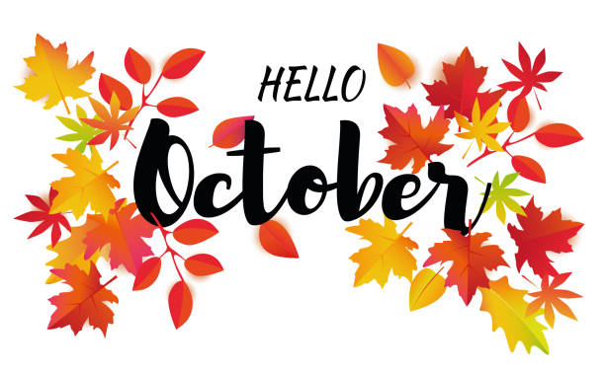 | RF= Reduced Fat  V = Vegetarian Option  WG = Whole Grain  Uncrustable PBJ or Soy Butter Uncrustable w/ WG  Cheez-Its & Cheese Stick Offered Monday, Wednesday and Friday | 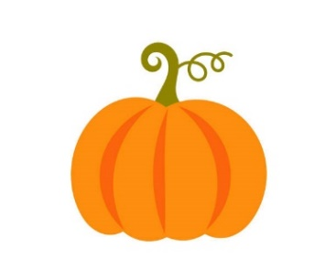 | KCS School Nutrition offers a variety of fresh whole fruit  or 100% fruit juice daily. Students may select up to two servings of fresh fruit offered daily.  Sandwich Trimmings(4) offered with all sandwich choices | Approximate grams of Carbohydrates per serving is shown in parenthesis  Mayfield Milk Choices - 1/2 pint serving  White Skim(13) While 1%(13) Fat Free Chocolate(20)
October 3rd | October 4th | October 5th | October 6th | October 7th
Choose 1 Entrée  Wild Mike’s Cheese or Pepperoni Pizza (34)  5 WG Chicken Nuggets (20) w/ WG Roll (32)  WG Uncrustable PBJ (32) w/ Cheez-Its (14) & Cheese stick (1)  Side Item  Mashed Potatoes (17) w/ or w/o gravy (4)  Sweet Yellow Corn (15)  Garden Salad (2)  Baby Carrots (5) | Choose 1 Entrée  2 WG Max Cheese Sticks (32) w/ ¼ cup Marinara Dipping Sauce (3)  Crispy Chicken (15) Sandwich on WG Bun (30)  Mini Chef w/ Ham (4) w/ WG Biscuit (27)  Side Item  Tater Tots (19)  Fresh Steamed Broccoli w/ Cheese Sauce (5)  Garden Salad (2)  Baby Carrots (5) | Choose 1 Entree  French Toast Sticks (37) w/ Sausage (2)  Homemade Grilled Cheese (34)  WG Uncrustable PBJ (32) w/ Cheez-Its (14) & Cheese stick (1)  Side Item  Crispy Hashbrowns (31)  Caesar Salad (5)  Veggie Nibbles (5) | Choose 1 Entrée  Charbroiled Hamburger (1) or Cheeseburger (3) on WG Bun (30)  Tony’s Cheese or Pepperoni Pizza (35)  Turkey & Cheese (2) on WG Bun (30) w/ RF Doritos (20)  Side Item  Curly Fries (25) Glazed Carrots (15)  Caesar Salad (5)  Veggie Nibbles (5)  Dessert  Chocolate Chip or Sugar Cookie (18) | 4 Wild Mike’s Cheese Bites (28)  Large corn dogs  WG Uncrustable PBJ (32) w/ Cheez-Its (14) & Cheese stick (1)  Side Item  Waffle Fries (26)  Fresh Steamed Broccoli w/ Cheese Sauce (5)  Caesar Salad (5)  Veggie Nibbles (5)
October 10th | October 11th | October 12th | October 13th | October 14th
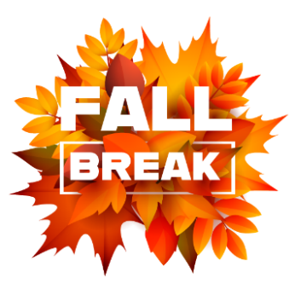 | 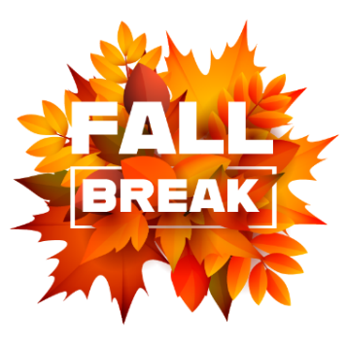 | 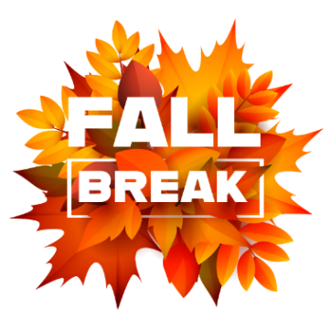 | 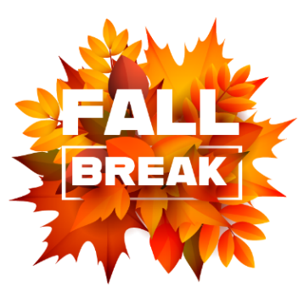 | 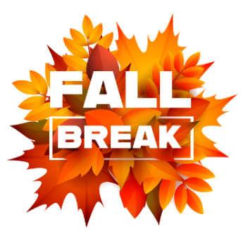
October 17th | October 18th | October 19th | October 20th | October 21st
IN  Service | Big Daddy’s Cheese or Pepperoni Pizza (42)  5 WG Chicken Nuggets (20) w/ WG R  WG Uncrustable PBJ (32) w/ Cheez-Its (14) & Cheese stick (1)  Side Item  Mashed Potatoes (17) w/ or w/o gravy (4)  Sweet Green Peas (11)  Caesar Salad(5)  Baby Carrots (5) oll (32 | Choose 1 Entrée  WG RF Fritos (16) Chips, Chili & Cheese (26)  Tony’s Cheese or Pepperoni Pizza (35)  WG Uncrustable PBJ(32) w/ Cheez-Its(14) & Cheese Stick(1)  Side Item  Tater Tots (19)  Sweet Yellow Corn (15)  Garden Salad (2)  Baby Carrots (5) | Choose 1 Entrée  Nick’s BBQ Sandwich (2) on WG Bun (30)  WG Chicken Tenders (3) w/ WG Biscuit (27)  Grilled Chicken (1) Salad w/ WG Roll (32)  Side Item  Curly Fries (25)  Bush’s Baked Beans (30)  Garden Salad(2)  Veggie Nibbles (5)  Dessert  Jell-O | Choose 1 Entrée  Charbroiled Hamburger (1) or Cheeseburger (3) on WG Bun (30)  WG Crunchy Fish Sticks (22) w/ WG Roll (32)  WG Uncrustable PBJ (35) w/ Cheez-Its (14) & Cheese stick (1)  Side Item  Oven Baked Fries (14)  Green Beans (4)  Caesar Salad (5)  Baby Carrots (5)
October 24th | October 25th | October 26th | October 27th | October 28th
Choose 1 Entrée  Stuffed Crust Cheese or Pepperoni Pizza (31)  5 WG Chicken Nuggets (20) w/ WG Roll (32)  WG Uncrustable PBJ (32) w/ Cheez-Its (14) & Cheese stick (1)  Side Item  Mashed Potatoes (17) w/ or w/o gravy (4)  Sweet Yellow Corn (15)  Caesar Salad (5)  Baby Carrots (5) | Choose 1 Entrée  Spaghetti (42) w/ or w/o Meat Sauce (10) & WG Roll (32)  Corn Dog (30)  Grilled Chicken (1) Salad w/ WG Roll (32)  Side Item  Crispy Hashbrowns(31)  Green Beans (4)  Caesar Salad (5)  Baby Carrots (5) | Choose 1 Entrée  Crispy Chicken (15) Sandwich on WG Bun (30)  Tony’s Cheese or Pepperoni Pizza (35)  WG Uncrustable PBJ (32) w/ Cheez-Its (14) & Cheese Stick (1)  Side Item  Waffle Fries (26)  Fresh Steamed Broccoli w/ Cheese Sauce (5)  Garden Salad (2)  Veggie Nibbles (5) | Choose 1 Entrée  Cheesy Chicken Nachos (32)  Homemade Grilled Cheese (34)  Mini Chef w/ Ham (4) w/ WG Biscuit (28)  Side Item  Ranchero Beans (20)  Caesar Salad (5)  Baby Carrots (5)  Dessert  Chocolate Chip or Sugar Cookie (18) | Choose 1 Entree  Charbroiled Hamburger (1) or Cheeseburger (3) on WG Bun (30)  Hot Dog w/or w/o chili and cheese (13) on WG Bun (30)  WG Uncrustable PBJ (32) w/ Cheez-Its (14) & Cheese stick (1)  Side Item  Oven Baked Fries (14)  Bush’s Baked Beans (30)  Garden Salad (2)  Veggie Nibbles (5)

October 31st
Choose 1 Entrée
Big Daddy’s Cheese or Pepperoni Pizza (42)

5 WG Chicken Nuggets (20) w/ WG Roll (32)

WG Uncrustable PBJ (32) w/ Cheez-Its (14) & Cheese stick (1)
Side Item
Mashed Potatoes (17) w/ or w/o gravy (4)
Sweet Yellow Corn (15)
Garden Salad (2)
Baby Carrots (5)

