San Juan Education Foundation
PBL Project Report

Date: April 2, 2012
- Project Name: Northridge Elementary Organic Garden
- Applicant Name: Melissa Benke
- School Name: Northridge Elementary
- Grant dollar amount: $5000.
- Brief Purpose of Project (100 words):
A school garden can be used to meet a wide variety of learning standards; not just content standards, but also standards for teaching and instruction that are student-centered, involving active investigations that rely on students’ own environment as a context for learning.
A student garden will stimulate and motivate children to achieve academic excellence in many ways. Since students will get to harvest what they grow, they will have motivation to cultivate a healthy, productive garden. The more crops produced in their garden bed, the more they get to eat. There is added incentive to learn best gardening practices so that students don’t kill living things. Students will also be required to share their findings, observations, comments and questions with their peers, in their notebooks, and on the Northridge Garden Wiki. Students who prefer visual forms of presentation can use images, drawings or video to showcase their talents. Other students will have the opportunity to comment on all additions to the Wiki, which will motivate the creators to add work they will be proud to share.

- Please briefly list specific outcomes:
What did students learn?
Students learned how to use iPad apps and online resources to research gardening issues.
Students learned how to plant, care for, harvest, and compost various vegetables and flowers using multiple resources including: websites, manuals, iPhone and iPad apps, parents, teachers, and Master Gardeners.
Students learned how to trouble shoot irrigation problems.
Student Council members learned how to plan, publicize and conduct various contests within the school in regards to the garden.
Students planned and assisted a community garden ribbon cutting ceremony.
Students learned how to use an online wiki to communicate and collaborate with each other, parents and teachers, throughout the school year and summer.
Students learned how to create an extra-curricular (Horticulture) club.
Students learned how to use Google Calendar to plan and schedule summer watering and maintenance of the garden.
Students learned how to use document projectors to transfer their 4” X 8” mural designs onto 4’ X 8’ boards.
Students learned which paints, primers, glazes, epoxies, and embellishments will best withstand weathering on garden murals.
Students learned that weather patterns have an affect on the growth of plants.
Students learned how to use local planting guides to choose seeds and seedlings that were appropriate to grow at specific times in our climate.
Students learned proper weed abatement techniques for organic gardens.
Students learned and reinforced proper etiquette and writing skills by writing thank you letters to contributing community members.
Students creatively expressed their hopes and dreams for the garden in art and writing.
Student Council members learned proper meeting protocol when voting on various Garden decisions.
Students learned how to start seedlings indoors.
Students learned that seedlings started indoors need to be exposed to wind and sun to strengthen them before transplanting.
Students learned how to maintain a worm composting bin.
Students learned how the amount of sunlight on different areas of the garden affects the growth of plants.
Students learned that hard work can be fun and a source of pride.

What evidence do you have that students learned what you intended?

The health of the garden is evidence of proper gardening techniques and care.

Students wrote about their experiences and findings in their notebooks.

The Northridge Wiki was used by students to research, share and discuss garden information. Administrators of the wiki could view a daily site view graph to see the amount of user traffic on the site and monitor and edit student usage.

Parents shared that many students started small balcony and backyard gardens at home.

Many parents came to the garden with their children before and after school and during the summer. Students were observed teaching their parents about what they learned about gardening.

Last year’s Horticulture Club students taught this year’s teachers and classmates about what they learned through participation in the club.

How did students respond to the learning experience?

Students begged to work in the garden before and after school and during their recess and lunch times. A large group of students volunteered to maintain the garden throughout the summer. My fourth grade class wrote about their favorite school days as those spent in the garden. Most students look at the garden with a great sense of pride, especially those who saw the seeds that they planted sprout, grow, and produce flowers or vegetables. The Special Education – E.D. class was excited to see that their zucchini plant was the most prolific producer in the whole garden. The 6 month process of construction and preparation was a great source of interest and excitement for the whole school.

What data/records do you have to substantiate the learning experience?

The Northridge Garden Wiki contains pictures and links showing student involvement and learning. (http://northridgegarden.wikispaces.com/)

Collected writing shows that students learned about community involvement, pride in hard work, new gardening skills, and the value of collaboration and peer support.

Feedback from parents showed that students have an increased enthusiasm for learning and eagerness to participate in garden related activities.

Feedback from neighbors and community members shows increased admiration and an improved reputation of the school due to the existence of the garden.

- What were the strongest learning components of the grant?
Collaboration: In order to have a successful garden, students needed to participate in group decision-making, interdependence, integration of peer and mentor feedback, providing thoughtful feedback to peers, and working with others as student researchers. Students needed to keep in contact throughout the summer to confirm that the garden would be kept watered or all of their work would be ruined.
Authentic tasks:
Students communicated with each other and gardening experts to trouble shoot gardening issues, discuss best practices, and gain more information to guide their actions and choices.
Students took what they learned in the garden and applied it at home in their own gardens.
Students used the iPads and internet to research and identify which insects were beneficial and which were harming their plants. Then they learned what type of pest control was appropriate for an organic garden.
Students harvested crops to share with their classmates, trade with other classes, or take home.
Multiple presentation modes:
Students used iPhones, iPads, gardening magazines, books, and websites to research gardening issues. The Northridge Garden Wiki was used to share information, collaborate, communicate, and plan. After a school wide garden mural contest, students learned how to use document projectors to transfer their drawn designs onto 4 ft. by 8 ft. boards, which could later be painted and decorated. Other students drew and wrote about their gardening experiences and data collection in their notebooks.

- What did not work as well as you expected?

The original irrigation plans were vetoed by M & O after receiving the grant. I did not understand that the existing sprinkler heads could not be used and adapted to create drip irrigation for the raised beds. Instead, we had to use a self-tapper and drag a hose in and out of the shed and across the walkway, each time we had to water the garden. While this worked, it was cumbersome, especially for children. It was also a tripping hazard.
I am still working with M & O to adapt existing irrigation to have water within the garden. We plan to have students create self-watering systems out of recycled 2-liter bottles if irrigation isn’t installed by this summer.

Last year, many teachers, overwhelmed with the demands of new curriculum, were not able or willing to take their classes to the garden to maintain their grade level raised beds. This year, several teachers have given their grade level beds to the Horticulture Club to maintain.

The abnormally warm winter led to cold weather crops that did not produce and bolted early. Students were disappointed, but learned how weather affects crops.

There was minor vandalism and theft that has stopped now that the surveillance cameras are constantly recording activity around the school. Students were very upset when blooming sunflowers and other plants were ripped out of the beds and left on the ground.

- What recommendations would you make to other teachers who might want to implement your grant?
Talk to the Facilities and Planning Department (Maintenance and Operations) before making any plans. Discuss irrigation possibilities and locate all irrigation blueprints for your site before creating a plan or budget. Get approval from M & O before writing your grant. Overestimate the amount of time and money needed to complete the project.

Make sure that there are several staff members committed to assisting you with the garden project. Make especially sure that most teachers are willing to have their students participate in gardening if you plan to have a raised bed for each grade level.

Create an extra-curricular Horticulture Club with eager students who want to care for the garden when teachers can’t, or during vacations.

Talk to local Scout Troops to find out if any potential Eagle Scouts want to build all or part of your garden as their Eagle Project. Local scouts built 8 of the 9 beds and 6 benches. Another scout planted a tree and a hexagonal bench surrounding it. The Brownie Troop of several Northridge students created signs to label each of the raised beds.

Talk to local churches about their volunteer days. Mormon’s Helping Hands sent about 50 members out to pull weeds, build an additional raised bed, trim bushes, and clean up the whole school.

Contact Americorps NCCC about sending community service workers to your school to do hard manual labor.

Talk to local Master Gardeners about adopting your school. They can come to student council or PTA meetings to discuss garden curriculum or to encourage support or volunteerism.

Partner with your school’s PTA. They may be willing to support the garden in the future through their fundraising. They may also publicize the need for volunteers.

Engage your school’s student council. They can be excellent publicists and can rally the school to collect items, fundraise, and generate excitement and participation.

Partner with Lowes! You can also apply for a Lowes Toolbox for Education Grant to add to the STARS grant to increase the budget for your garden. The people in the commercial sales department of Lowes in Citrus Heights were and continue to be incredibly helpful, patient, and supportive of our garden and school.

Before you spend any of the grant money, talk to the people in the grant department about the rules and protocols of purchasing anything. Follow their directions, ask questions, and be very careful about organization and documentation.

Look at the links on the Northridge Garden Wiki (http://northridgegarden.wikispaces.com/) or email me if you have any questions. mbenke@sanjuan.edu.

- Based on the definition of PBL, how close would you say your grant came to meeting the intent of the grant?
The Northridge Garden Grant comes very close to meeting the intent of the grant. In evaluating the project, I find that it is advanced in these areas:

- Adults in the “real world” are likely to share gardening/farming best practices and/or questions addressed by the gardening project.
- The gardening experience has meaning to the students and community.
- Students apply new knowledge to a realistic and complex community garden concept.
- Students use high performance work organization skills (e.g., work in teams, use technology appropriately, communicate ideas, collect, organize and analyze scientific and environmental data and information).
Students gather information from a variety of sources and using a variety of methods (interviewing and observing, gathering and reviewing information, collecting data, model-building, using on-line services).
- Students have multiple contacts with outside adults who have expertise and experience who can ask questions, provide feedback, and offer advice.
- Students have the opportunity to observe and work alongside professional adults and community members in a green garden relevant to the project.
Outside adults provide students with a sense of the real-world standards for this type of work.
- students receive timely feedback on their works in progress from teachers, mentors, and peers.
Final product is a culminating exhibition or presentation that demonstrates their ability to apply the knowledge they have gained.

The areas needing refinement are academic rigor and assessment practices.

Project Name: Northridge Elementary Organic Garden
School Name: Northridge Elementary School
Length of Project: ongoing Teacher(s): Melissa Benke
Professional Assistant(s) (if applicable): Felicia Wimberly – PTA President
Phase One | BEGINNING OF PROJECT  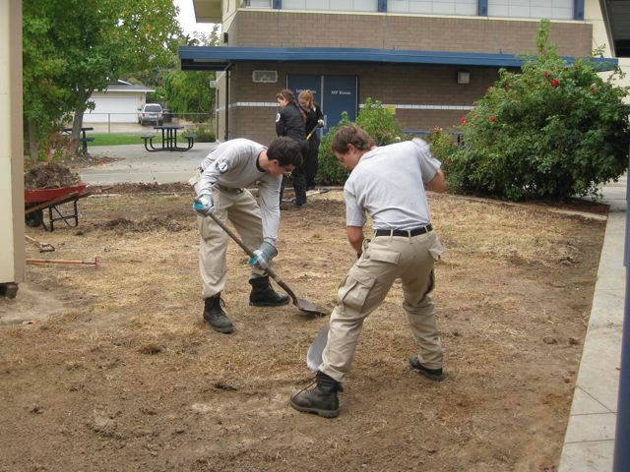  October 23, 2010: Americorps NCCC volunteered their time and effort to clear the weeds and roots from the garden area. At the same time, they cleared brush, trimmed bushes, pulled weeds, and beautified the whole school.  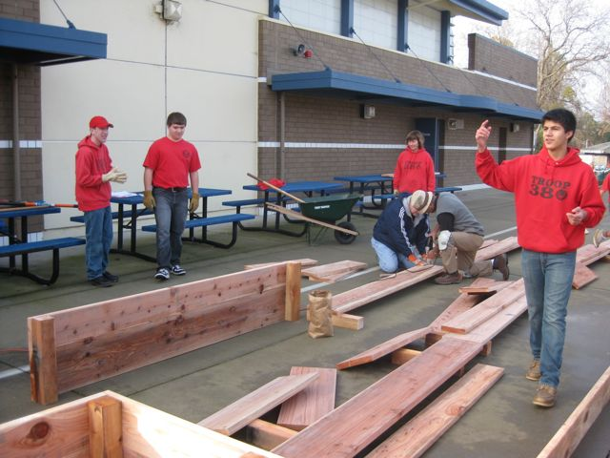  Sameer Punia directed Boy Scout Troop #380 in the building and installation of the raised beds in January of 2011. The STARS grant paid for the building supplies and the scouts provided the tools and labor to make the redwood beds. (See Eagle Scout Proposal for details.)  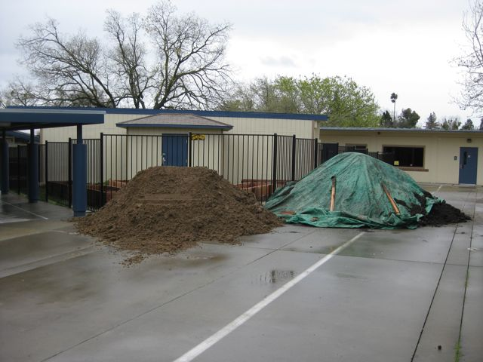  In March, 2011, Hasties (Super Dump) delivered soil for the beds and decomposed granite for the ground. The decomposed granite was recommended by SJUSD M&O dept. for weed abatement and for ADA requirements, in case we have staff or students in wheelchairs.  We chose a 6 ft. tall wrought iron fence to enclose the garden, since we had problems with recurring vandalism at our school. The gate is 4 ft. wide to accommodate wheelchairs and wheelbarrows.  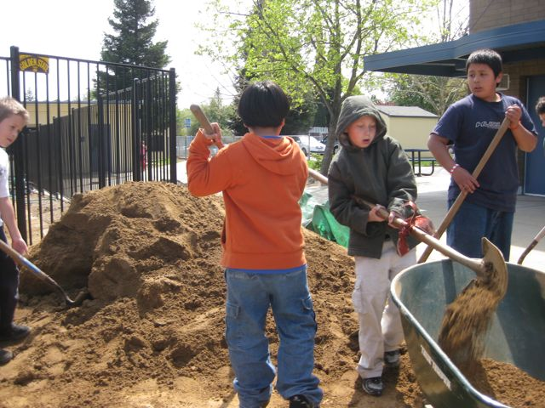  Students hauled soil into the garden to fill the beds. They spread and leveled the decomposed granite over the ground throughout the whole garden.  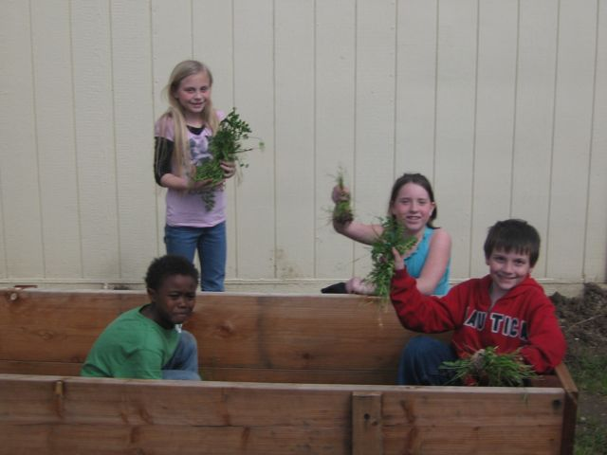  Weed abatement has been a constant problem since we can’t use chcmical herbicides in our organic garden. Before soil could be added to the raised beds, students had to remove weeds again.
Phase Two | DEVELOPING THE PROJECT  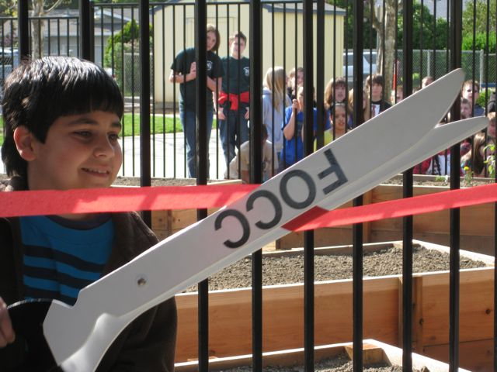  Student Council President Matthew Betashour helped to lead the ribbon cutting ceremony for the grand opening of the Northridge Garden.  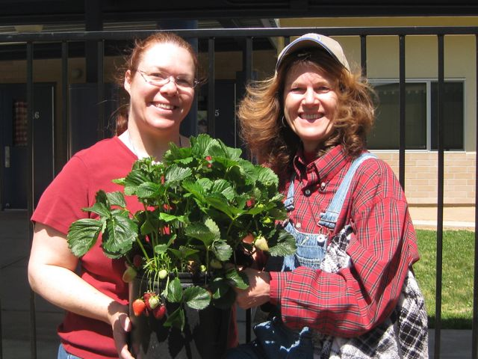  Fair Oaks Rotary donated many plants. Others were donated by Northridge families or paid for through the STARS grant. Many plants were started from seed.  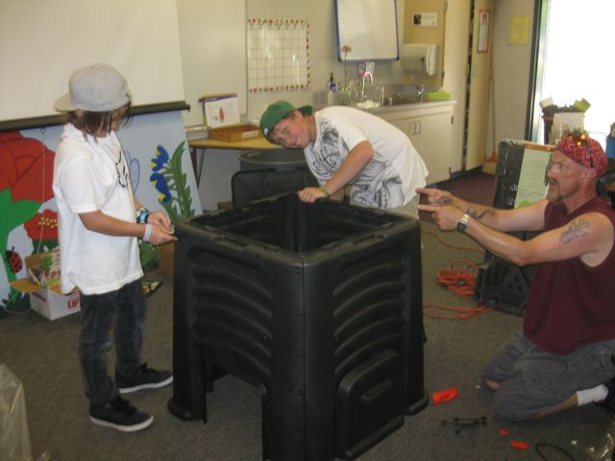  Horticulture Club students and a parent volunteer constructed a composting bin for the garden.  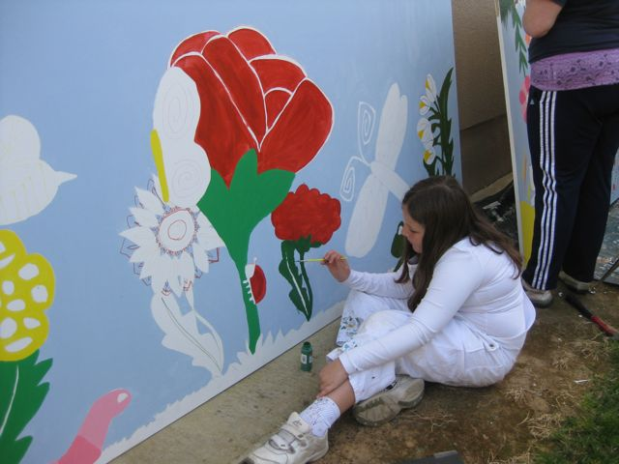  Students participated in a mural design contest. 2 winners were chosen by student council and had their designs enlarged and drawn onto 4 ft X 8 ft. primered boards. Students and volunteers painted and embellished the murals before they were sealed to withstand the elements.  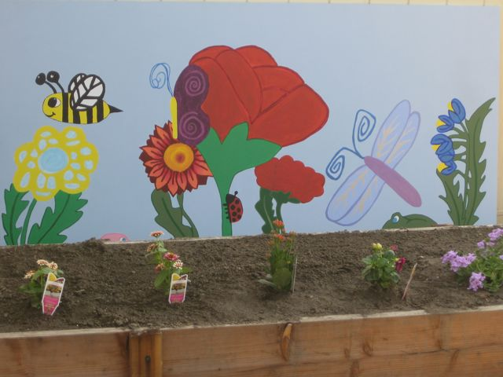  5th grader, Kylie Jay’s finished mural.  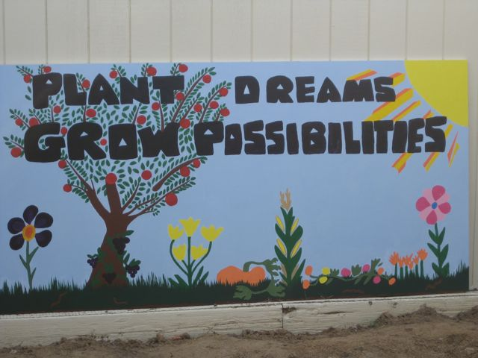  4th grader, Catherine Pless’s finished mural  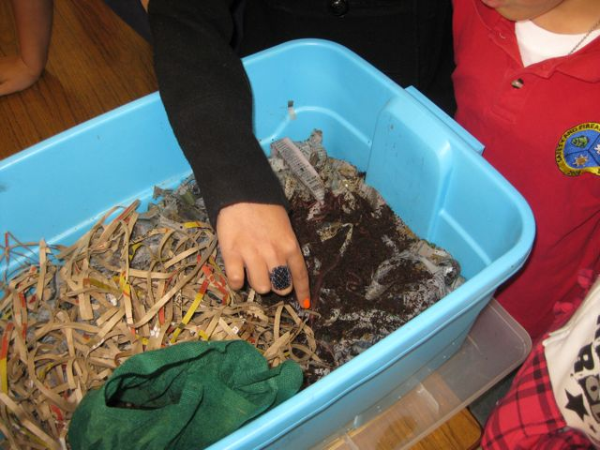  A worm bin was created to compost leftovers from student snacks and lunch. (plant matter only) Students were in charge of feeding and caring for the worms, and later collecting their castings.  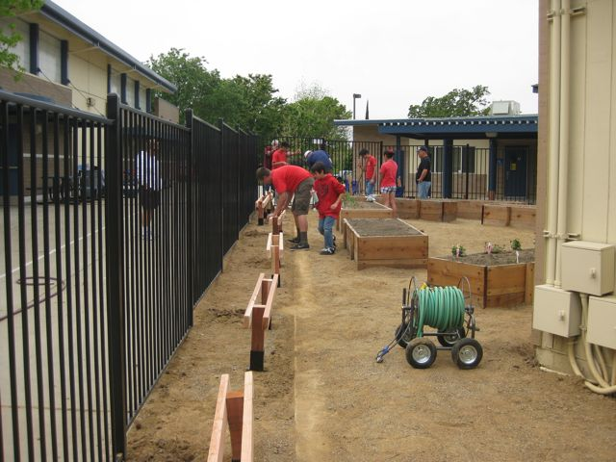  Alex Trimm, another Eagle Scout candidate from Troop #380, built benches for the garden.  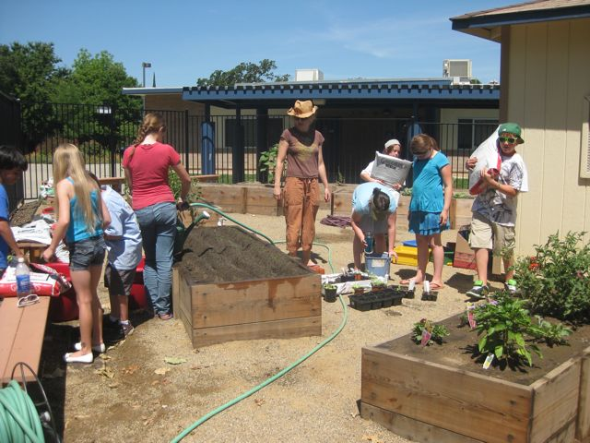  The Horticulture Club was created to take care of the garden over the summer. Students and parents used Google Calendar to schedule meet ups and the Northridge Wiki to communicate in between meetings.
Phase Three | CONCLUDING THE PROJECT  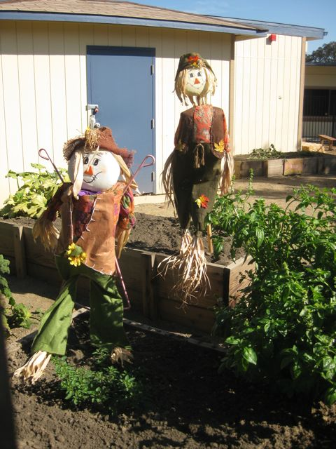  The garden was used during Northridge’s annual Country Faire. Students created scarecrows, which were shown in the raised beds as part of a contest. Parents and community members were invited to walk around and view the plants and scarecrows. They picked ripe tomatillos to take home with them.  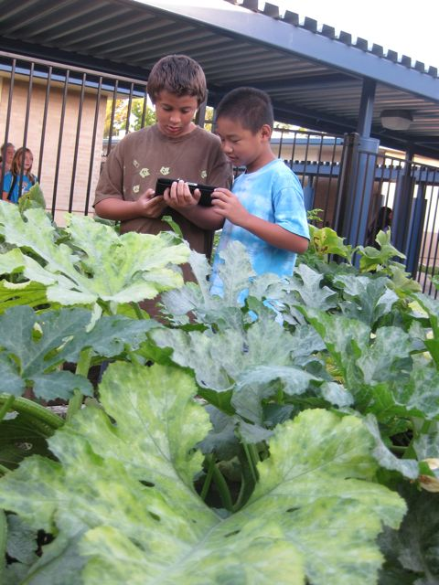  Students used iPads while in the garden, to research insects that they found. They also used gardening apps that guided them on proper plant care. Pictures were taken with the iPad camera.  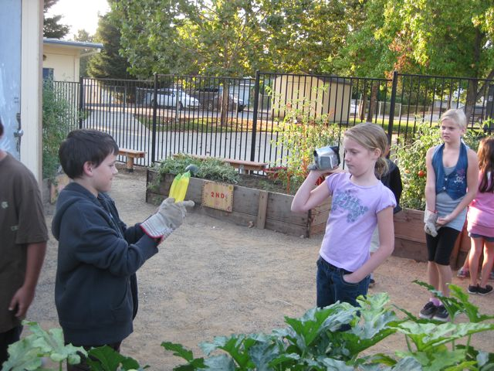  Students used a video camera to record findings, discuss gardening issues, and document activities.  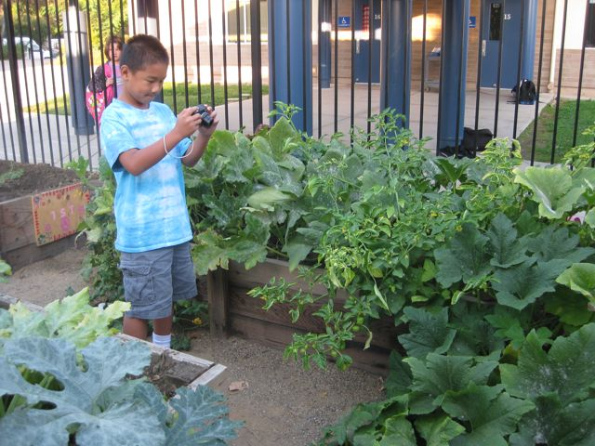  Digital cameras were also used to record data.  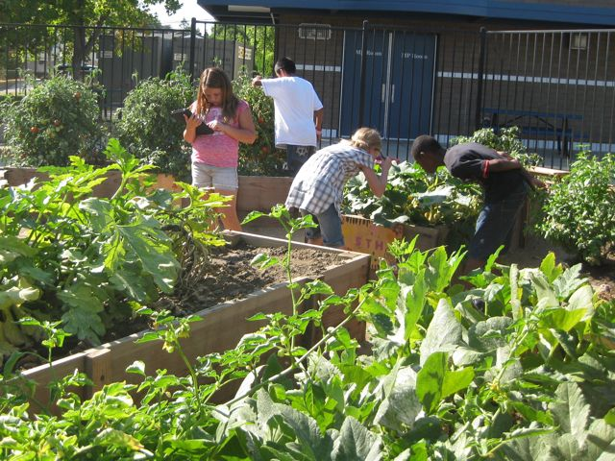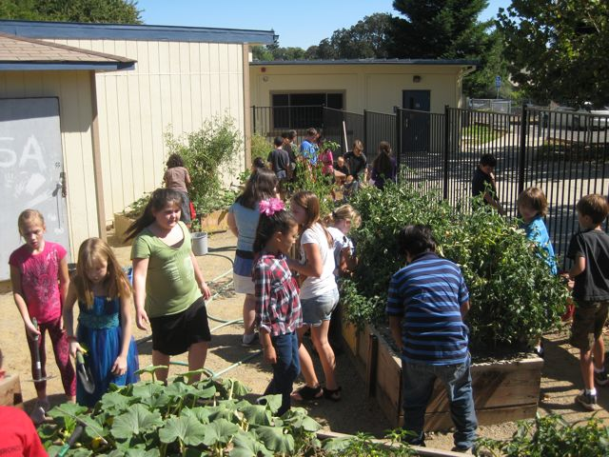  Students worked in teams to complete investigations and cooperatively manage multiple tasks.  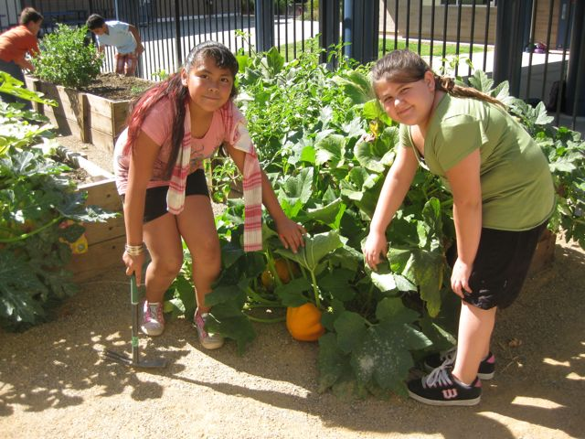  The sixth grade bed produced interesting pumpkins, just in time for Halloween.  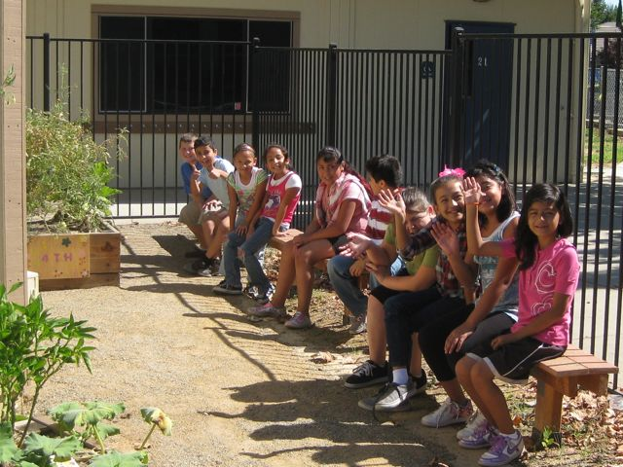  Students use the benches to rest, wait for instructions, write in their notebooks, read, work with seedlings, etc….  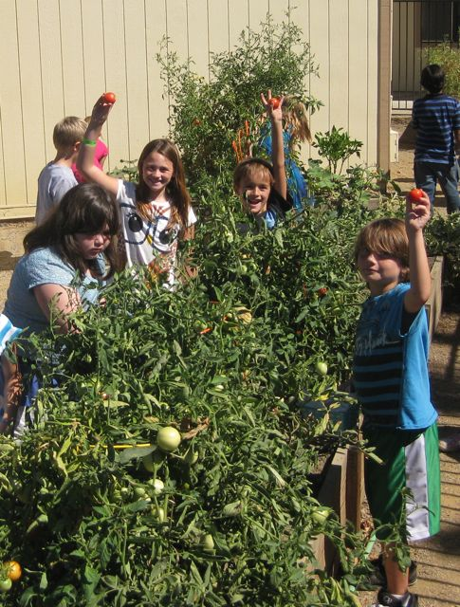  Harvesting fresh, ripe tomatoes was a favorite activity.  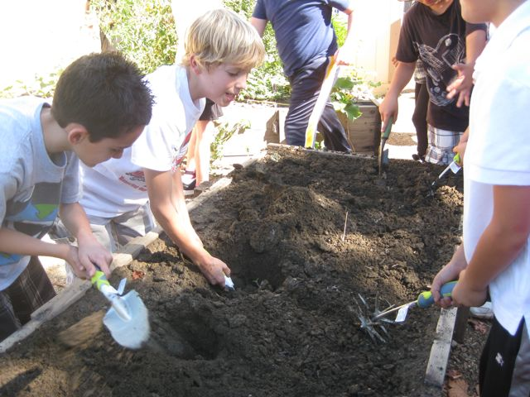  Summer crops were ripped out, cut apart, and composted. Students worked the soil, learning about best soil conditions for plant growth. Winter crops were chosen by students, after referring to a Sacramento area planting calendar.
Comments | There will hopefully, never be a conclusion to this project. We realistically hope to keep improving, adapting, and expanding our garden for years to come.  We plan to continue the Horticulture Club again this summer so that we can have fresh vegetables when students return to school in August.  Please feel free to contact Melissa Benke (Garden Coordinator) if you have any questions about the STARS grant or gardening at school. Please look at the Northridge Garden Wiki first, as the links may have the information that you need. http://northridgegarden.wikispaces.com

Applicant Signature: __________________________________

Principal’s Signature:_________________________________

