
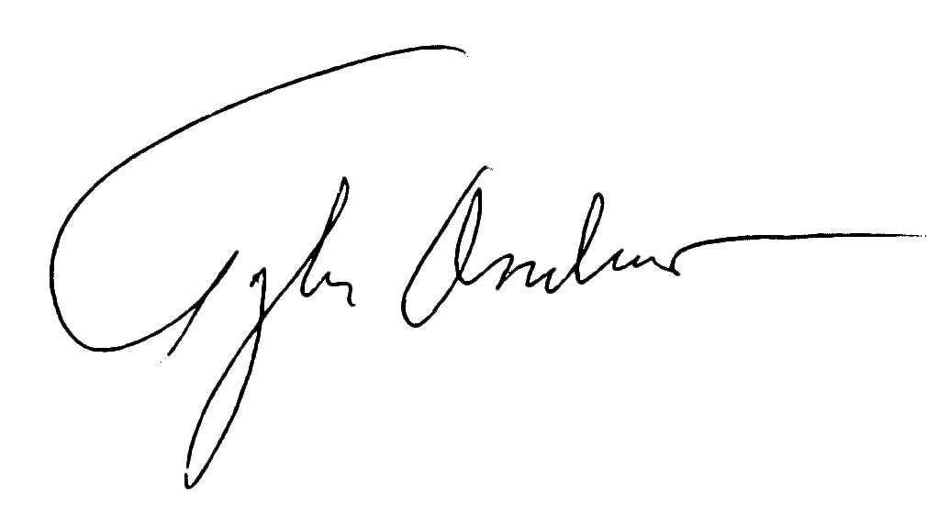
Beautiful D.R.E.A.M.
BBB Accredited since ,
meets all BBB Accreditation Standards
and supports the principles of BBB which
include ethical business practices,
honesty, integrity, reliability and trust.
Tyler Andrew
President & CEO serving BBB Northwest + Pacific
August 12, 2020

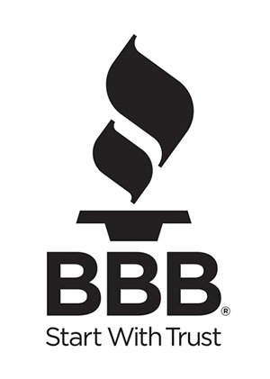

BBB ACCREDITATION AGREEMENT

(“you”) apply for accreditation by Better Business Bureau (“BBB”) and agree to abide by the terms and conditions set forth below. You understand that this agreement is not effective until accepted by BBB.

You agree you will notify BBB if you merge, get acquired or consolidate with another business, and acknowledge that any resulting new business must re-qualify for BBB Accreditation.

1. Compliance with BBB Code of Business Practices (BBB Accreditation Standards)
You agree you have read and understand the BBB Code of Business Practices (“the Code”) (found at: www.bbb.org/en/us/code-of-business-practices) and certify that you meet the standards set out in the Code. You agree to comply with the Code, as it may be amended by BBB.

2. Authorization to Use BBB Trademarks
a. General authorization. During the term of this agreement, BBB grants you a nonexclusive, non-assignable and nontransferable license to advertise your BBB accreditation and use BBB trademarks only as set out in this agreement. You agree that BBB trademarks may not be otherwise used, copied, reproduced, or altered in any manner.
b. Use of Accreditation Plaques and Decals. You may display the BBB accreditation plaque and decal at your place of business and at trade shows. You may also display the decal on your business-owned vehicles.
c. Use of BBB Seal. You may, within the scope of permission granted below, advertise your BBB accreditation by using the BBB Accredited Business seal (“the seal”) (Attachment 2), as it may be modified by BBB. BBB will provide the seal in various sizes to you. You must receive prior written permission to use another size, and approval will not be granted unless the new size meets minimum height requirement for “BBB” of 1/8 inches tall. Nothing in this agreement or in your use of the seal or BBB name will give you any right whatsoever in the BBB name or seal, or in similar names or seals, beyond the right granted in this agreement.
d. Advertising BBB rating. You may, within the scope of permission granted below, advertise your BBB rating. Upon learning of a change in your BBB rating, you must immediately correct any advertising that includes the rating. You are encouraged to include the seal in conjunction with advertising your BBB rating.
e. Scope of Permission.

i. Offline advertising media.
You may state “BBB Accredited Business” or you may display the seal in the following media: newspapers, periodicals, billboards, posters, direct mail, flyers, yellow pages or other directory advertising, telephone, TV or radio spots, business cards, stationery, invoices, facsimile cover sheets, other business documents, and patches. Accredited Business patches may be placed only on company owned clothing. If all your physical locations are within this BBB’s service area, you may advertise your accreditation wherever you do business. If you have physical locations in other BBBs’ service areas, your advertising rights are restricted to this BBB’s service area unless permitted by agreement(s) with other BBBs.

You may advertise your BBB rating wherever you are permitted to display the seal in offline advertising media except that you may not advertise your BBB rating in yellow pages or any other directory that cannot be immediately revised if your BBB rating changes.

ii. Online advertising
You may also display the seal to identify your BBB accreditation on your web site and on web sites where you advertise so long as (1) you include the words “Click for Review” adjacent to or below the seal as shown in Attachment 2 and (2) the seal hyperlinks to your BBB Business Profile.

You may advertise your BBB rating on your web site and on web sites where you advertise as long as the advertising can be immediately revised if your BBB rating changes.

iii. Email signatures
You may also display the seal, with a hyperlink to your BBB Business Profile, as part of your signature block in business emails.

3. Termination/Suspension
a. By BBB. BBB may suspend and/or terminate this agreement at any time if you violate the terms of this agreement or if the trademarks licensed herein are invalidated or cancelled. If this agreement is suspended or terminated, you agree to immediately cease using the seal and/or BBB trademarks. If suspended, you may request review of the suspension under applicable procedures set forth in our Bylaws. Unless the suspension is set aside following a review, suspension will become final and this agreement will be terminated.
b. By You. After completion of your 12-month commitment, you may terminate this agreement on thirty (30) days written notice to us.
c. Following termination, you agree to immediately: stop using BBB trademarks in all media, destroy any materials bearing BBB trademarks, remove BBB plaque and decals from display, return BBB plaque and decals to BBB, and to remove all online identification of affiliation with BBB.

4. Fees
You agree to pay fees as set by BBB’s Board. You agree to meet all financial obligations to BBB, including but not limited to, BBB Accreditation fees, sponsorships agreements, event participation, advertising fees. All fees shall be deemed fully earned once paid and shall be non-refundable.

5. Term
The term of this agreement begins when accepted by BBB and continues unless terminated by either party or for your failure to pay annual fees.

6. Indemnification
You agree to indemnify and hold BBB and International Association of Better Business Bureaus, Inc. (as trademark owner on behalf of the BBB system) (IABBB) including their employees/officers/directors harmless against any loss, damage or expense (whether direct, indirect or consequential), including reasonable attorney’s fees, arising out of any misuse of BBB trademarks or of any violation of the terms and conditions of this agreement. You also agree to indemnify and hold BBB and IABBB harmless against any loss, damage or expense, including reasonable attorney’s fees, with respect to all third-party claims of any kind, including product liability, arising in connection with your BBB accreditation or participation in a related BBB program.

7. Limitation of Liability
You agree you will not sue BBB and/or IABBB, including their employees/officers/directors, for monetary damages on any matter concerning this agreement. BBB makes no representations, warranties, or covenants of any kind, either expressed or implied, regarding title to or ownership of any rights in any marks, validity of any marks, the right to license any marks or non-infringement of the rights of others in any marks.

8. Relationship of Parties
a. You are not and will not represent yourself as an agent, representative, partner, subsidiary, joint venture, or employee of BBB, nor can you represent that you have any authority to bind or obligate BBB in any manner or in any thing. You shall not challenge the rights of BBB and/or IABBB in and to their trademarks or take any action inconsistent with such rights.
b. Nothing in this agreement or in your use of BBB trademarks shall confer any endorsement or approval of your products or services. Your use of these marks is intended only to convey BBB accreditation and a commitment to abide by the Code, and you agree to only use BBB marks in such a manner.

BBB dues may be tax deductible as a necessary business expense.
They are not considered a charitable contribution and therefore are not deductible as a charitable contribution.

