**Clinical IT**

**Provider Informatics**

**Provider Handoff**

Click on the **Provider Handoff** to open the Provider Handoff tool, this will assist with end-of-day handoffs and a snapshot of the patient for rounding use.

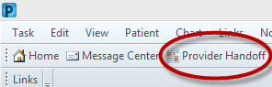 After opening the Handoff, select the needed Patient List from the dropdown. Then establish a relationship with listed patients.

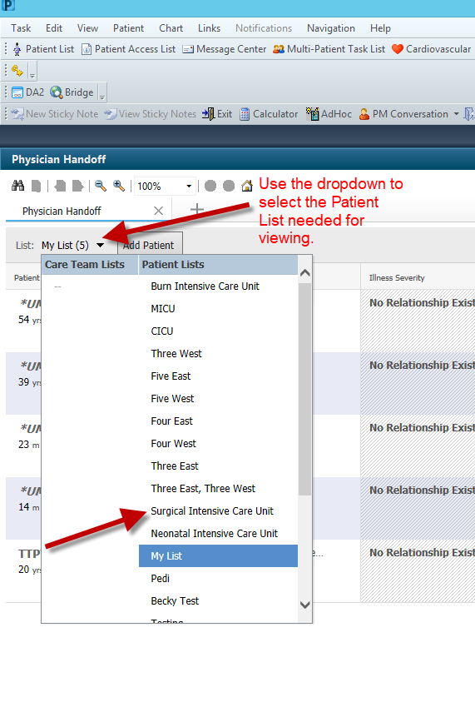 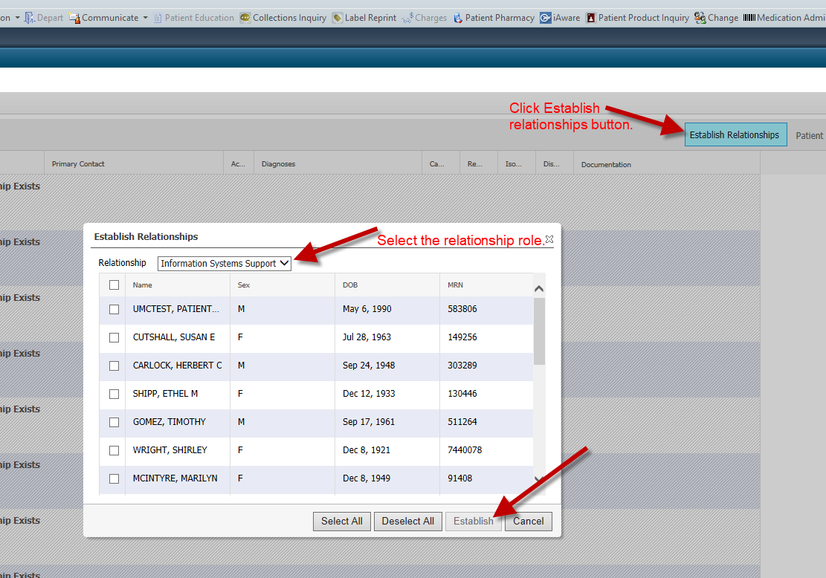

The handoff will load all patients from the Patient List selected if you have an established relationship.

Double clicking the patients name will launch the patient’s chart. A single click on the various fields will allow for status changes, quick glances and options to route to specific portions of the patient’s chart. 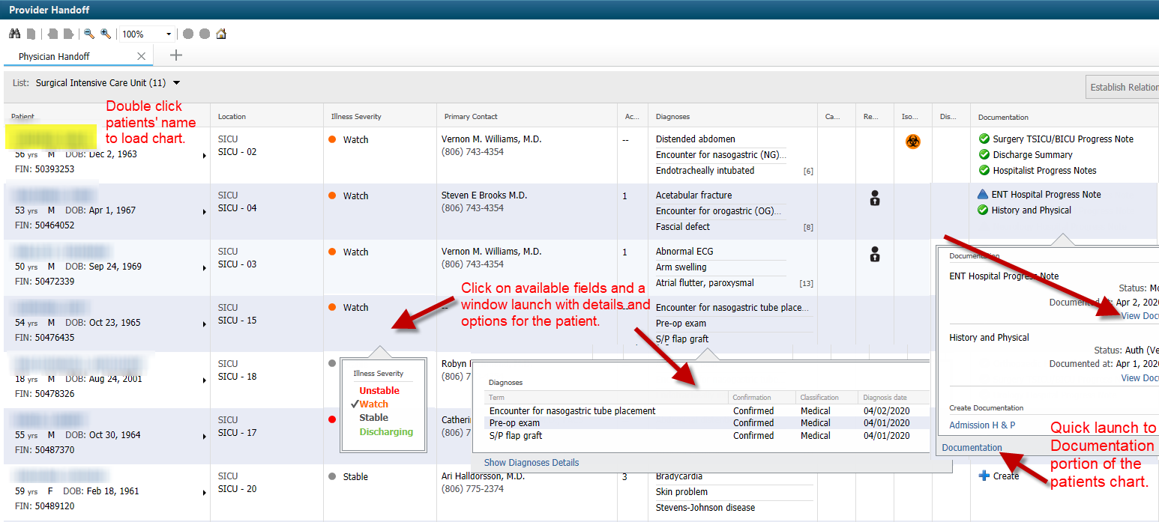

By clicking the expand arrow on each patient, the ability to utilize IPASS, quickly view Clinical Data and manage the Care Team is available.

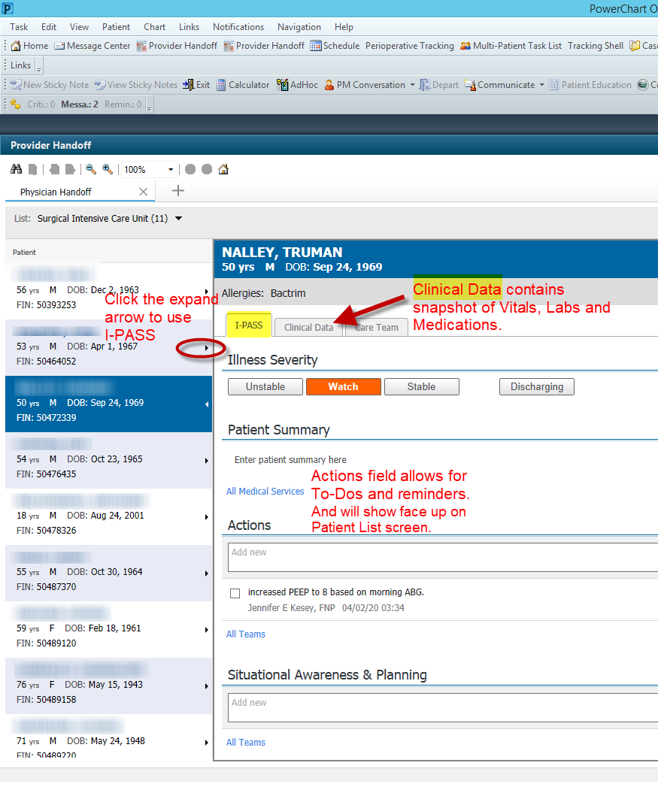

The Provider Handoff also offers the ability to print and perform Patient Assignments.

Printing

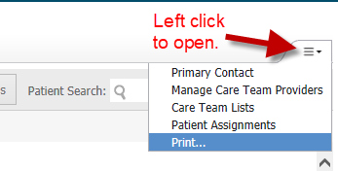 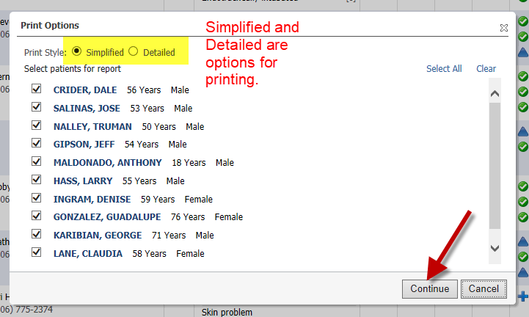

Patient Assignments

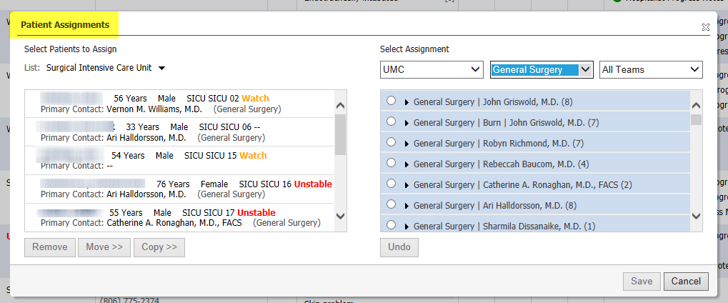

**Call the UMC Provider Support line for assistance or for more education 775-8255**