DNR Consent and Order
The 2017 Texas Legislature added new Subchapter E to the Health & Safety Code Chapter 166, entitled “Health Care Facility Do-Not-Resuscitate Orders.” The new law establishes requirements for the issuance of a DNR order.
- INPATIENTS. The law applies to patients who are admitted to UMC under observation or as an inpatient. This does not include outpatient settings such as radiology, clinical laboratory, Southwest Cancer Center, home health, outpatient rehab, and emergency center. For outpatient areas, continue to honor the Texas “Out-of-Hospital Do-Not-Resuscitate Order” if the patient has one.
- INFORMATION. Upon admission, UMC must provide the patient, or the person authorized to make treatment decisions on behalf of the patient, information about Advance Directives and DNR Orders.
- CONSENT. The consent of the patient or patient’s surrogate decision-maker is necessary for a DNR order except in very limited circumstances. Use the UMC DNR Consent form. This form can be printed by any HUC or nurse and is located on the UMC Intranet with other consent forms.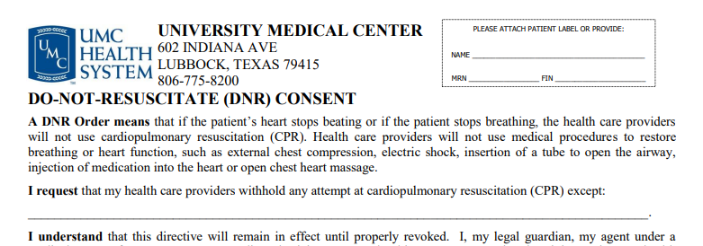
- ATTENDING PHYSICIAN. Only an Attending Physician may issue a DNR order. The Attending Physician is the physician selected by or assigned to a patient who has primary responsibility for a patient’s treatment and care. It may include another physician within the primary physician’s service who is covering for the primary physician. It does not include resident physicians, fellows, or advanced practice providers. The consent form must be valid, signed, and on the chart PRIOR to placing any order for DNR.
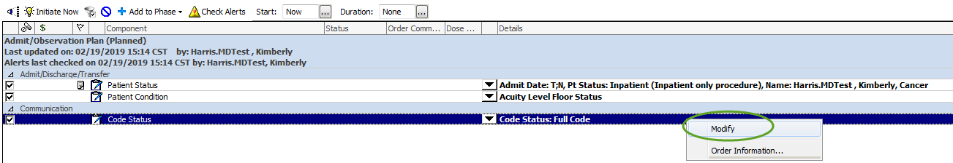

If you have questions, please contact Legal at 761-0995. Michael Economidis is the main point of contact for consent issues, but Lois Wischkaemper and Kristi Ward are also available

