Please take note that in order for the correct information to populate in the providers notes, the social history has to be completed in a very specific way. Follow the steps listed below.
- In the Adhoc under social habits you will need to modify each category.
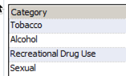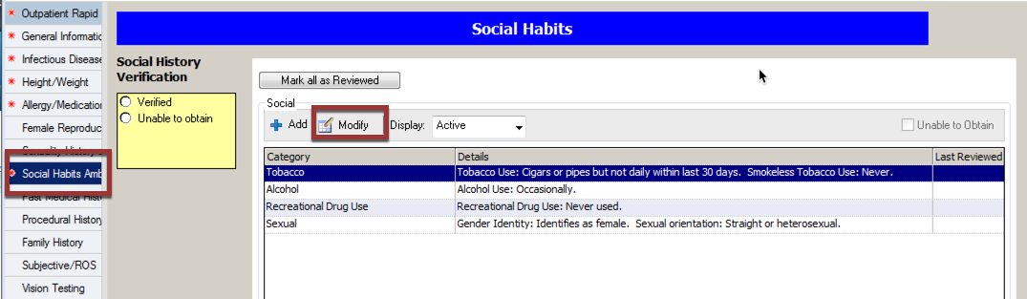
- Tobacco update if need then click ok
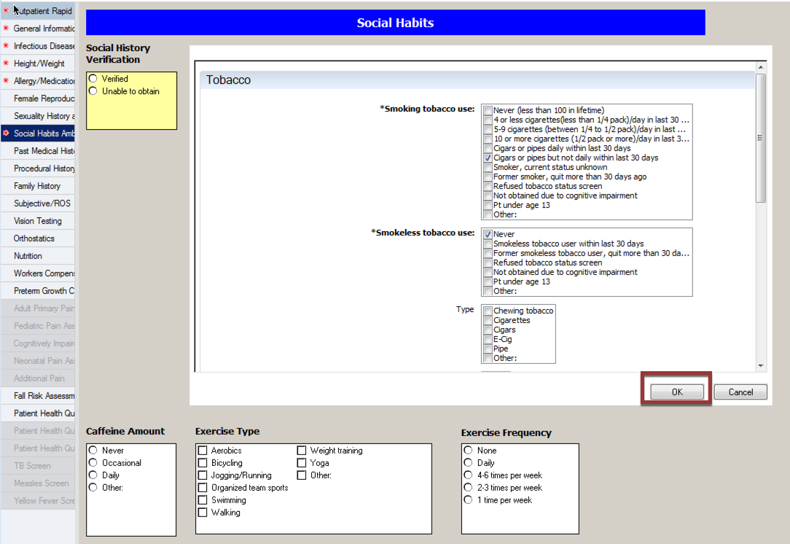

- Alcohol updated if needed then click OK
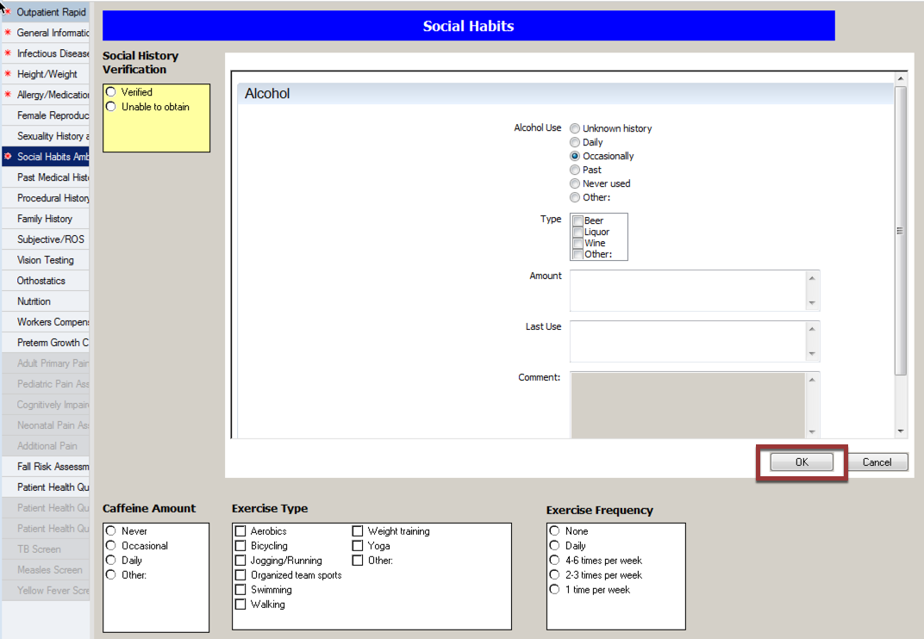

- Recreational Drug Use Update if needed then click OK
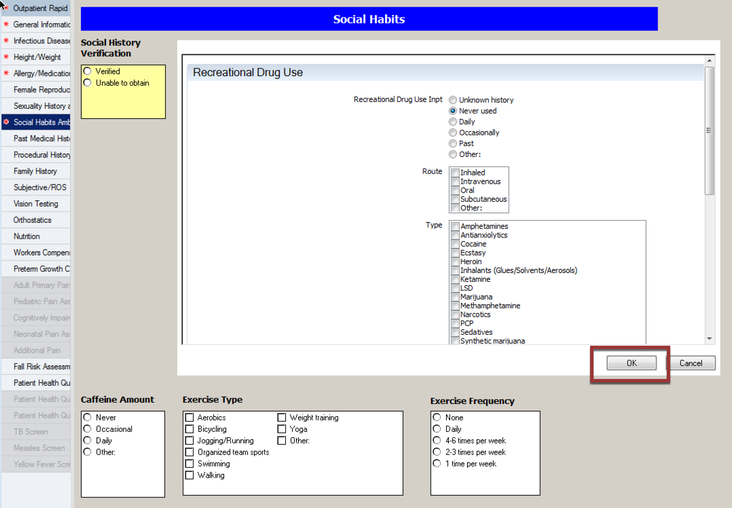

- Click on Sexual update if needed then click OK
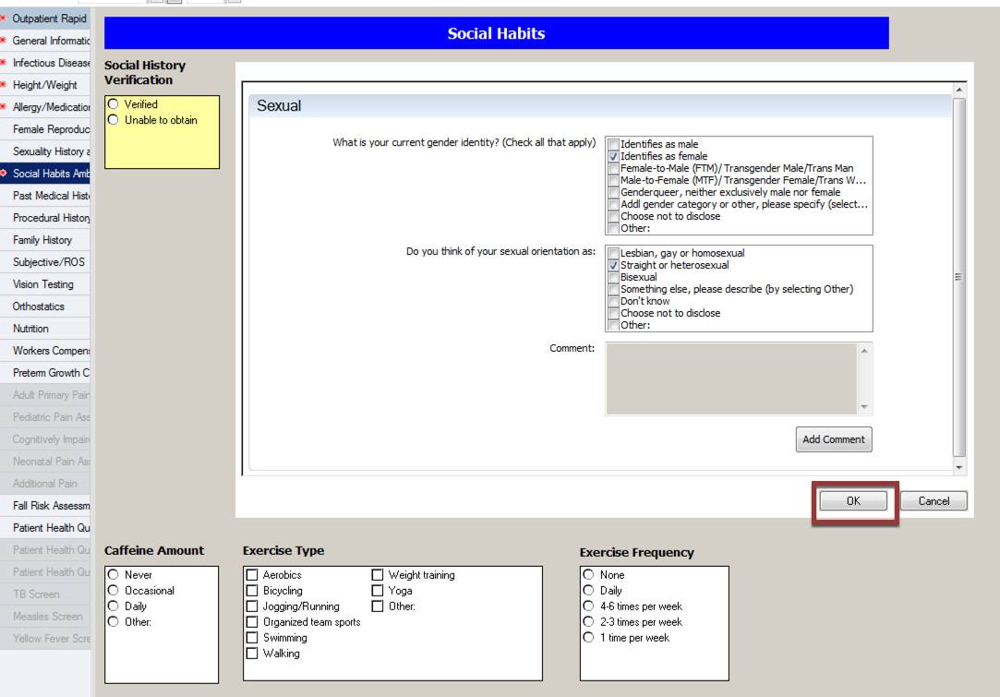

- Click on Mark all as Reviewed.
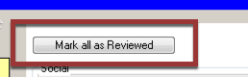

- Click Verified in the Yellow box.
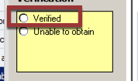

- If the patient is new you will need to click add
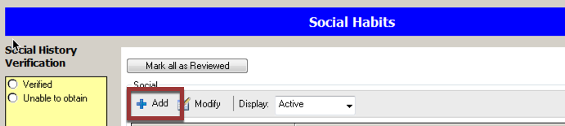

Please Note: Do not click add and create a new line for each social hx category. Please use the modifiy button add make the changes.

