Due to the upcoming changes with Dynamic Documentation, the first five services lines converting will notice a small difference when ordering either Vascular Lab or Cardiopulmonary orders.
The folders will look the same; the difference will be that most of them are no longer caresets. The Schedule Heart Station Procedure order has been removed. That order will be placed automatically for you via a rule in the system. The nurse/scheduling staff will still receive the task and PowerForm as before.
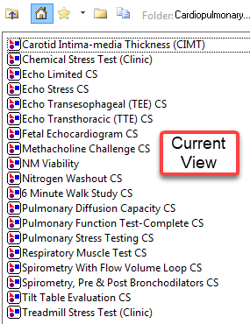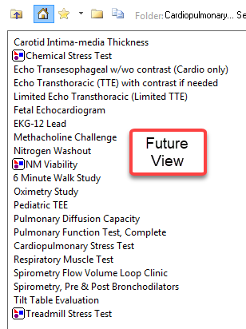
When placing the non-careset orders, you will no longer receive the pop-up screen (Figure 1).
Figure 1: Screen Shot of Old Careset
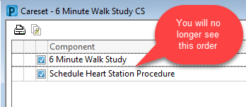
As always, please call any of the HELP desks for questions.

