ALL stress tests are now powerplans instead of caresets for single orders. The ***“Why”*** for this is to ensure the correct type of imaging order is placed.

1. Search for “stress” within the orders window or navigate to the Stress Folder

There is also a folder called “Stress Tests”

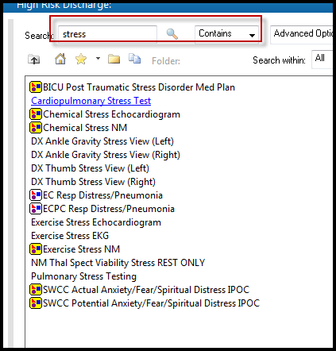

1. When you select the plan, the imaging/type options for stress are available. **If you do not choose an order, by clicking in the square, you are NOT placing any order.** Complete the needed fields as indicated by the blue circle with the X. This means you need some additional information on the order

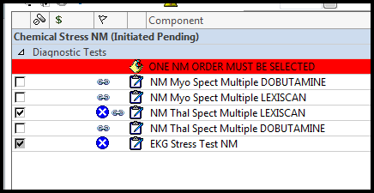

1. Complete the required fields, and sign the plan

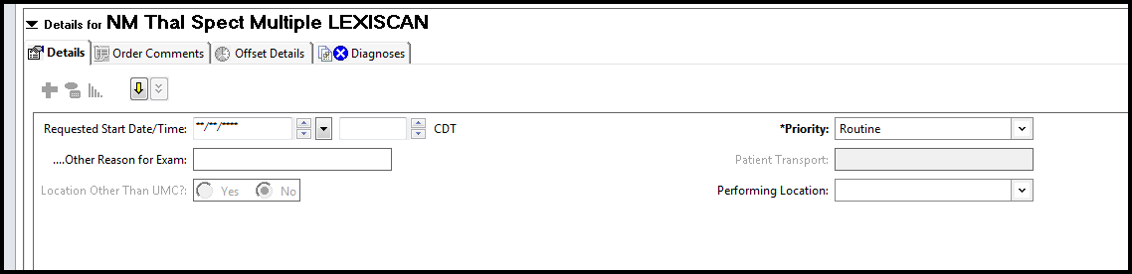

1. If no order is selected, you will receive this message. You will need to click “Cancel” and go back and chose the test you want to be completed on the patient

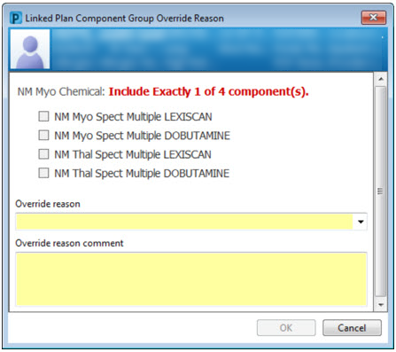

***You cannot order from this screen; you must click cancel and order from the powerplan***