Recommendations: New Chlamydia Screening Recommendation

Chlamydia Screening
New Chlamydia Screening recommendation will be added on 10/9/19
Who qualifies?
- Female persons aged ≥ 16 and ≤ 24 years
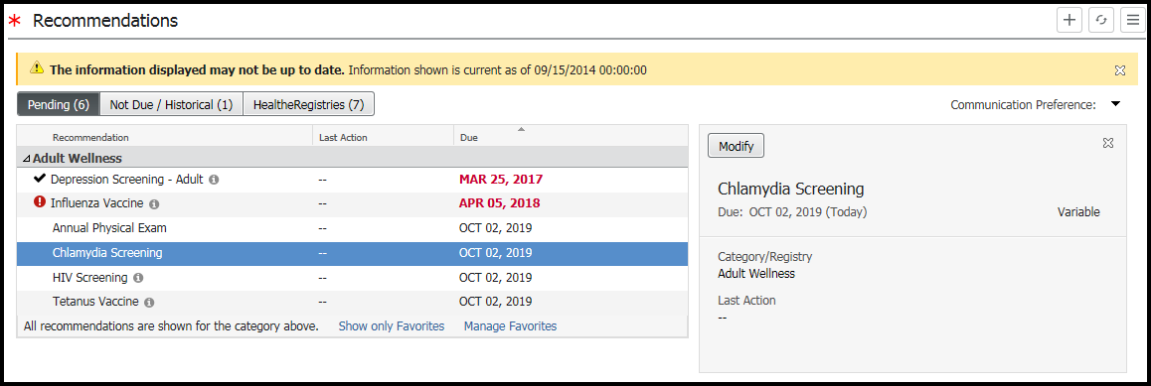

Remember to follow the steps below when new recommendations are created to keep them unhidden
- Click the “hamburger icon” on the Recommendation component
- Click “Settings” to display all settings applicable to the Recommendations component
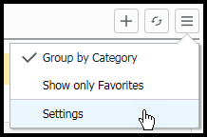

- Navigate to Favorites and click to unhide hidden items that align to our organizational recommendations and quality programs
