**Question:** Can **Texas Tech Clinics** use the new **Lab Add On Process**??

**Answer:** **Yes!**

When placing orders for Lab Add On, ensure that the **Priority is Lab Add On** and the **Future Order is set to No**:

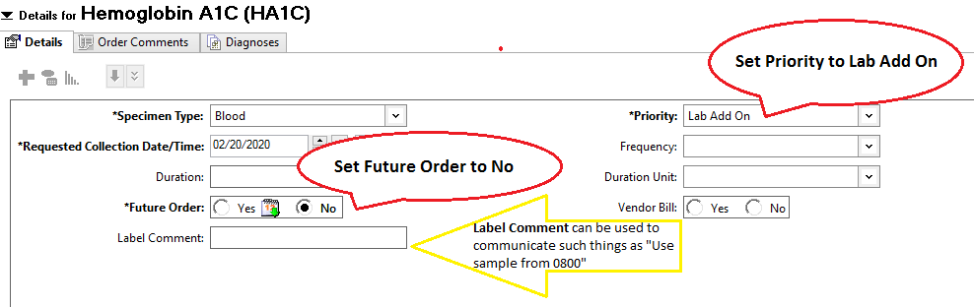

**Note**: The Label Comment can be used to communicate with the Laboratory such as when specific samples need to be used for the Add On.