The intent of this document is to educate end users about the Inventory Management Workflow for completing the immunization task.
The system attempts to find an existing lot when scanning or manually searching for a lot – both workflows pull information from the MPage/Inventory Mgmt. Worklist when charting an immunization in Medication Administration Record (MAR).

Task List Workflow:
- From the Multi-patient Task List, select the patient which the immunization was ordered, or from the patient Task list select the immunization medication that is being administered.
- The administration window will appear with the Lot # field yellow and the manufacturer and expiration date dithered:
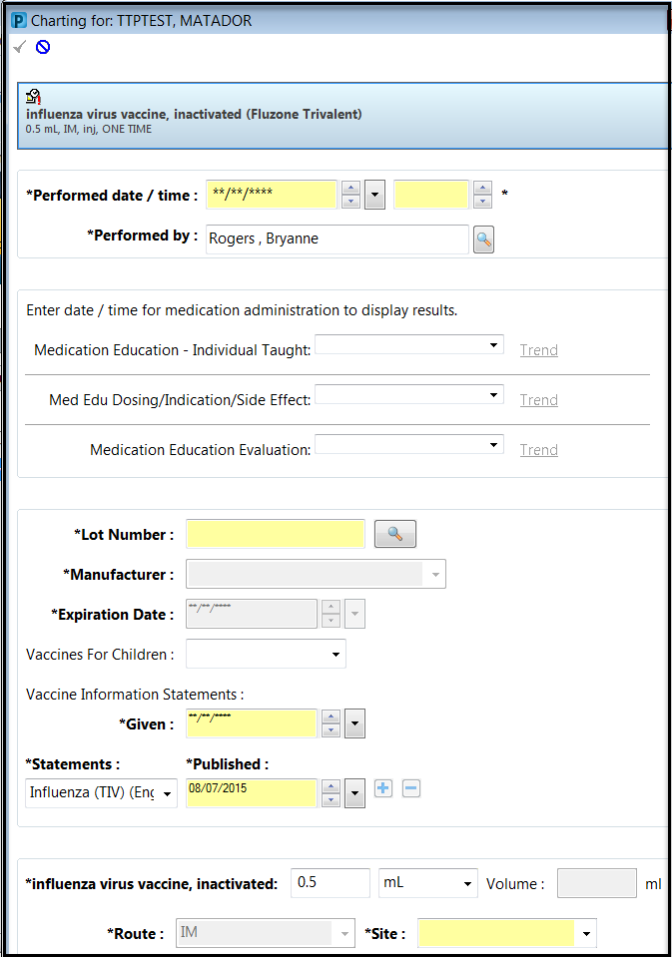

- Enter the Lot number and select the magnifying glass search icon -

- The Lot Number Selection Window will appear for you to select the Lot # associated with the medication vial:
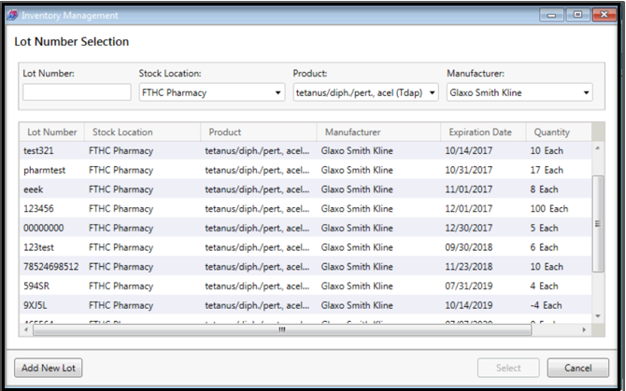

Note: If you click on the Binoculars and receive the following error message, it means that the LOT for this immunization has not been added or the order does not match the inventory for your location.
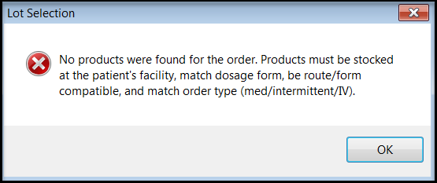

- Once you select the appropriate Lot # the Manufacturer information and Expiration date associated to that lot will automatically fill in:
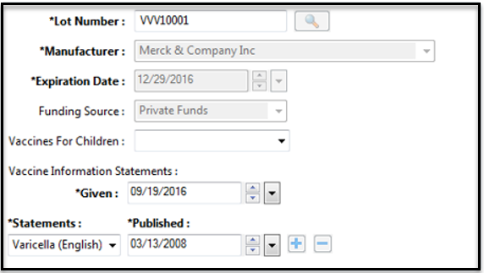

- After filling out the other required fields select the Sign Documentation button and finalize the administration.
NOTE: Shortcuts - using the ‘T’ for the date fields enters the current date; using the ‘N’ in the time fields will enter the current times.

NDC documentation:
The NDC will continue to be documented in the Comments field:
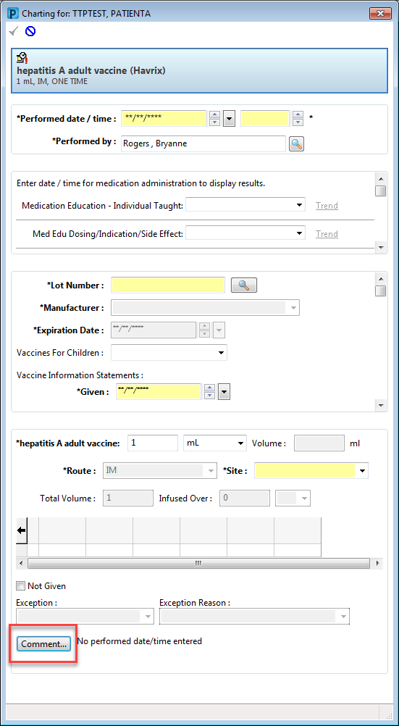

New Lot #:
Note: this workflow is not recommended as the typical workflow – only in situations where a Lot # has yet to be added into the MPage.
- If the Lot # is not in the MPage or available within the Lot Number Selection Window > Select the Add New Lot Button at the bottom of the Lot Number Selection window:
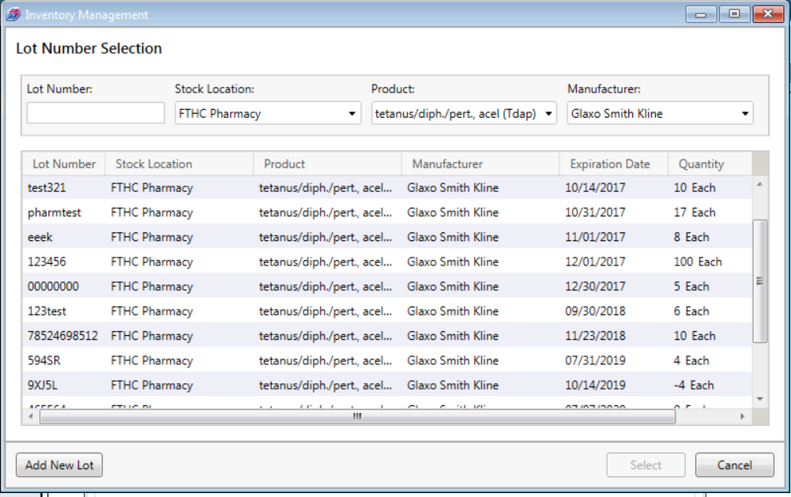

  - The Add Lot window will appear > enter in the required information for that immunization.
The Lot Number field is Case Sensitive.
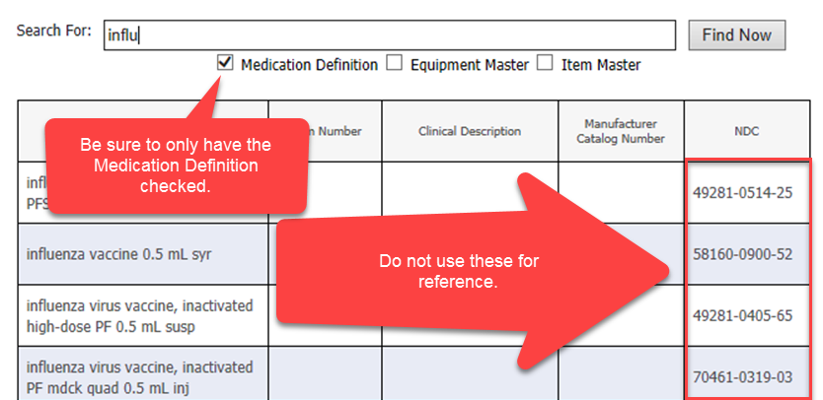

- Enter the Lot Details within the Define Item Location Properties component.
  - This is where the NDC will need to verified.
    - If the NDC is not available or needs to be updated, contact EMR help desk. The NDC will need to be added by the UMC Medication Management Team.
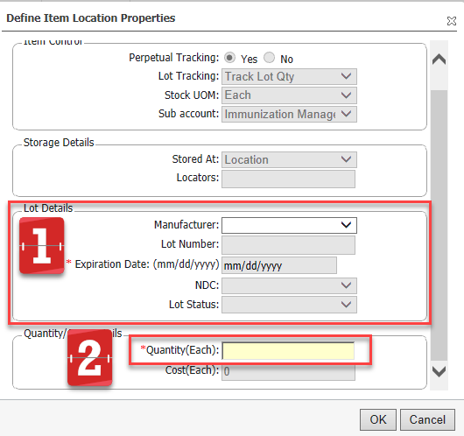

- Once completed the Immunization should appear on the selected Immunization management list.
