Name Change: MSSP Education to Quality Measures

PowerForm & Workflow MPage Component Update
- MSSP Education PowerForm will be updated to display “Quality Measures” instead of “MSSP Education”
- Regulatory Documentation Workflow MPage component will be updated to display “Quality Measures” instead of “Regulatory Documentation”
  - Name change to the MSSP Education PowerForm located on the drop-down list for the “Quality Measures” component
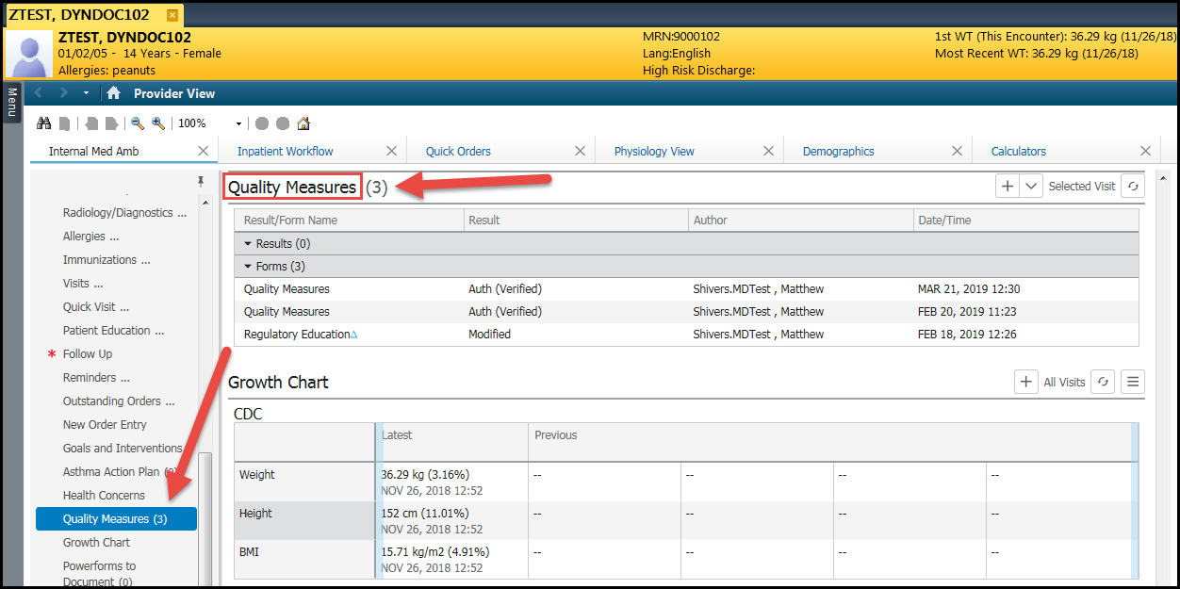
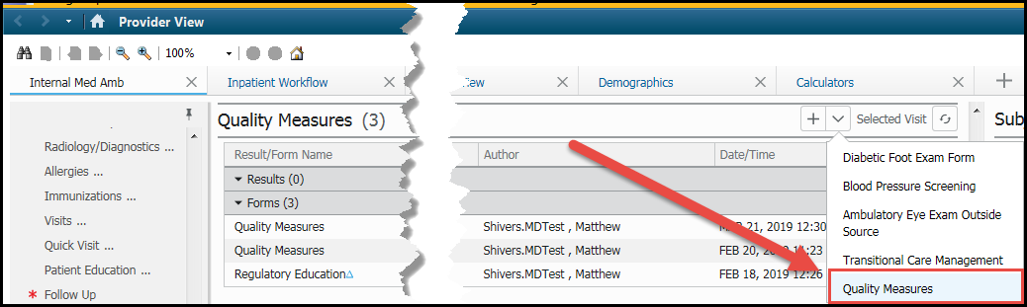
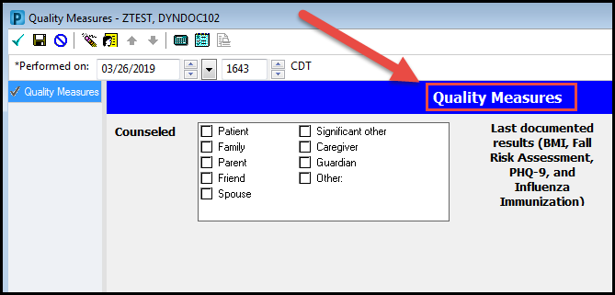
  - Name change to the PowerForm located under AdHoc
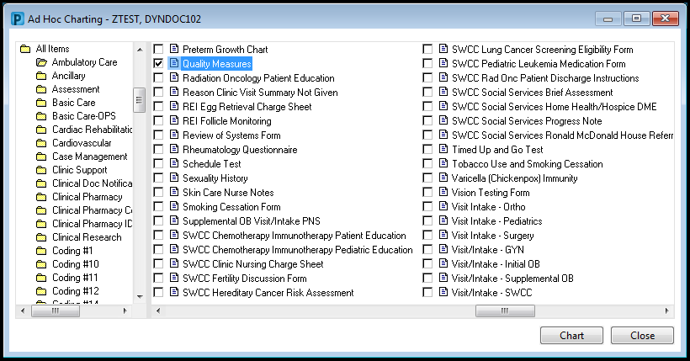

PowerNotes Update
- MSSP Education section in PowerNotes will be updated to display “Quality Measures” instead of “MSSP Education”
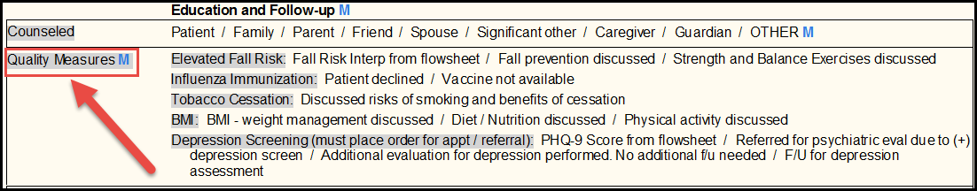

Dynamic Documentation Update
- MSSP Education section in Dynamic Documentation will be updated to display “Quality Measures” instead of “MSSP Education”
