**Clinical IT**

**Provider Informatics**

**Education on Utilizing Out of Office Notifications in Cerner Message Center**

**WHO**

**Setting:** **Ambulatory, Inpatient**

* MD
* APP
* Resident/Fellow

**WHY**

* Notify colleagues and care team when you are out of office and not available to reply to messages.
* Direct any senders to colleagues/backups while you are out of the office.

**QUICK STEPS**

1. Select **Manage Out of Office** from the Inbox buttonon the Toolbar Menu. The Out of Office dialog box will display.
2. Select the **I am Currently Out of the Office Until** option.
3. Select a date. This is an optional step that notifies senders when you will return to the office.
4. Click OK.
5. The **Out of Office** status is valid until you turn off the indicator, regardless of the actual date entered in the Out of Office dialog box.

**DETAILED STEPS**

**Manage Out of Office**

Complete the following steps to set your out of office:

1.    Select **Manage Out of Office** from the Inbox button on the Toolbar Menu. The Out of Office dialog box will display.

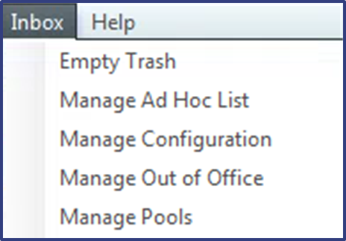

2.    Select the **I am Currently Out of the Office Until** option.

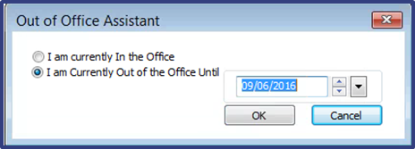

3.    Select a date. This is an optional step that notifies senders when you will return to the office.

4.    Click OK.

The Out of Office status is valid **until you turn off the indicator** (see below), regardless of the actual date entered in the Out of Office dialog box. (Note, The PVINBOX prompt below will not appear when accessing an inbox as proxy (i.e., viewing a colleague’s inbox).)

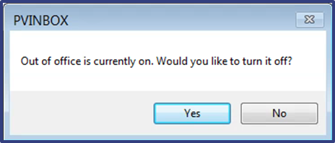

 If an item is forwarded to a recipient with Out of Office configured, a **Valid Recipients Currently Out of Office notification** will be returned to the sender with the relevant date.

