**Updates to Infectious Disease Intake Assessment**

Functionality Expansion and Changes from Foreign Travel to US and Foreign Travel

After a systematic assessment of workflow and clinical decision support (CDS) related to infectious diseases documentation in PowerChart, it was found that an enhancement was needed. This enhancement includes updating existing nurse intake documentation and development of new alerts for nursing staff and providers. It was developed with several goals in mind:

* Improving patient **AND** staff safety
* Preparation for emerging **AND** re-emerging infectious diseases (i.e., the recent resurgence in Ebola, multi-drug resistant Tuberculosis, Yellow Fever, Zika)
* Preparation for contagious diseases re-emerging within the United States (i.e., Measles, and Mumps due to anti-vaccination movement)
* Standardize forms between inpatient and outpatient

To prepare, as well as to align ourselves with the national Centers for Disease Control and Prevention (CDC) initiative (CDC, 2018), we had round-table discussions with subject matter experts and selected several disease processes found to be either underdeveloped or non-existent in the system that needed the highest attention:

* Ebola (exists, undergoing update)
* Zika (exists, undergoing update)
* Yellow Fever (new build)
* Tuberculosis (enhanced build)
* Measles (new build)

The existing PowerForm, *Infectious Disease Screen*, has been updated to aid in easing the transition for the nursing staff. It is the same form currently used, only with upgrades and modifications.

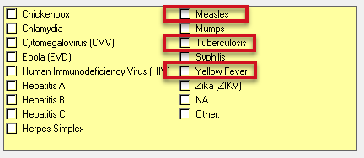

You will notice a new flow immediately to the form **(Figure 1).** A definition of what “exposure” means has been added to aid you in describing it to your patients. If they state they have an exposure to Measles, Tuberculosis, or Yellow Fever, sub-sections will present themselves to be filled out with whatever applicable information is needed to convey a clean and accurate alert to staff and providers later **(Figures 2, 3, and 4**, **respectively).**

**Figure 1: Infectious Disease Screen PowerForm**

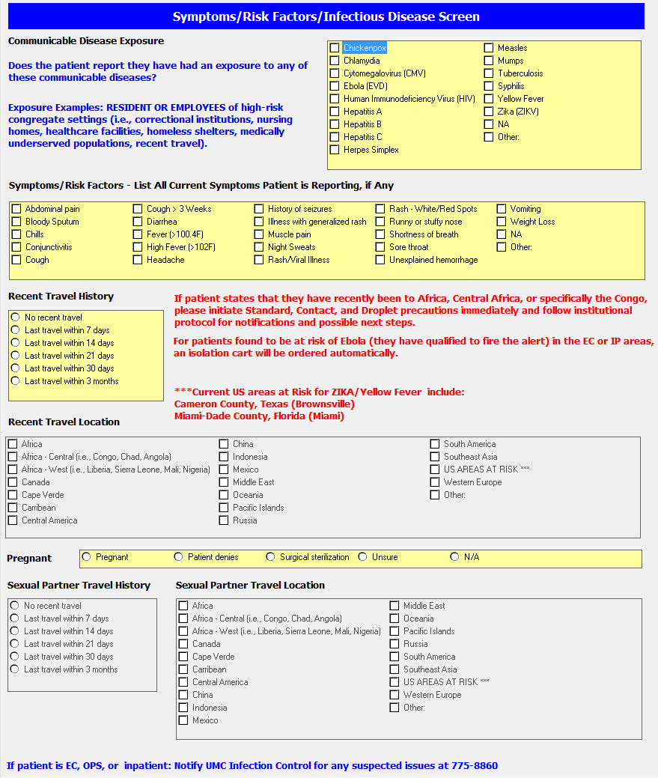

**Figure 2: Measles Screen**

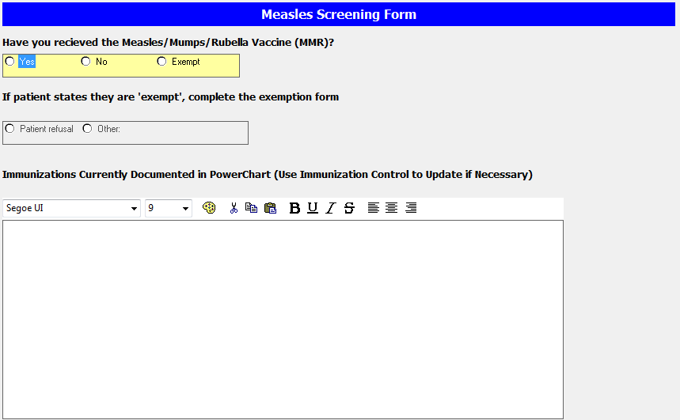

**Figure 3: TB Screen**

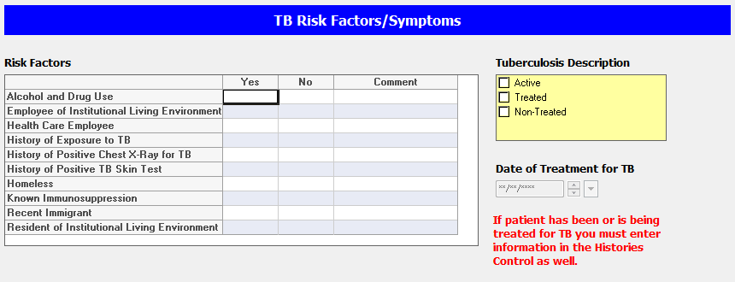

**Figure 4: Yellow Fever Screen**

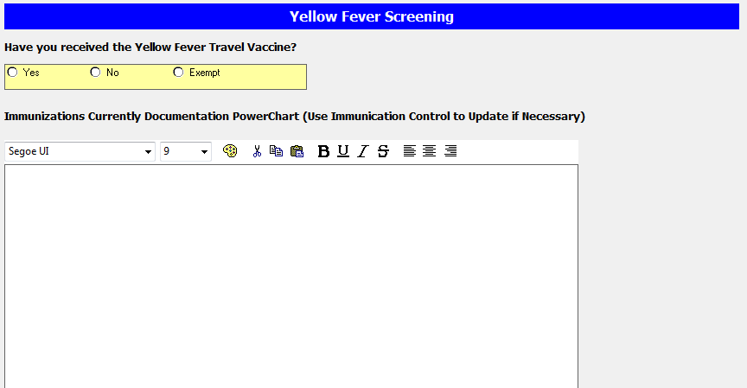

The next area updated is the Symptoms field. To make things easier, it is now a multi-select box **(Figure 5).** Check all symptoms that apply if your patient states they have any. You may select “NA” if they do not. Make sure to address this field if they do have symptoms; this will ensure the alert fires on possible active TB patients rather than latent ones. Random chart reviews will be conducted to assure proper usage of the new fields.

**Figure 5: Symptoms and Risk Factors**

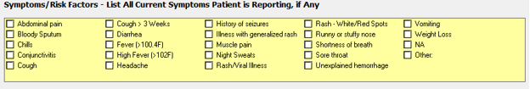

The form, in its current state, lends itself to only travel assessments outside the United States. For example, this is of no use if Ebola returns to Dallas, Texas, or some other location within our borders. Measles and Mumps have already had recent outbreaks in Texas. Yellow Fever will most likely follow Zika this summer in South Texas. Modifications were made to address this.

You will note the addition of “US AREAS AT RISK***” as one of the new options **(Figure 6).** Definitions of current high-risk areas are in red next to the options. This will be updated quarterly unless there are urgent updates needed (i.e., Ebola in Dallas, etc.). When asking recent travel history, make sure to say **ANY** recent travel, whether inside the United States or not.

**Figure 6: Travel History Updates**

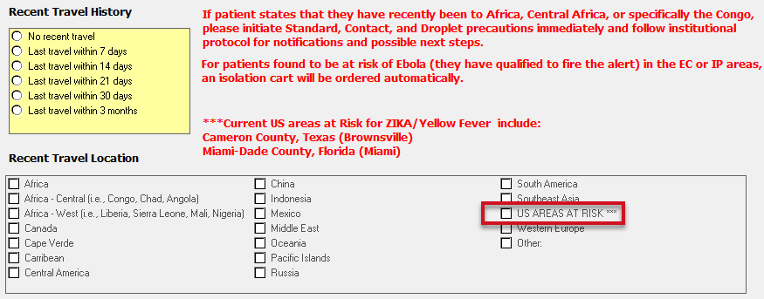

The rest of the PowerForm is relatively unchanged except the updated locations for the sexual partner to reflect the same locations as the ones the patient is presented with **(Figure 7).**

**Figure 7: Pregnancy and Sexual Partner Travel History**

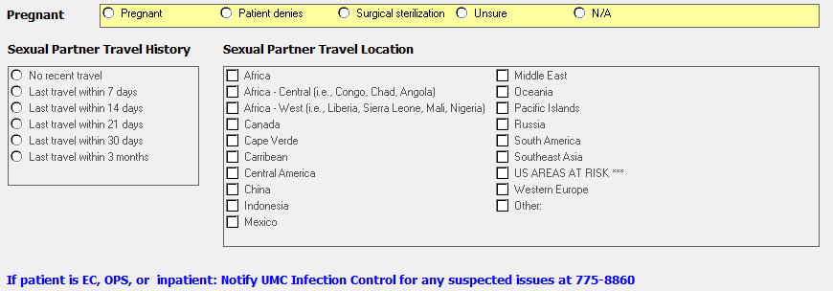

As of July 30, 2018, if applicable algorithms are met, an alert will be fired for Ebola and Zika (already exists), as well as Yellow Fever, Tuberculosis, and Measles (new). Other disease processes will be added later as the need arises or by subject matter expert request.

Continue to rely also on your clinical critical thinking skills when working with potentially infectious patients; always follow your institutional protocol. Clinical decision support provides guidance, but your clinical expertise will aid in whether the situation calls for further action or not.

**References**

Centers for Disease Control and Prevention. (2018). *Adapting clinical guidelines for the digital age.* Retrieved from https://www.cdc.gov/ophss/WhatWeDoACG.html

Centers for Disease Control and Prevention. (2018). *CDC travelers’ health, 2018.* Retrieved from https://www.cdc.gov/ncezid/index.html

Fairley, J. K., Kozarsky, P. E., Kraft, C. S., Guarner, J., Steinberg, J. P., Anderson, E., . . . Wu, H. M. (2016). Ebola or not? evaluating the ill traveler from ebola-affected countries in west africa. *Open Forum Infectious Diseases, 3*(1) doi:10.1093/ofid/ofw005

Texas Health and Human Services. (2018). *Health advisory: Ebola outbreak in the Democratic Republic of the Congo* [PDF]. Retrieved from https://www.dshs.texas.gov/IDCU/disease/ebola/Final-Health-Advisory-Ebola-in-DRC-052118.pdf