Recommendations: Documenting Historical Procedures

New Action to Document Historical Procedures on Recommendations
On 10/9/19, the following recommendations will gain the ability to document from the Recommendations component to satisfy the recommendation and to write to the Procedure Histories table:
- Breast Cancer Screening
  - Bilateral Mastectomy Procedure
- Cervical Cancer Screening
  - TAH – Total Abdominal Hysterectomy Procedure
- Colorectal Cancer Screening
  - Colonoscopy Procedure
  - Fiberoptic Sigmoidoscopy Procedure
  - Flexible Sigmoidoscopy Procedure
  - Sigmoidoscopy Procedure
Follow the steps below:
- Navigate to the Recommendations component
- Choose the Actions dropdown to select a historical procedure that will satisfy the recommendation
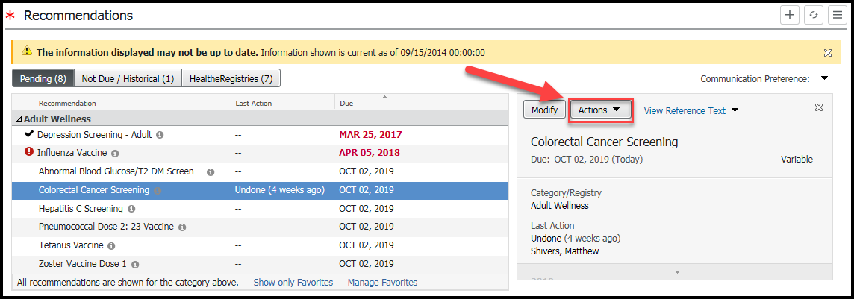
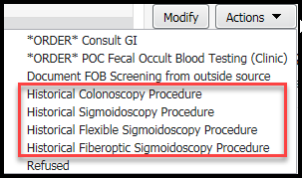
- Fill out the time the procedure occurred, provider, and location of procedure
- Click Save
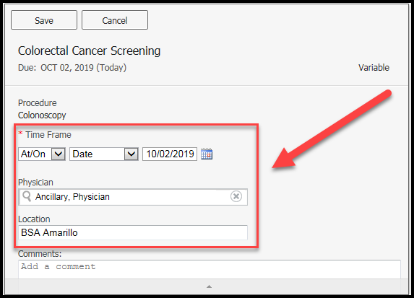
- Navigate to the Procedure Histories table to find the newly document procedure
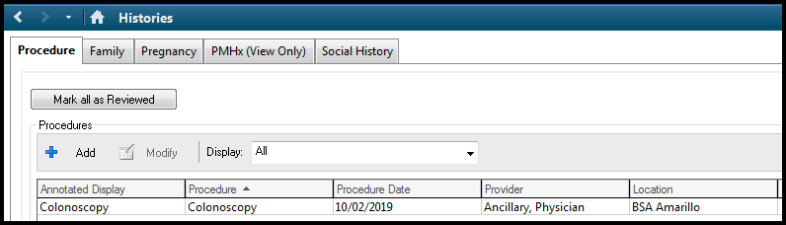
- Review Recommendations or HealtheRegistries to see the satisfied recommendation
