2015 CEHRT/Meaningful Use Stage 3/PIP: Sexual Orientation & Gender Identity

Sexual Orientation & Gender Identity (SOGI)
As a part of the 2015 CEHRT (Certified EHR Technology) requirements, our electronic health record (EHR) must have the capabilities to document sexual orientation and gender identity (SOGI). Utilizing this feature will allow us to improve our patient care by capturing a patient’s sexual orientation and preferred gender identity.

SOGI can be documented in Cerner using the Social History Control, and can be accessed via Histories on the Table of Contents/Menu or by documenting in the control via a PowerForm.
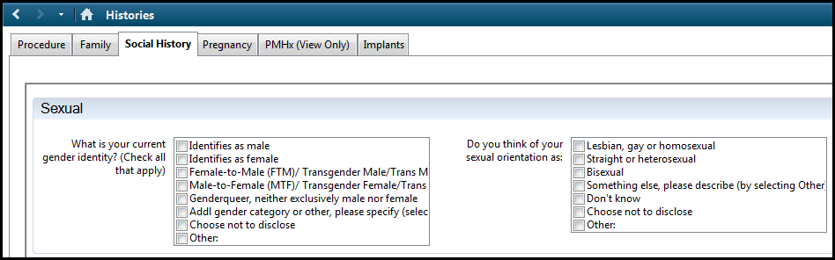

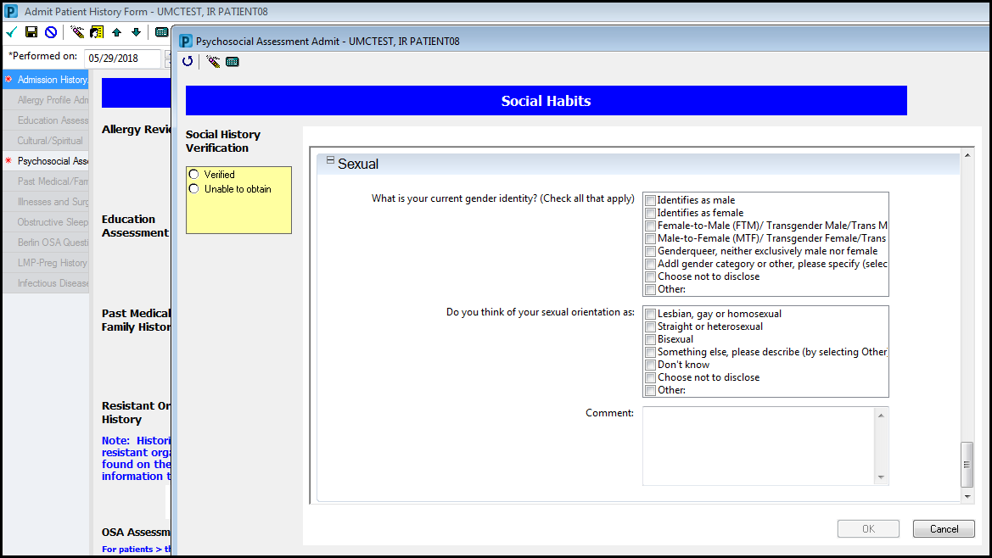

2015 CEHRT/Meaningful Use Stage 3/PIP: Sexual Orientation & Gender Identity

Sexual Orientation & Gender Identity (SOGI) – Transgender Alert
The new Social History Control has the Gender Identification field; similar to the one in the Sexuality History PowerForm. In order to maintain the Transgender Alert (patients that are transitioning from one gender to another and cannot yet legally change their name in the EHR), the Sexuality History form will be renamed and continued to be used for the purposes of adding documentation for the Transgender Alert.
Due to upcoming functionality for documenting Birth Sex, the Sex at Birth field will be removed in the near future.
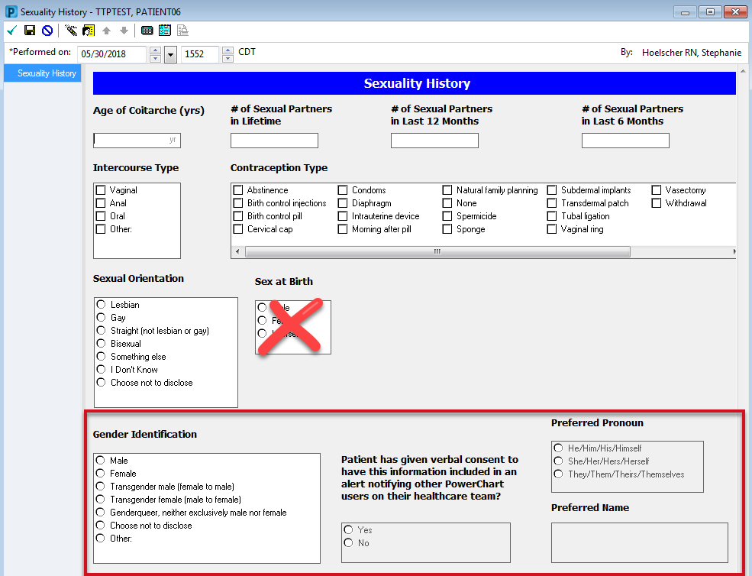

For those allowed to update the birth sex or admin sex in PM Conversation:
Select PM Conversation from within a patient’s chart.
Select Admin/Birth Sex

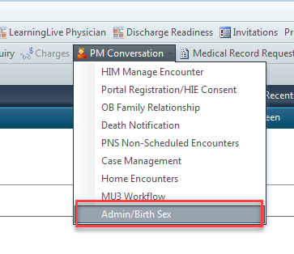
Document the appropriate/legal admin or birth sex field.
Select OK.

