Explorer Menu is being replaced with Discern Report Portal. Please review the following instructions to locate reports.
How to access reports using Discern Reporting Portal:
Select Discern Reporting Portal on the tool bar in PowerChart or add to your AppBar, see last page.
PowerChart: AppBar Icon:
Locate appropriate report, using the Search box will be the most efficient method to search.
Clicking on the star will indicate that this is a Favorite report, and will fall into the My Favorites tab for future use.
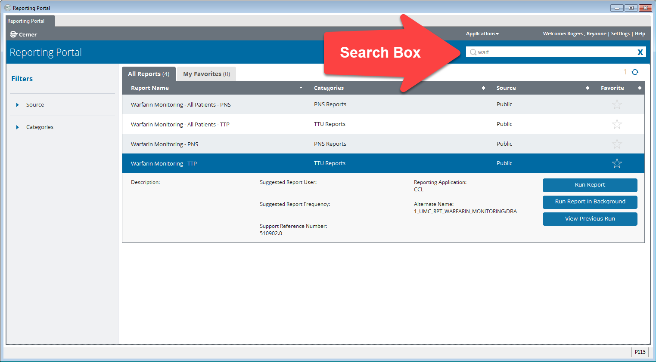
Click Run Report, enter the prompts and select Execute.
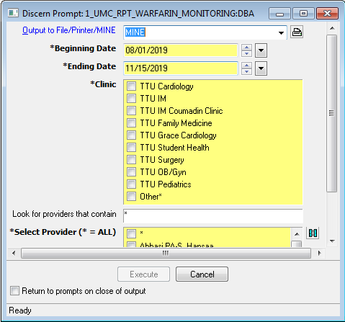

The report will result:
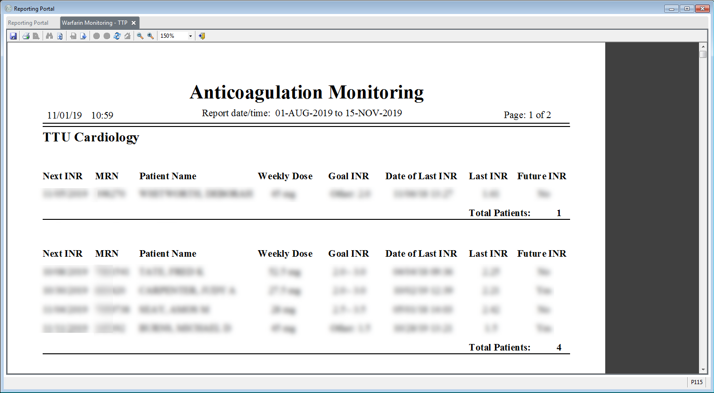
How to add to AppBar:
Open AppBar, click on the AppBar icon and select Customize and open the Buttons tab.
Selecting the Applications, ensuring the checkmark appears, will allow them to display on your AppBar.
