With new requirements for Promoting Interoperability Program (PIP), formerly Meaningful Use Stage 3, and CEHRT technology, the Social History control with the Nursing Adhoc is being updated!

You will have the same options, just in a slightly different format. You will still be able to document the patient’s social history within the Intake form, it will simply have a more updated appearance.

The look of the Social Habits Ambulatory section currently looks something like this:

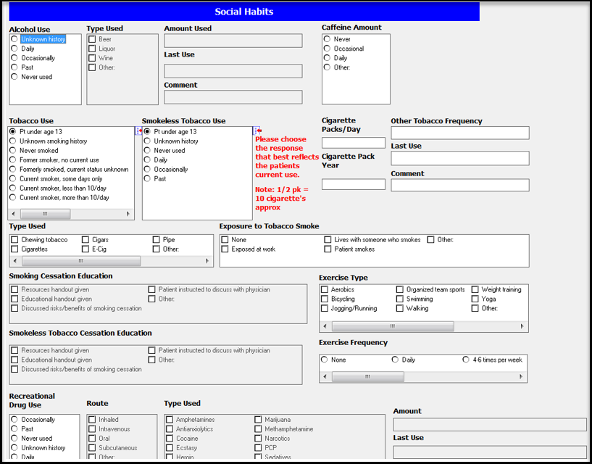

Mid July, the updated look will roll out and revealing a more sleek appearance. Double clicking on any of the key terms, will launch open the forms, making them available for you to document patient information:

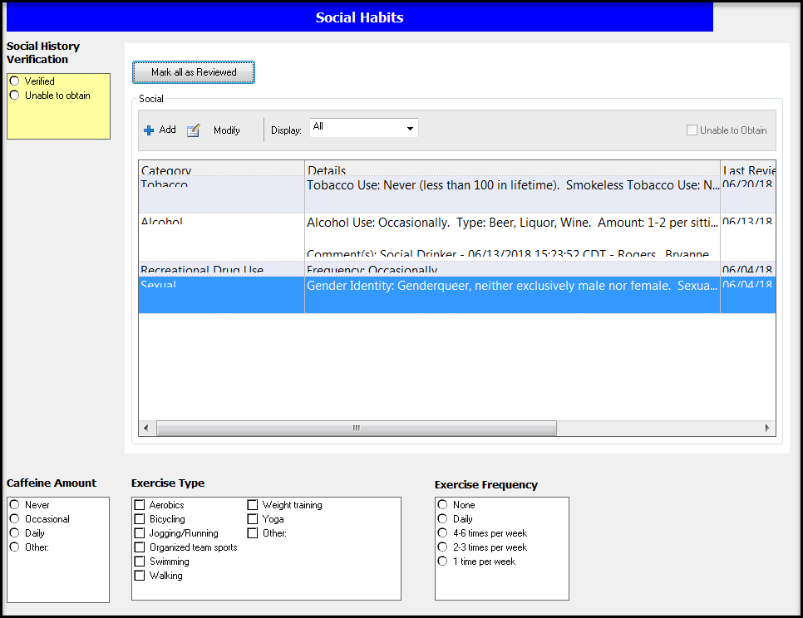

There are 4 fields within the Social history component, Tobacco, Alcohol, Recreational Drug Use and Sexual.

Required fields are indicated with bold text and an asterisk (*), until these fields are address the OK button will be dithered.

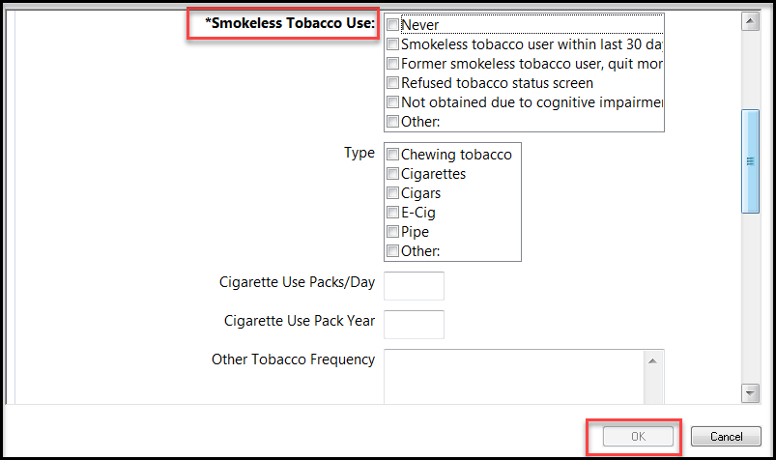

Once the information has been documented, select OK to update the patient record. Once back on the Social History home screen, click on Mark All as Reviewed (take credit for your work!) to update the Last Reviewed date to today’s date and select Verified in the Social History Verification box to the left.

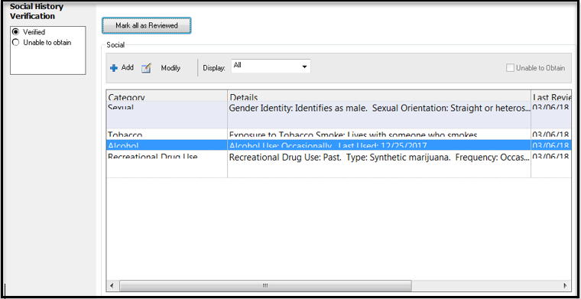

One Subsequent encounters: Once the social history has been completed in this process, follow the following instructions to verify and update.

Verify with the patient that the information is accurate, ***if it IS correct***, click on Mark All as Reviewed (take credit for your work!!) to update the Last Reviewed date to today’s date and select Verified in the required box. And you are finished with Social History.

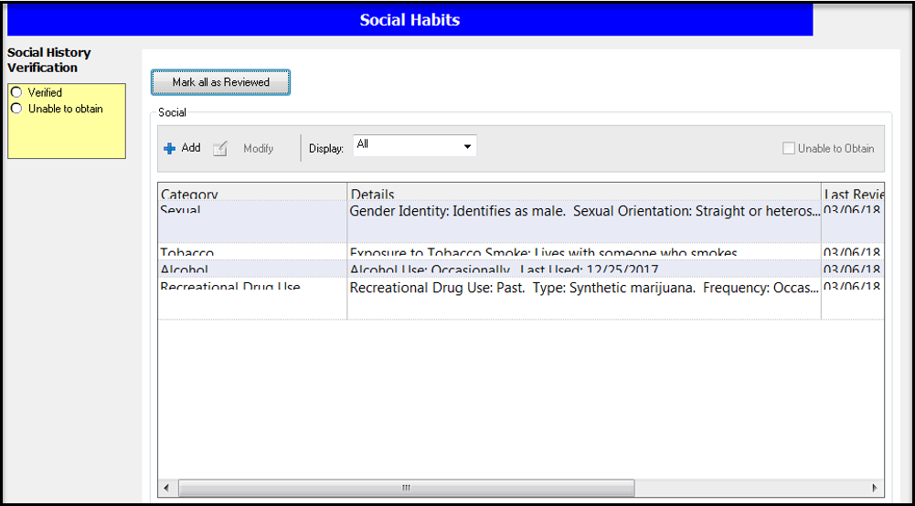

***If it IS NOT correct,*** select the control that needs to be updated, and select Modify.

In this example, we are going to modify the Tobacco control. Highlight the Tobacco control, then select Modify.

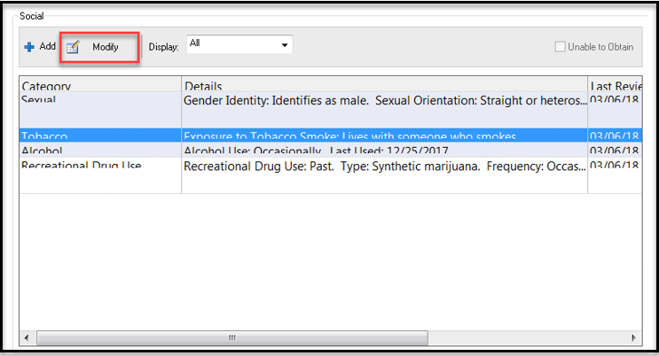

Make the necessary updates and select OK.

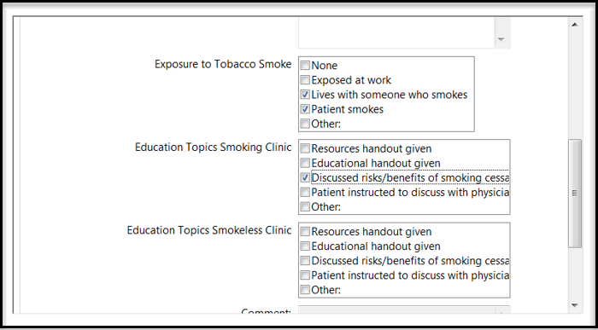

Reviewing the Tobacco Control, you are now able to see the updates to this control.

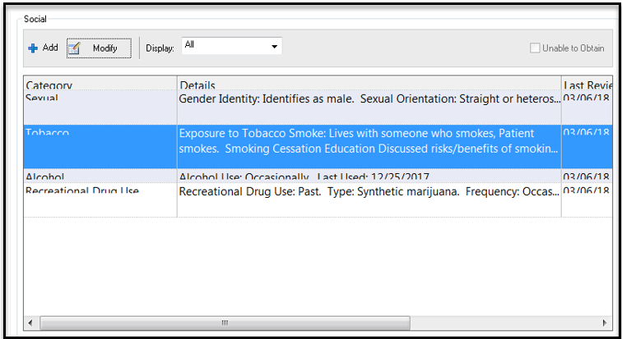

Right clicking on the desired control, you are able to view more options that allow you to edit the controls. Note that this is where you can review the history of the control.

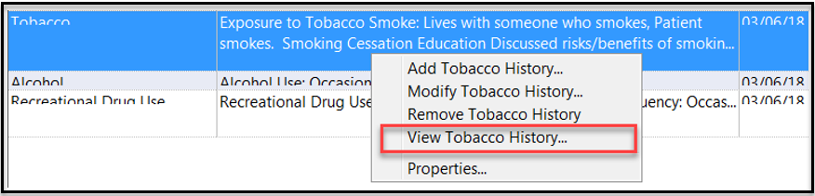

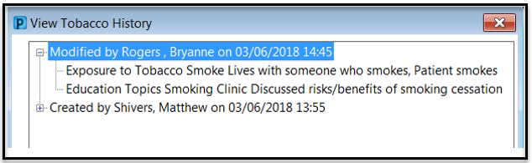

Every six months, the information will need to be updated, this is indicated by a red indicator beside the section requiring updating. Double click the section requiring attention to open, verify the information and update accordingly, or if no data has changed, chart the previously documented details again.

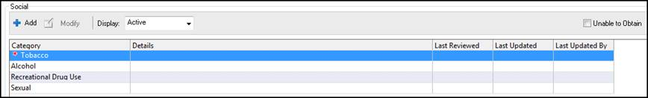

Once completed select the OK and Verified options.

Appropriately completing this process will remove the red indicator.

