Provider Enhanced Workflow
- Place the PowerPlan:
Adult Outpatient Surgery Plan or the Pediatric Outpatient Surgery Plan
- Complete the required fields.
  - New required field- the “Outpatient Surgical Procedure” order will require completion of a new PowerForm
  - Complete the PowerPlan then select Orders for Signature to activate the form
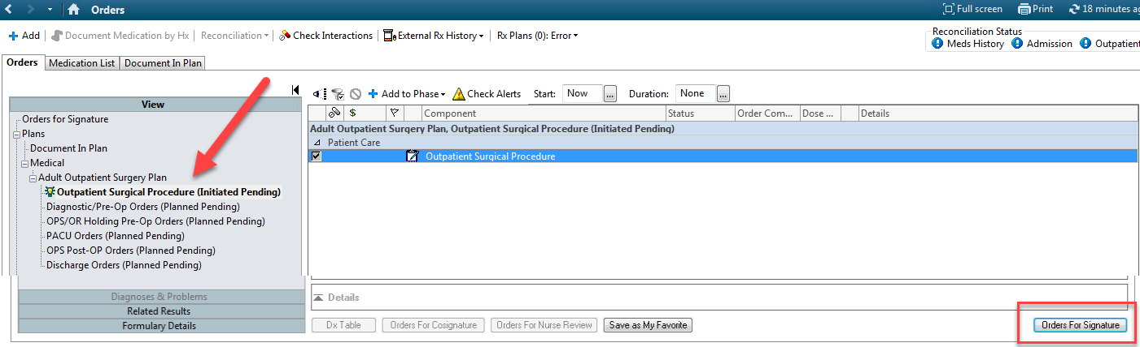
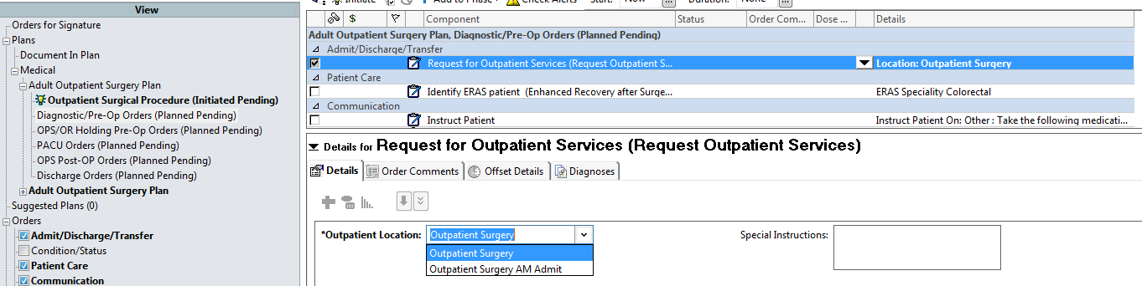
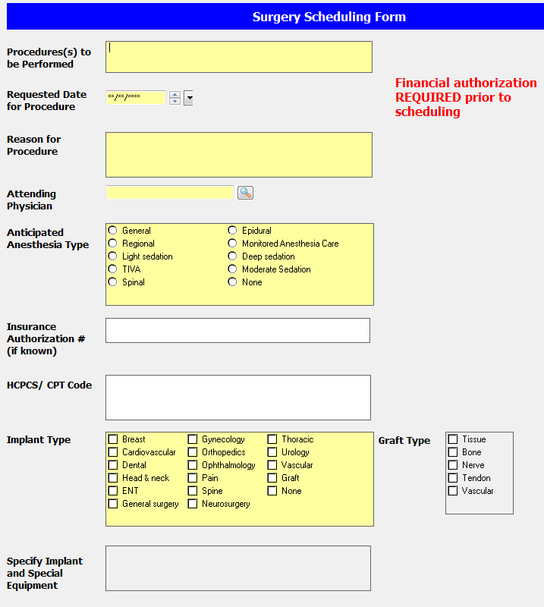
- Old order for Request for Outpatient Services is still there, it is now the second phase and most of its fields are now in the new PowerForm
- All PowerForm fields in yellow are required.
- Implant type field MUST be addressed
- Details of the specific implant should be entered into the “Special Implant or Special Order” section
- Once signed the form will be modifiable under Form Browser and viewable in Clinical Notes.

Communication/Prior Auth Process – Nurses/Managed Care/PSS Staff
Cerner Message Center will be used to communicate
- Pools have been created for Clinics and UMC to share all communication via message center.
- To start this process generate a message from with the appropriate Patient’s chart and send from your Scheduling Pool. Use the appropriate note type only. You may continue to insert the template that you have previously used.
- Use this pool communication to share information regarding the prior authorization process.
- When completed forward the communication to the UMC Authorization Pool.
- Simultaneously, submit case for SurgiNet SchedBook, UMC will confirm the authorizations and presence of PowerPlans, PowerForms and the H&P. when the process is complete the OR Scheduler will respond back to your pool with the OR case, date and time.
It is only after all this information has been confirmed that OR Scheduling will post the case to the schedule.

Contacts:
UMC OR Process & OR Scheduler/Coordinator Support
Outpatient Surgery 775-8612
775-8615

Technical Support (PowerPlan, PowerForm, Orders, Message Center)
UMC IT Help Desk: 775-9109
TTP Help Desk: 743-4357

