Recommendations: 2018 Code Upgrade Changes

Overview
On 11/16/19, we will be upgrading Cerner from 2015 code version to 2018 code version. The 2018 Code Upgrade will change and enhance Recommendations for all users.

Changes
Below are all of the changes that will occur to Recommendations on the 2018 code version.
Priority, Source, and Orders Columns
Removed “Priority” column, and added “Source” and “Orders” columns
- Source column displays sources of the recommendations. Ex - HealtheRegistries, System, User, or Manually added.
- Orders is an actionable column that allows the user to add orders
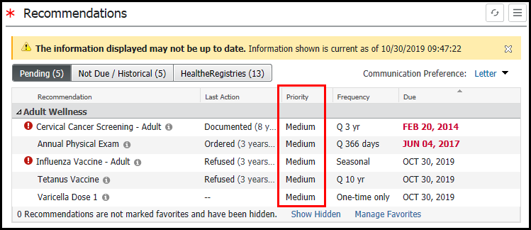
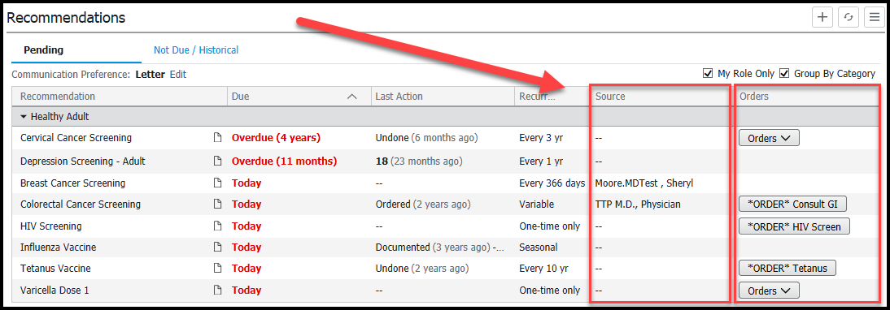

To find the Priority of a recommendation, highlight/select a recommendation to view the priority in the detail pane.
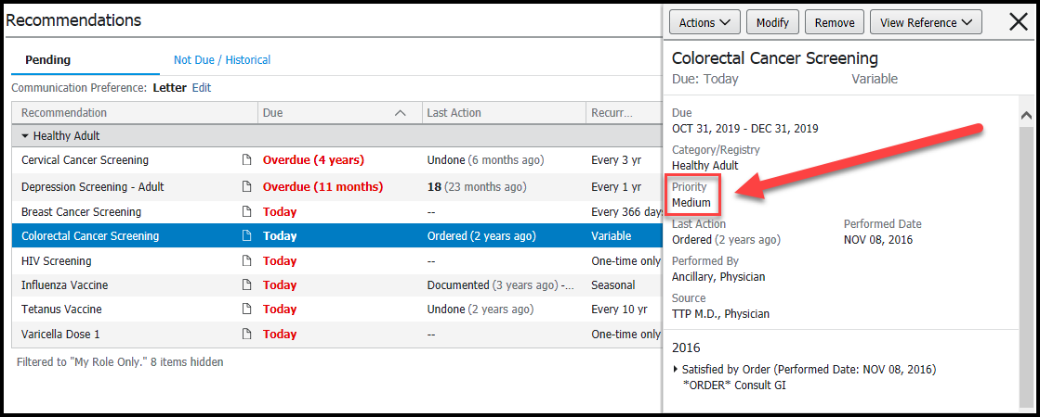

View Reference Text
A new “paper” icon was added to indicate reference text is available to learn more about a recommendation and how to satisfy the recommendation.
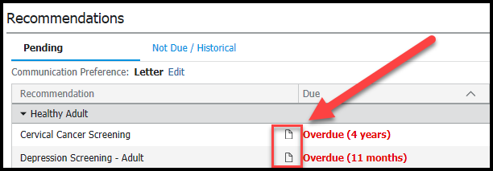

Navigate to the detail pane to View Reference Text for the recommendation.
Click the View Refence link to find reference information about the recommendation, and click the external links within the Reference Text for more guidelines or reference material.
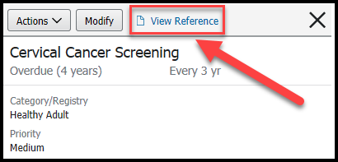
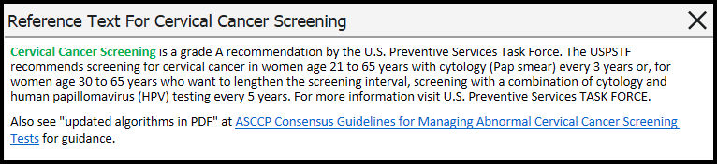
Recommendations Component Tabs
Pending, Not Due/Historical, and HealtheRegistries tabs count was removed and are no longer boxes.
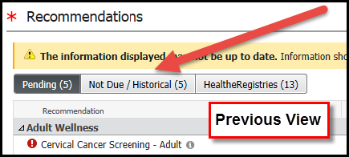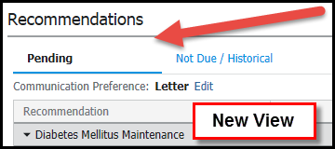

Note: Not all HealtheRegistries measures were built to display on the Pending and Not Due/Historical Tabs. Only those measures that align to our quality programs were built to display on these Tabs. To see all HealtheRegistries measures the patient qualifies for, see the HealtheRegistries Tab.

Favorites
Favorites option is removed from the settings “hamburger” button window and replaced with the label “Manage My Role Filter…”
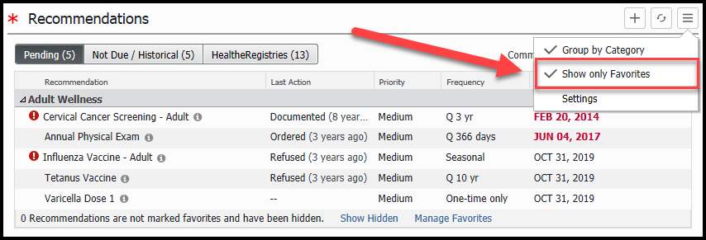
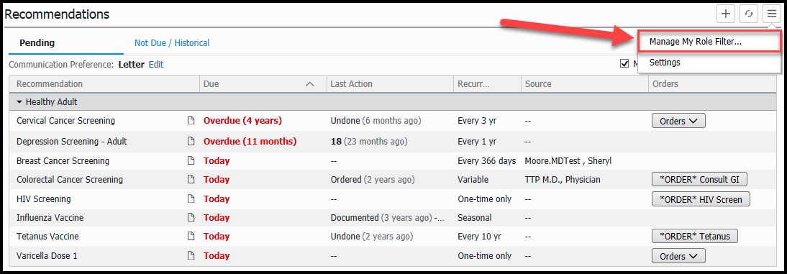
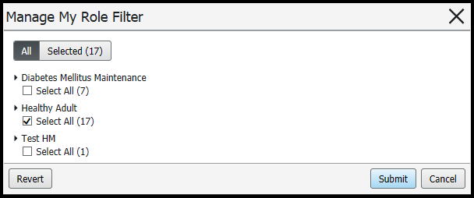

When “My Role Only” filter has been applied, it will only show what has been set as your favorites. Any recommendations that are not visible under “My Role Only”, will be hidden and the component will display a total of hidden items at the bottom of Recommendations.
Check/uncheck “My Role Only” box to display what has been set as favorites or are hidden.
