Admin Sex & Birth Sex
As a part of the 2015 CEHRT (Certified EHR Technology) requirements, administrative sex must be documented separately from birth sex to comply with new HL7 specifications.
Please Note: Administrative sex is used for administrative purposes such as insurance billing.
Birth sex is the sex assigned at birth on the birth certificate that is used for clinical purposes.
Administrative sex is collected during registration in IDX, GE Centricity, or GPMS and is visible in Cerner on the blue banner bar. This sex value can be modified by the appropriate staff when legal documentation is presented. The modification of the administrative sex should only occur within one of the registration systems. Do not alter via a PM Conversation
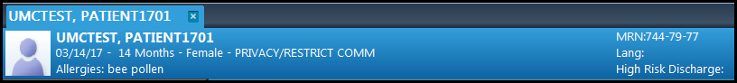
To Update the Admin/Birth Sex on a patient’s Chart:
Navigate to PM Conversation along the top Tool Bar.
Click on the arrow to open to the options and select Admin/Birth Sex.
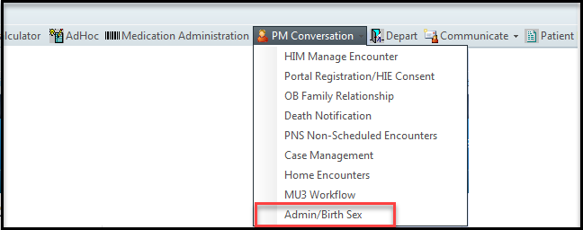
Birth sex is visible in the Admin/Birth Sex PM Conversation and will default to the same value as the administrative sex for any new patient that has never had a visit in Cerner. The birth sex value can be modified by the appropriate staff, if needed. Typically, this value is different than administrative sex for patients that have transitioned and can be modified when legal documentation is presented. For example, if a patient is registered and arrived as a female but they were born as a male, the Admin/Birth Sex tool may state, Female/Female. This would need to be updated to reflect Female/Male (Admin/Birth sex).
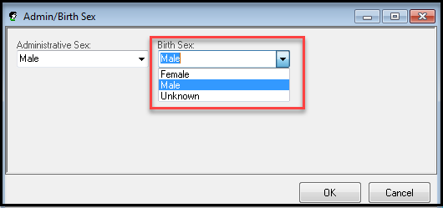
The modification of the birth sex can only occur using Admin/Birth Sex PM Conversation.

