Recommendations: How to Show Hidden Recommendations

How to Show Hidden Recommendations
Hidden Recommendations occur when new recommendations/expectations are created. In order to show all new or hidden recommendations, follow the steps below to align with our organizational recommendations and quality programs.
- Navigate to the Recommendations Workflow MPage component
- Select the “hamburger” icon above the component
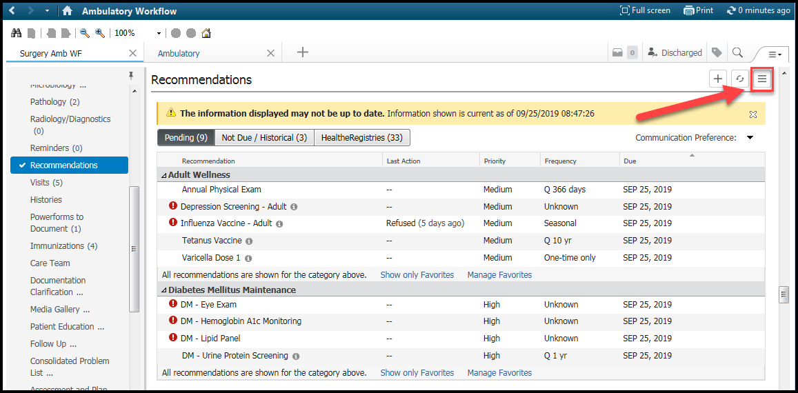
- Click “Settings” to display all settings applicable to the Recommendations component
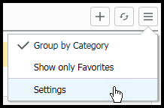

- Navigate to Favorites and click to unhide hidden items that align to our organizational recommendations and quality programs. You will not see the icon when all available recommendations are moved over to the right-hand box.
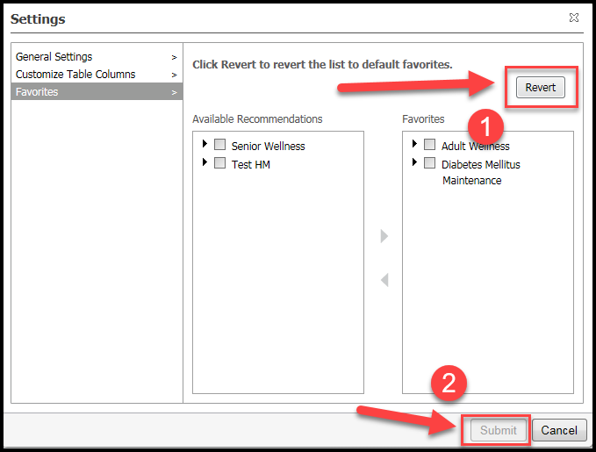

- To ensure that all recommendations are showing, make certain you see the statement ‘All recommendations are shown for the category above’ in the recommendations window.

