**Reminder: Tamiflu Dosing**

**Per manufacturer recommendations,**

**Tamiflu should be adjusted for renal impairment.**

**Renal function should be viewable in PowerChart in *Related Results* while prescribing.**

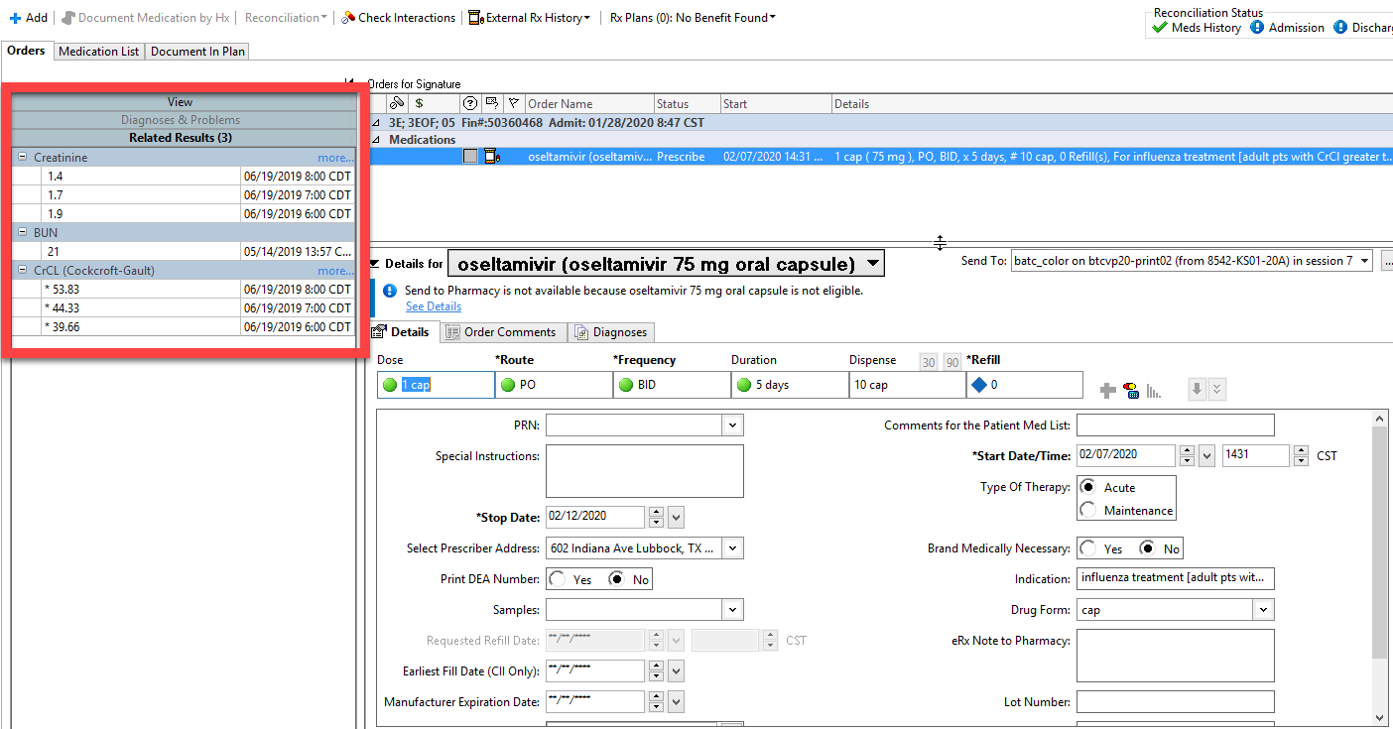

**Adult Influenza Treatment: Renal Impairment**

* Adults with renal impairment (Moderate, CrCl greater than 30 up to 60 mL/min): 30 mg orally twice daily for 5 days
* Adults with renal impairment (Severe, CrCl greater than 10 up to 30 mL/min): 30 mg orally once daily for 5 days
* Adults with ESRD on hemodialysis (CrCl 10 mL/min or less): 30 mg orally immediately, then 30 mg after every hemodialysis cycle; treatment duration not to exceed 5 days from the time of the initial dose
* Adults with ESRD on continuous ambulatory peritoneal dialysis (CrCl 10 mL/min or less): Single 30-mg oral dose immediately
* Adults with ESRD not on dialysis, influenza treatment: Use not recommended

**Adult Influenza Prophylaxis: Renal Impairment**

* Adults with renal impairment (Moderate, CrCl greater than 30 up to 60 mL/min): 30 mg orally once daily
* Adults with renal impairment (Severe, CrCl greater than 10 up to 30 mL/min): 30 mg orally every other day
* Adults with ESRD on hemodialysis (CrCl 10 mL/min or less): 30 mg orally immediately, then 30 mg after alternate hemodialysis cycles
* Adults with ESRD on continuous ambulatory peritoneal dialysis (CrCl 10 mL/min or less): 30 mg orally immediately, then 30 once weekly
* Adults with ESRD not on dialysis, influenza prophylaxis: Use not recommended