Ambulatory Organizer

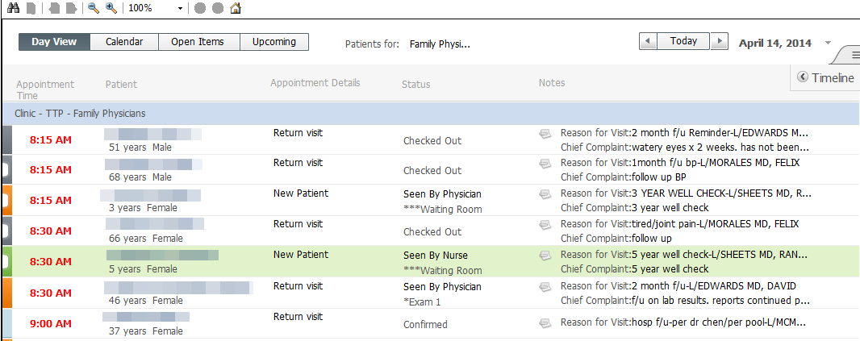

The purpose of the Ambulatory Organizer Mpage is to provider a simple view for the ambulatory provider to access and manage their patient schedule, documentation, and charges.

It is a snapshot of appointments as well as long-term calendar of appointments, outstanding tasks for charges and documentation. Current day tasks display on the same view as today’s appointments while older tasks for the past 7 days display in a separate view.

There are four views within the Ambulatory Organizer: Day View, Calendar, Open Items, and Upcoming.

We will delve into each of these sections presently.

DAY VIEW:

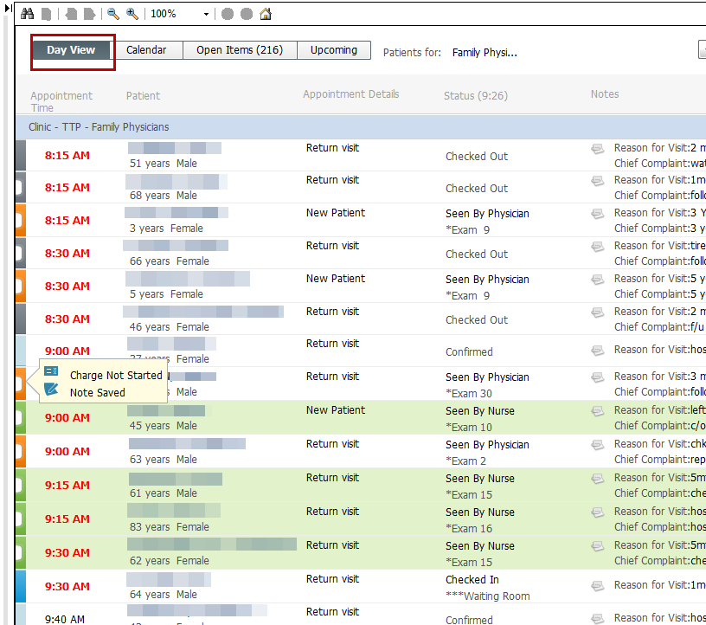

From here you can select your schedule in the “Patients for” area.

If you have an OR schedule, you can select that for yourself as well.

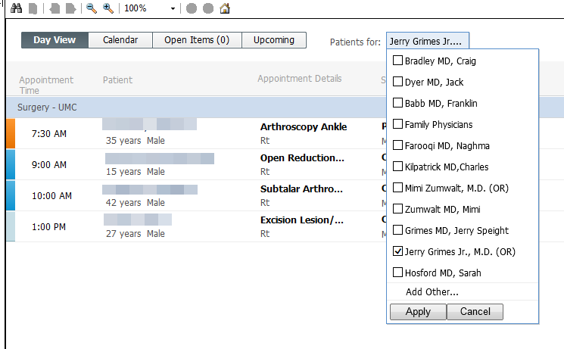

You will notice that there are several color statuses next to the patients displayed.

Each of these colors has a meaning.

Light Blue: Appointment Confirmed, but patient not yet checked in

Blue: Patient checked in

Green: Seen by nurse

Orange: Seen by resident, mid-level, or physician

Dark Gray: Patient checked-out

White: No show/cancelled/hold status

Hovering over the color statuses will show you a quick view of what has been done, and what is still due.

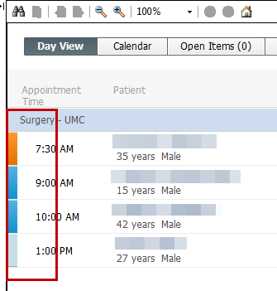

Columns are sortable if desired, alphabetical or reverse-alphabetical for the patient name column. There is also the appointment time column, appointment details column, status column, and notes.

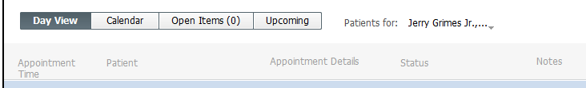

Hovering over certain areas of the day view provide you more information regarding the items in that column. For example, below is an example of the

*clinic schedule*, showing the cursor hovering over the “patient” column.

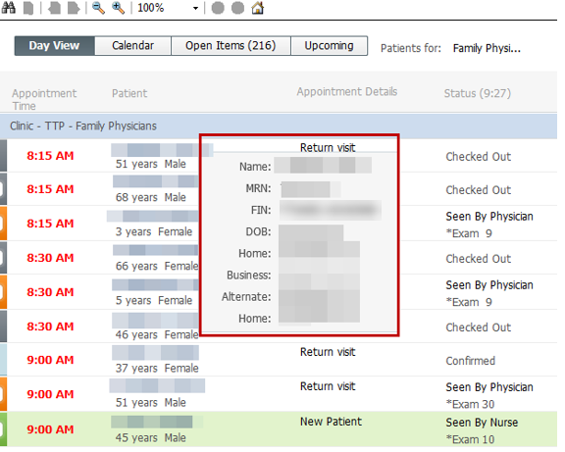

Below is the *surgery schedule* procedure appointment details column.

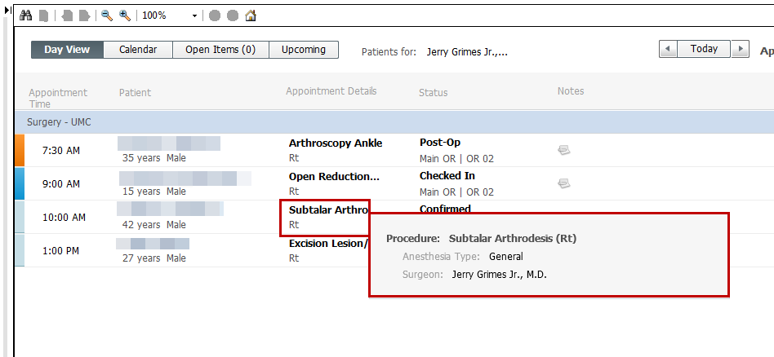

CALENDAR VIEW:

Both single day and week views are available here on the calendar view.

An orange line will display to show the current time.

Hovering over the appointment will display data such as patient name, DOB, MRN, FIN, and appointment type.

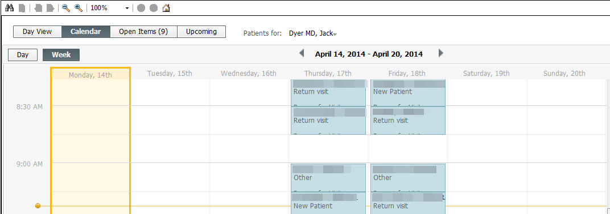

OPEN ITEMS:

The Open Items view shows the patients that have unfinished items remaining from yesterday through the past seven days since the appointment.

The appointments are divided into three sections: Yesterday, 2 Days Ago, and More Than 2 Days Ago.

Hovering over the items with the “outstanding actions” section will allow you to link to another section of the chart to satisfy this outstanding task. An option to manually satisfy the task from here may also be available in the future.

The tasks you may see here include:

Note Not Started

Note Saved (still needs to be signed)

H & P Not Started

H & P Saved

Pre-Op Orders Note Started

Charge Not Started

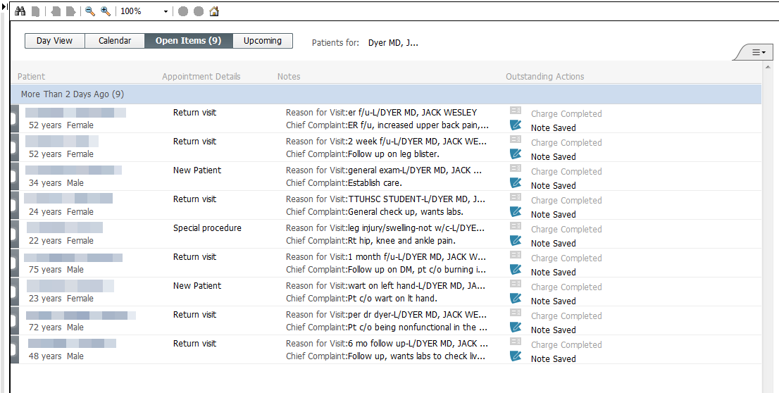

UPCOMING VIEW DETAILS:

This view is very similar to the Open Items tab, except that it only shows the future surgery appointments (seven days out), and it only displays the surgery reminder tasks (H & P and Pre-Op Orders) for a provider.

The appointments are divided into three sections: Today, Tomorrow, and 2 Days from now.

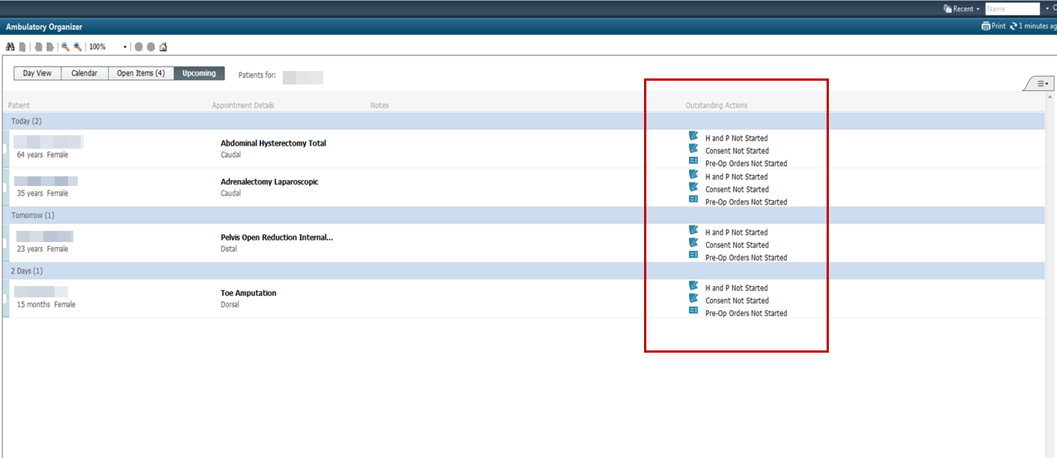

First Time Set-Up

1. Select the drop-down for “patients for:” section.

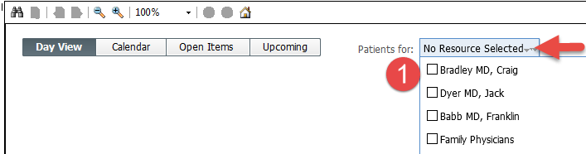

1. Select “Add Other…” and then type your name
2. And then select “Find”
3. Highlight your name and click “OK” (you will do this twice if you have a surgery schedule as well)

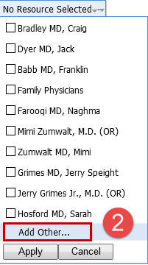 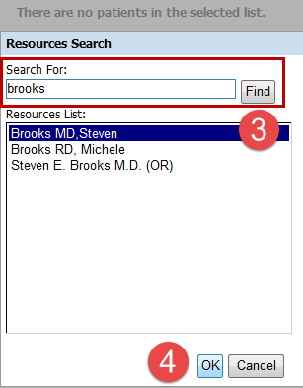

1. If you do have a surgery schedule, you will need to make sure both boxes

are selected, one for your clinic schedule and one for your surgery schedule.

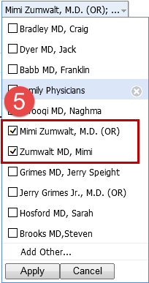

Select “Apply” and now your set-up is now complete.