MyTeamCare: Messaging Attachments

Reviewing a Messaging Attachment from a Patient
Patients will be able to send messages from MyTeamCare with an attachment to a clinic’s pool or provider. The workflow for reviewing a message with attachments is similar to our current messaging workflows. Use the steps below to review a message that contains a messaging attachment.
- Patient navigates to MyTeamCare and attaches a document to their message.
- The message is sent to the clinic’s pool or provider’s inbox.

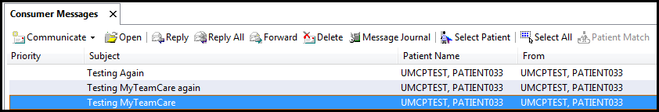

- Open the message to display the messaging attachment

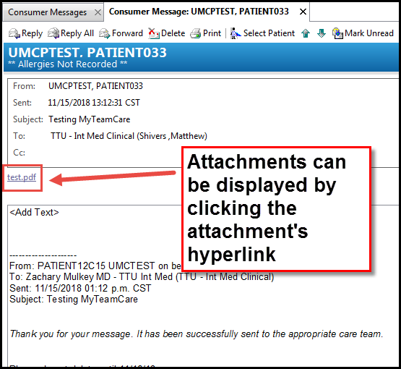
Saving a Messaging Attachment to a Patient’s Chart
- Select the correct In-Clinic Communication document type associated to your clinic’s location and select .

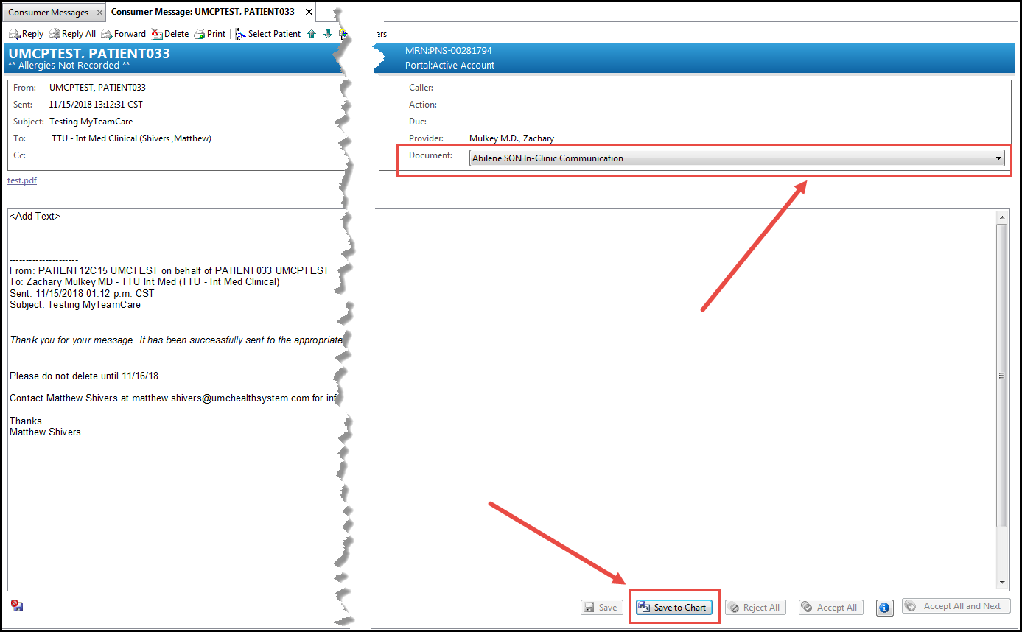

- Once the message and attachment have been saved, the attachment will be viewable under Clinical Notes.

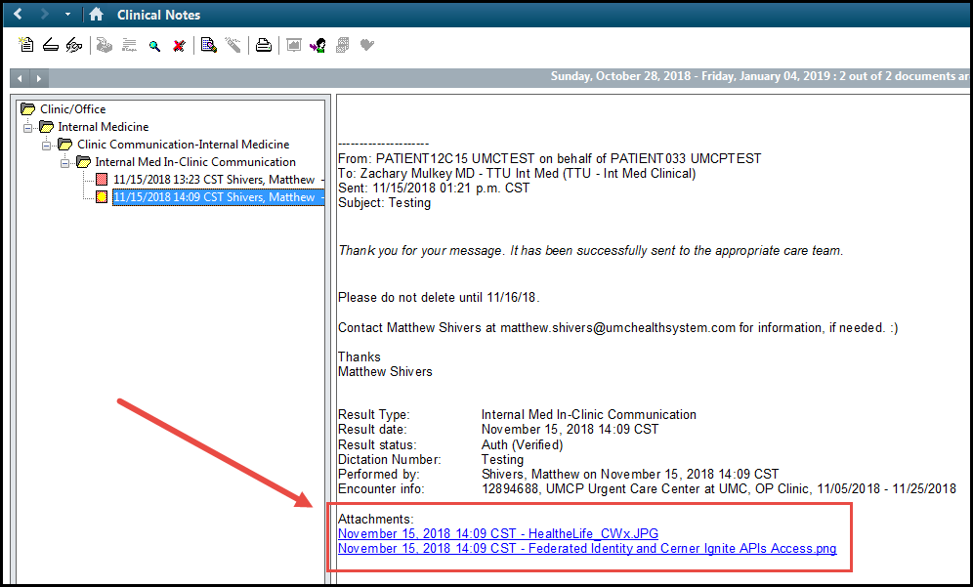

- A provider using Workflow MPages or Dynamic Documentation, they can view the attachment under the Media Gallery component.

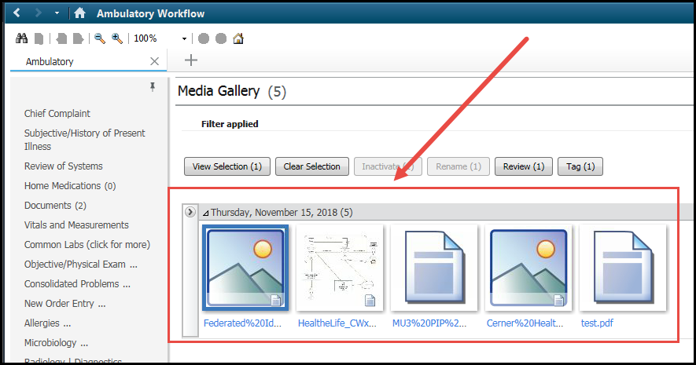

Forwarding a Message with an Attachment to a Provider
- Click “Forward” to forward a message to a provider

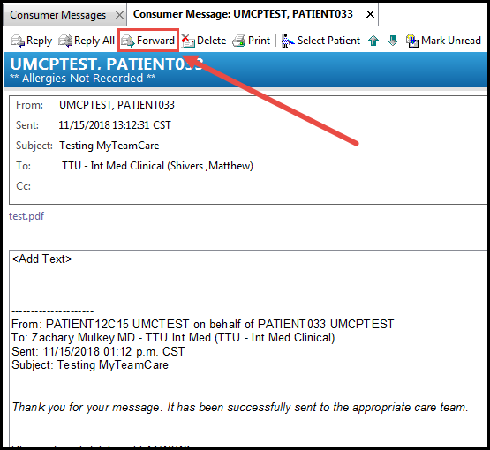

*** If you want a provider or the next staff member to view the attachment, do not select Reply or Reply All. Always select “Forward” in order for the attachment to be viewable to the next staff member! If Reply or Reply All is selected, it will not carry forward with the message to the next staff member. ***

- If a provider wants to save a message, they will follow the same process above for saving an attachment to a patient’s chart.

