**Cerner Workflow and Dynamic Documentation**

Cerner Workflow and Dynamic Documentation will ***go-live on December 11, 2018*** for Family Medicine, General Internal Medicine, General Surgery, Hospitalists and Pedi GI. The format of the notes created by these service lines will change.

No matter your service line, there are several items to take note of beginning December 11th.

1. You will need to update your documentation filter in order to see Dynamic Documentation.

Navigate to Powernote Documentation. Select the filter drop-down and select **All Physician Notes**.

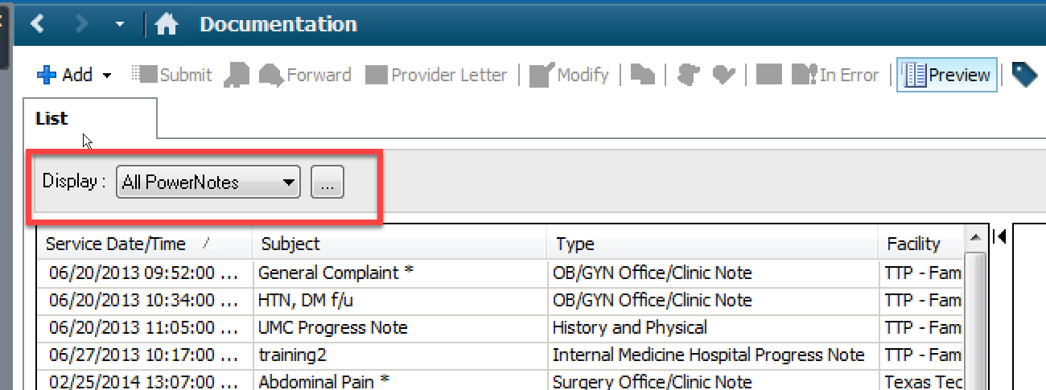

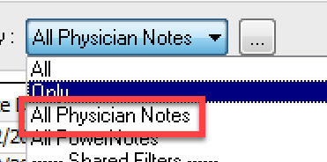

1. How to ensure the notes received from residents and APPs are sent to you for signature and not for review when notes need attestation statements and attending signatures.

Residents and APPs must select ‘Sign’ when forwarding notes to the attending. If they fail to select ‘Sign’ the notes will appear in the Documents to Review.

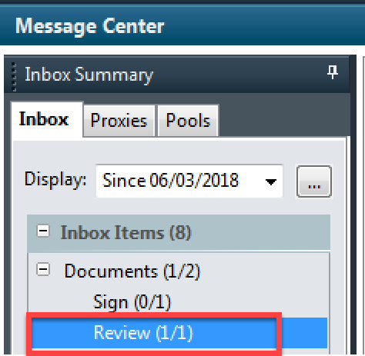

You **must** notify the provider to forward the document to you and request ‘Sign’ so that you can add your attestation statement and sign the document.

Click Refuse. Select Additional Forward Action of Review and search the resident/APP’s name that sent the document to you. Write in the comments ‘Please resend note as document to sign’

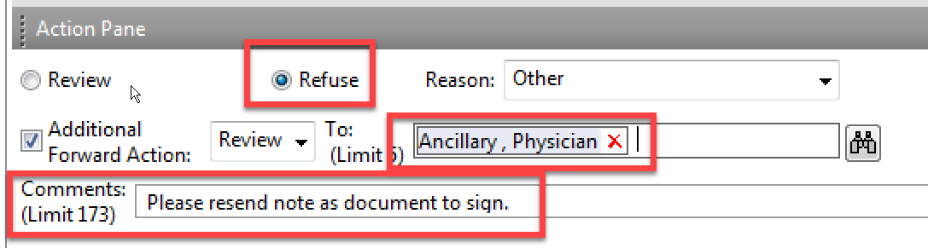

1. In order to make changes to the note, add attestation statement, ect, you will need to modify the note. You will not have the ability to correct these notes. You may strike through the documentation and add an addendum.

Click on the modify icon in order to modify as necessary.

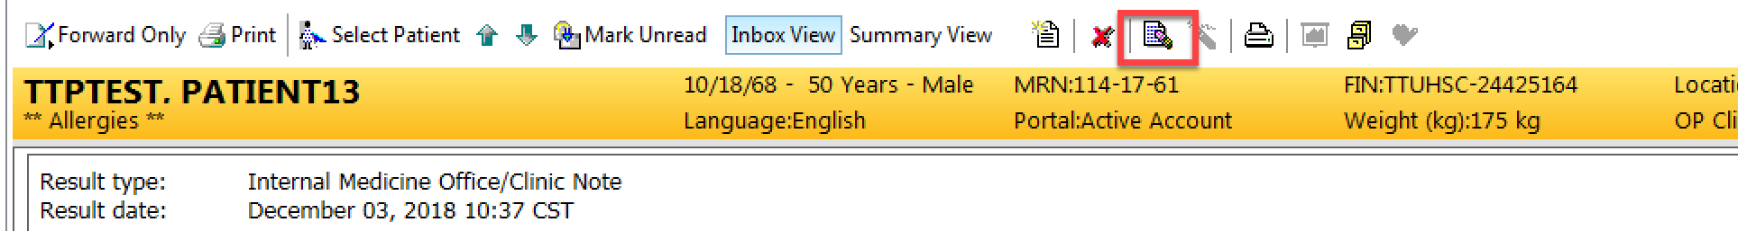

You can strike through by highlighting the term and click the ‘strike through’ icon.

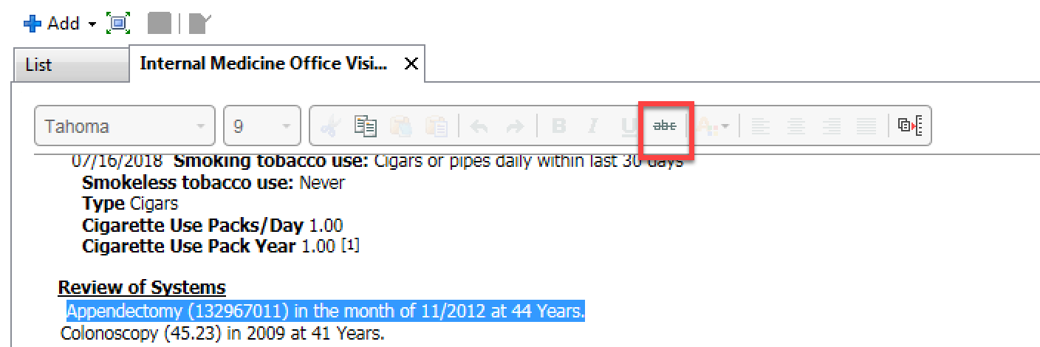

If you would like to strike through an entire selection or data auto-populated into the note, you need to click the ‘X’ icon located in the section that the data is in.

