In order to aid the ambulatory locations in documenting and tracking influenza vaccines, a new section has been added to the ambulatory intake PowerForms.
The fields are not required, but it is an expectation that this section is addressed, especially during the influenza season.
There are two fields to fill out, if applicable; in the event the patient has not had the vaccine, whether it was because they declined it or the vaccine was not available.
Provided also is a field that displays the influenza vaccines previously documented in the Cerner PowerChart system.

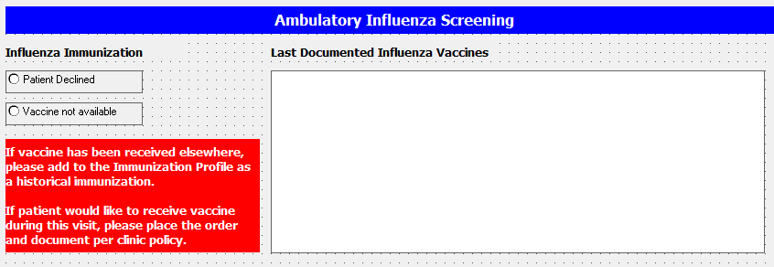
Please make sure to adhere to your department’s policy regarding addressing the patient's need for the vaccine, ordering of vaccine, and documentation of the vaccine (historical or otherwise) in the Immunization Profile tool in PowerChart.
