With the update of PowerChart’s summary pages, pregnancy tracking and documentation will move to a new Pregnancy Workflow mpage, replacing the outdated pregnancy summary mpage.

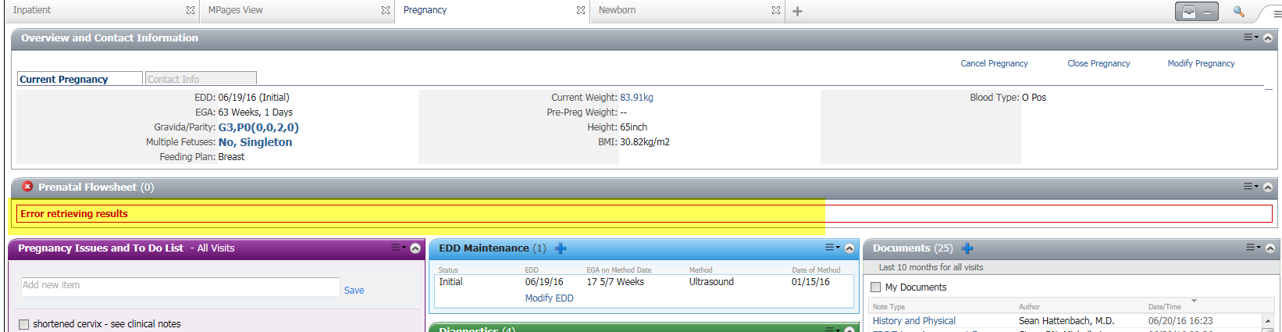

The new workflow mpage will have the same components as the old one, just in a different view. As Cerner moves us towards dynamic documentation, workflow mpages will start becoming more and more involved in the provider’s workflow.

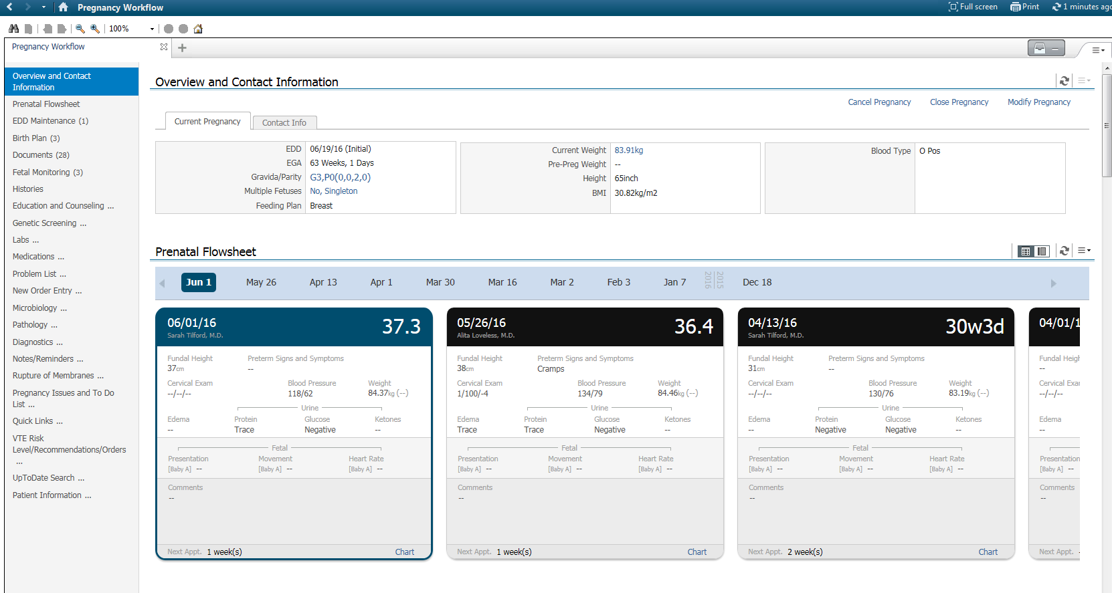

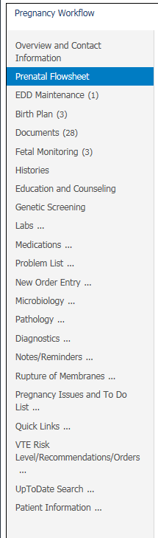
All the “widgets” or components on the previous summary page are now here, viewable as a mini table of contents on the left of the mpage.

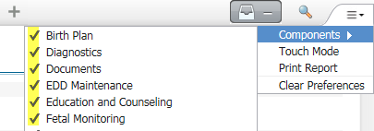

You can drag and drop the order of components if you wish.
You can also “hide” a component by going to the drop down in the upper right-hand corner, selecting “components” and de-selecting the one(s) you don’t wish to see. You can always re-add them later.

The Touch Mode command activates and deactivates touch mode for mobile devices. If you activate it while on a normal PC, it appears to only alter screen sizing.
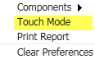

You will notice that many of the original components appear the same, such as the Overview and Contact Information section.

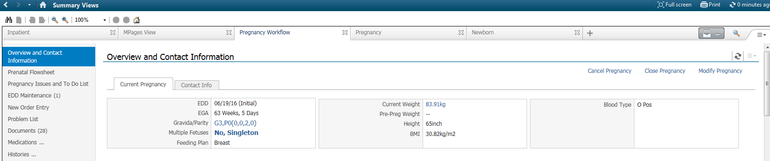

The Prenatal Flowsheet now contains the “monopoly cards” everyone knows and loves.
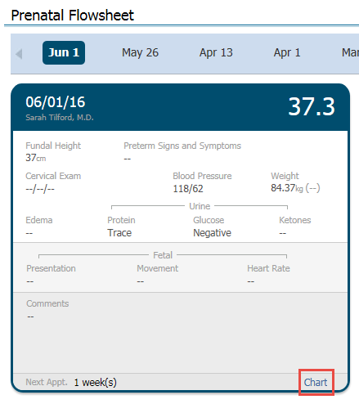
In the future, they will have a direct entry capability to chart directly onto the card.
With new functionality, all modifications will have to be done from iNET.
And the system will not allow you to document on cards from previous visits, for patient safety reasons.
You will also be able to view the cards as a flowsheet view as well, if you prefer.
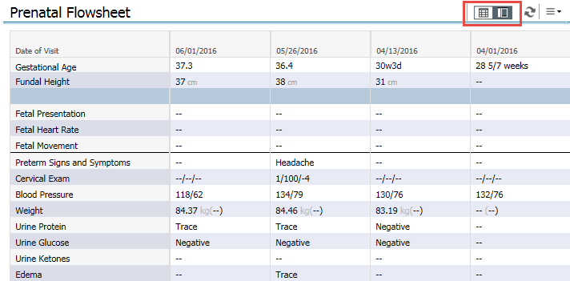

The To Do List is was kept and updated. It will now close and resolve all remaining items with the closure of the pregnancy. Remember, this is just like sticky notes and will not actually save to the medical record.
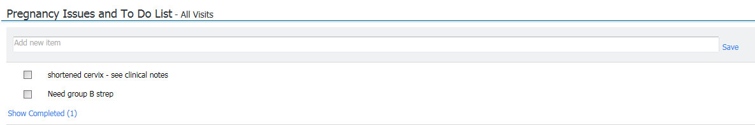

EDD Maintenance remains the same as well, with the exception of one very big improvement. The old error issues with calculating gravida/parity is resolved with the upgrade. You will no longer have to use the PowerForm to correct G/P issues.

Order entry remains the same. The folder items presented to you will correspond to whatever encounter you are currently on. The problem list looks slightly different but essentially functions the same. You can add, modify, and remove problems from this location.

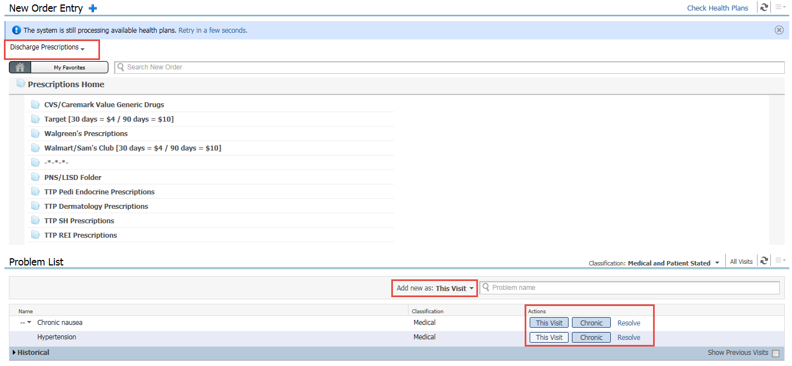

The multiple History components have been condensed into one for your convenience. The pregnancy summary page only contained the pregnancy and procedure histories. More can be added at a later date. Pregnancy history appears to be view only at this location, the Procedure control is fully modifiable.
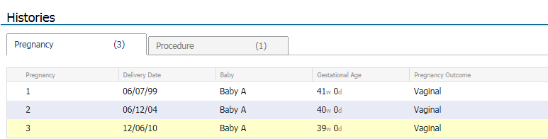

Diagnostics, laboratory, pathology, and micro virology are all mostly unchanged. You can view labs as the flowsheet view, or the ambulatory view.
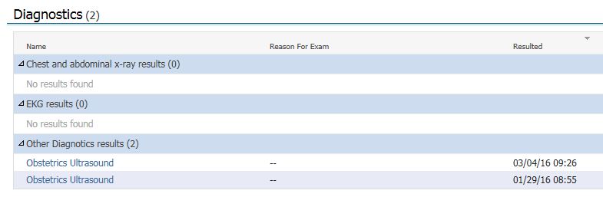
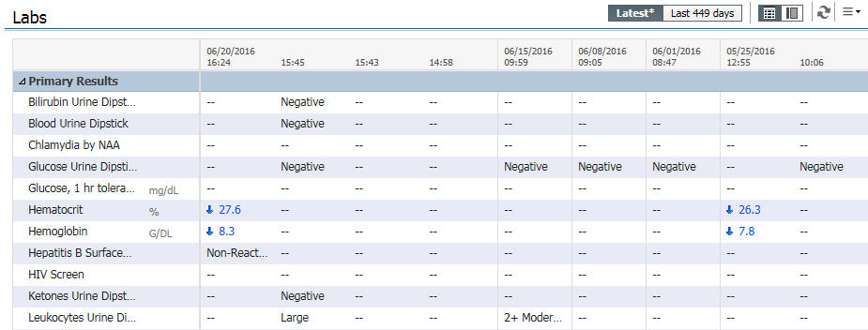

The Rupture of Membranes documentation component pulls from iNET’s Membrane Status section. The ROM clock counter starts with the documentation of membrane status and ends with the documentation of delivery date/time.

Birth Plan, Genetic Screening, and Education by Trimester remain the same. Documentation pulls for intake forms (usually completed on intake by the nurse). The blue “plus” signs by the title link to the PowerForms for direct documentation.
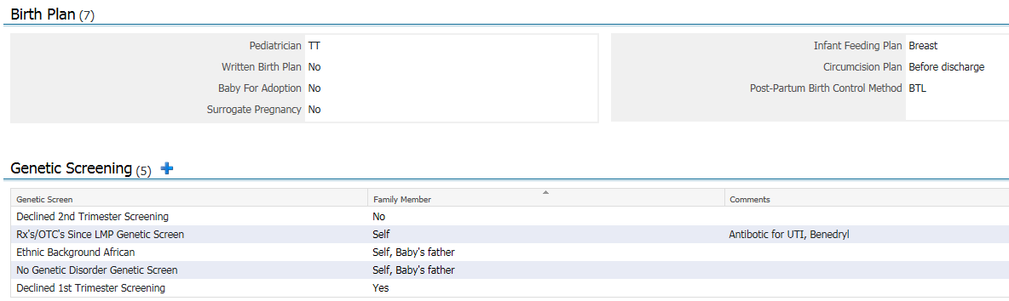
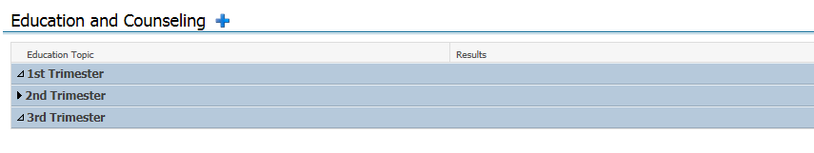
Fetal Monitoring remains the same with being the link to the Fetalink archives. Reminder that this is to view the archived static strips, not a dynamic display. Simply click the box next to the strip you wish to view and select
The rest of the components are the same.

