**ONE order will be REQUIRED**

**ALL** Mammogram orders are now powerplans instead of a single order. The ***“Why”*** for this is to ensure the correct mammo order is placed. We have added an option for IMPLANT orders. The radiologist read these in different views and the exam takes longer.

1. Search for Mammo orders using the “search” or navigate to the Mammo folder within the Radiology folder

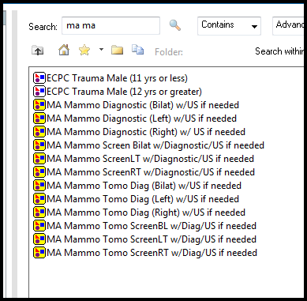

1. When you select the plan, the two mammo options are available. **If you do not choose an order, by clicking in the square, you are NOT placing any order.** Complete the needed fields as indicated by the blue circle with the X. This indicates you need some additional information on the order

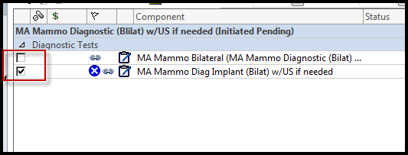

1. Complete the required fields

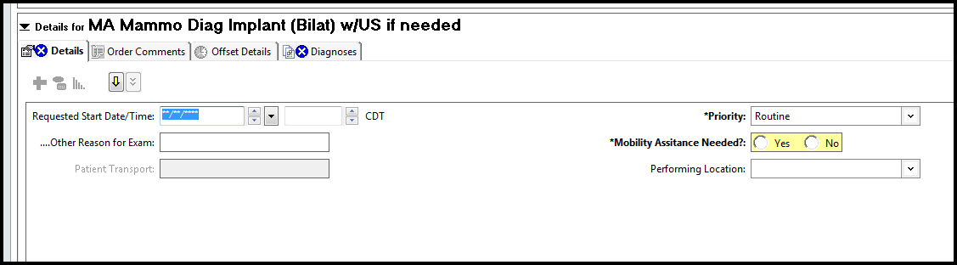

1. If no order is selected, you will receive this message. You will need to click “Cancel” and go back and chose the test you want completed on the patient.

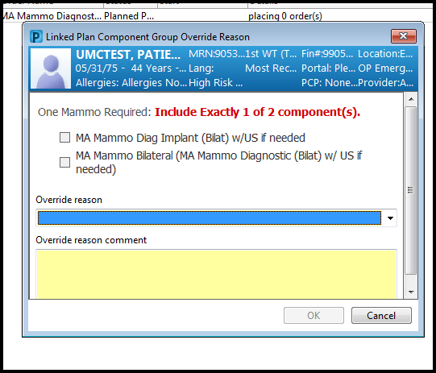***You cannot order from this screen; you must click cancel and order from the powerplan***