Social Services for Placement Changes
This is what the order looks like today, “Placement” is the only required field. All other fields and dropdowns are optional.
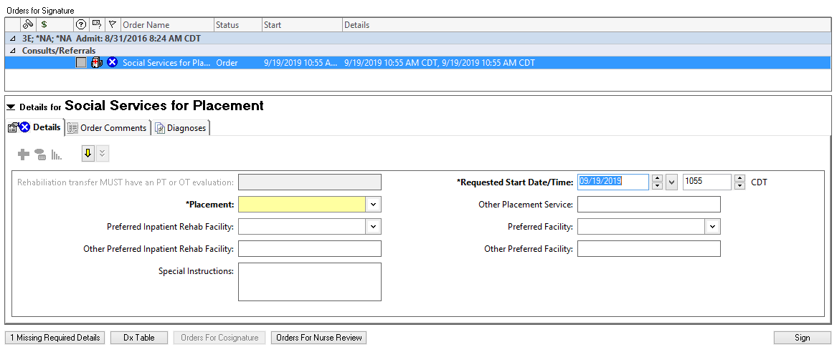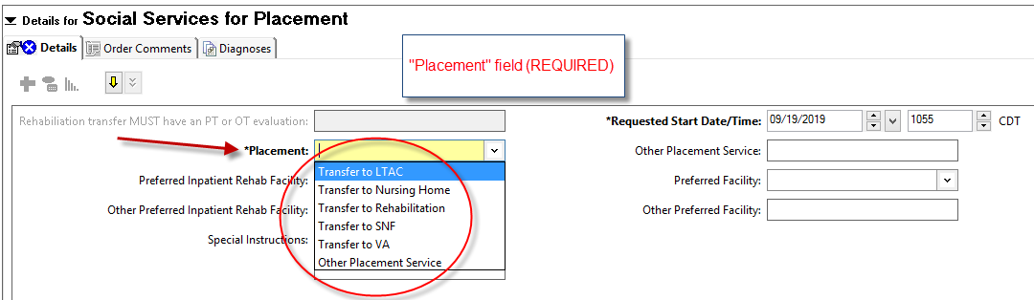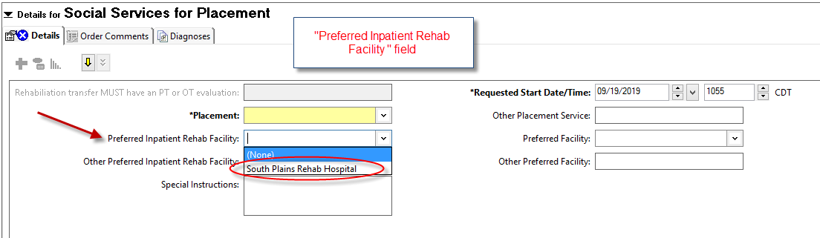
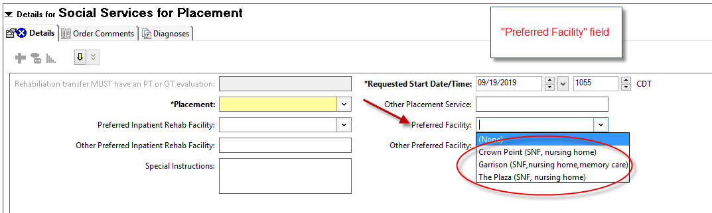
These are the changes that will take place. There are 2 required fields now.
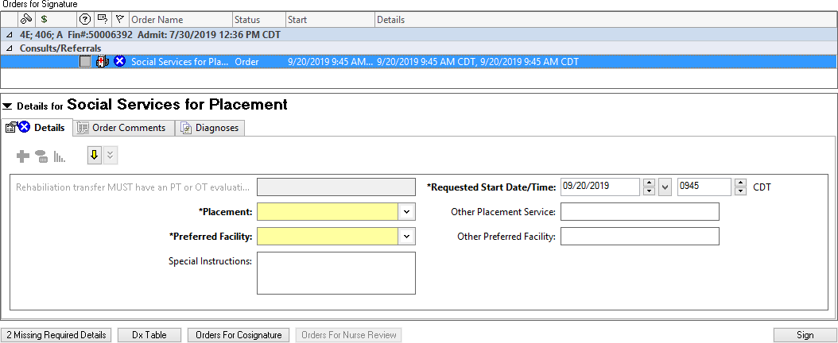

The “Placement” field is the same. If “Other Placement Service” is chosen, address the “Other Placement Service” field.
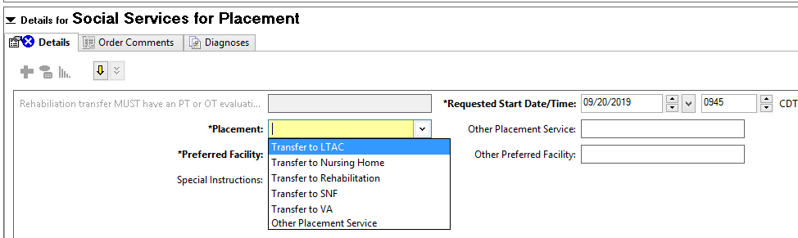

The options of “No Preference” and “Other” were added under “Preferred Facility” in case you have no preference or would like to choose a different facility. The “Other Preferred Facility” field should be addressed if the “Other” option is chosen from the “Preferred Facility” field.
Please note, the addition of “South Plains Rehab Hospital (IPR)” and removal of “The Plaza” in this field.
