New Vaping Category
To ensure we are capturing different forms of nicotine use, we are implementing a new Vaping Category within the Social History Control. The new Vaping Category will capture electronic cigarette use that contains nicotine or non-nicotine (flavorings only, marijuana, etc.) liquids/products.
- The new Vaping Category will be sequenced below the Tobacco Category
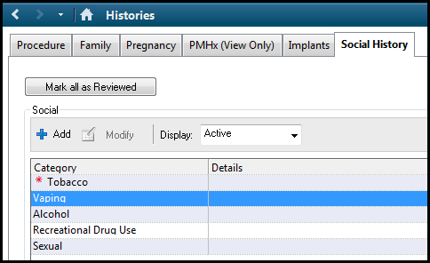
- Within the Vaping Category will be new sections to document the following:
  - Nicotine Use – Does the vaping device contain nicotine?
  - Device Type – What type of e-cig/electronic cigarette device?
  - Education Topics Nicotine
  - Comment – Comment box for additional comments, if needed
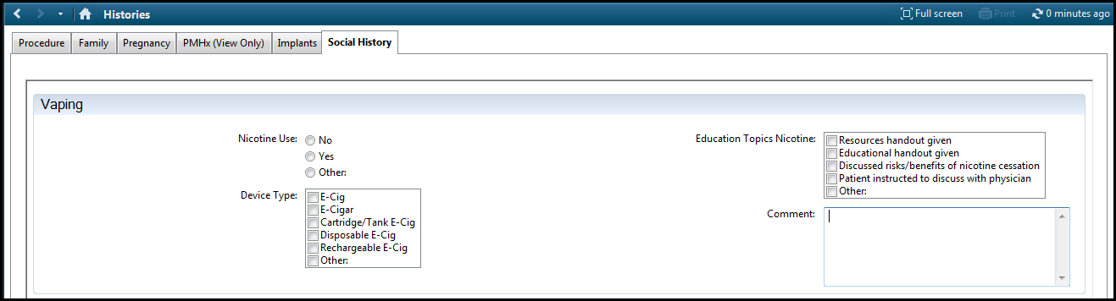

Tobacco Category Updates
- “Pt under age 13” response will be removed from the Smoking Tobacco Use and Smokeless Tobacco Use sections within the Tobacco Category
- “E-Cig” response will be removed from the Type section within the Tobacco Category
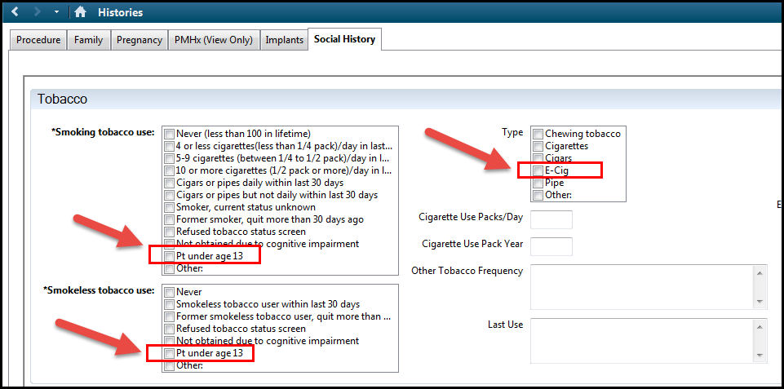

During the Tobacco Category update, some end-users may experience a “Social History Error” error. This error will only occur if the “Pt under age 13” or “E-Cig” responses were previously selected within the Social History Control and will be resolved quickly.
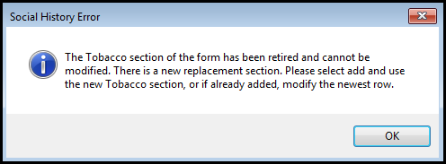
To resolve this error, IT Clinical will inactivate the Tobacco Category for all patients where the “Pt under age of 13” or “E-Cig” responses were previously selected within the Social History Control. After the Tobacco Category has been inactivated, please re-document appropriate responses for the Tobacco Category and Vaping Category.

