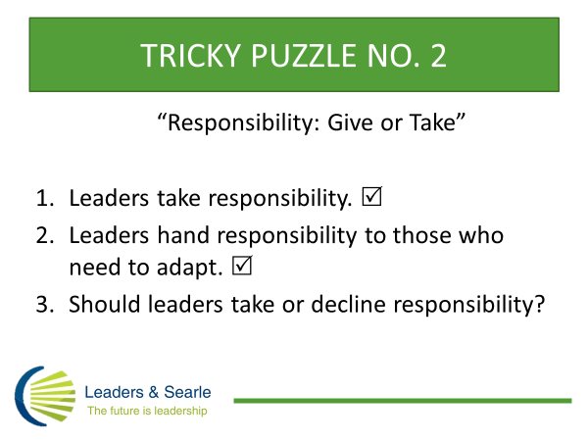

Taking responsibility is a key attribute of leadership. When we are spotting for future leaders in organizations we place a lot of emphasis on people who show responsibility and who are willing to take responsibility even beyond their own present role. Ron Heifetz argues that authority is no substitute for responsibility, which is why some folks in senior management roles are not great leaders and others with little authority exercise more powerful leadership. Yet senior managers can also fall for the trap of hogging responsibility – they become the font of all wisdom and a solution machine for their teams. This usually is ineffective and burdensome for the leader, but it can seem more glamorous or less risky than giving responsibility back to those who need to change, solve their own problems or perform better. Giving responsibility back to others is also a key act of leadership but it can be confronting and requires skill.
What makes responsibility even more tricky for leaders is that we can confuse it with its’ opposites, namely blame and guilt. This especially can happen when leaders experience setbacks and disappointments. Confidence might take a nose dive and a cycle of guilt or blaming ourselves and others can take over. I regularly advise leaders caught up in this uncomfortable churn to have some compassion for themselves and others, get back in touch with their commitments and find something they can take responsibility for. Taking responsibility for something appropriate, including our own emotions, can be a way out of the churn and into productive action, but only when leaders can distinguish it from blame. And nothing in my advice is an argument for passivity in the face of injustice – turning the other cheek may be appropriate for a mild slight or non-violent protest, but highly questionable if someone keeps punching you in the face.
Treasure -hunt Articles, Blogs, Podcasts and Workshops at www.searleburke.com for more Clues, perhaps starting with the article “Seven Sources of Power for Effective Leaders”.

