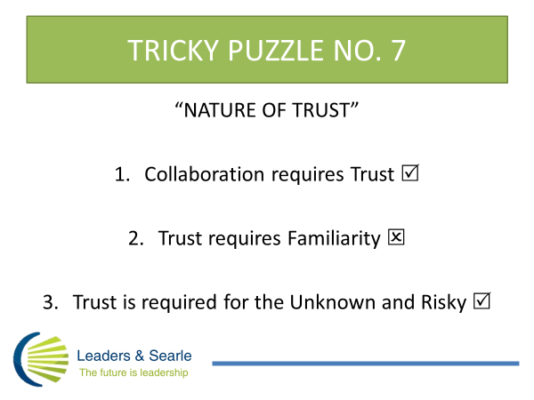

All our work with Executive Teams and Companies suggests there is a lot of confusion about the nature of trust. Many leaders believe time and familiarity are the pathway to trust, but this is an unreliable method which regularly breeds more mistrust.
People and businesses need trust so they can deal not with the familiar, but with the unknown and risky in colleagues and stakeholders. Trust cuts the time and oils the wheels for collaboration and high performance.
Something for the curious to ponder is the practical steps influential leaders can take to foster prudent trust? You can treasure-hunt for guidance at www.searleburke.com .

