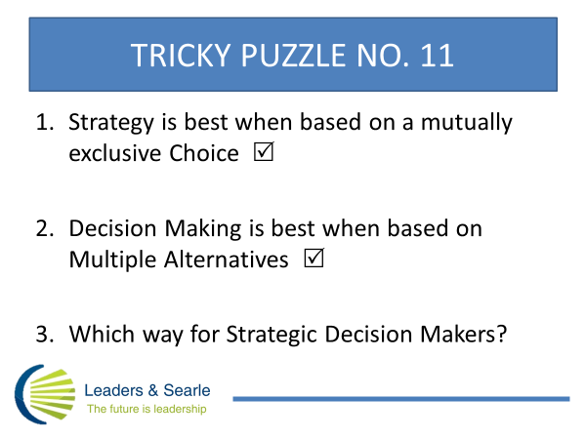

When I am coaching senior executives they often will seek advice about a challenge or opportunity which requires them to decide whether to do this or do that. I sometimes will suggest they add another “this” and maybe some more “thats” to the pot. Not only can this free up their creative juices and help them to escape the tram track of their pros and cons’ list, but research suggests that a diversity of perspectives and multiple options result in more successful decisions and more satisfied leaders.
Strategic thinkers, however, insist that strategy is a choice between two mutually exclusive alternatives. Leaders choose to go north and rule out going south. Strategists are critical of leaders who fail this basic pub test.
What is the best approach for Strategic Decision Makers? Treasure–hunt for guidance at www.searleburke.com and our August Blog.

