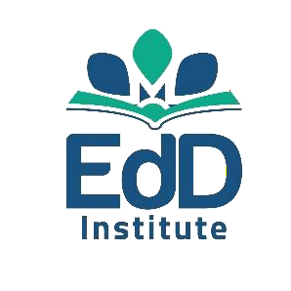
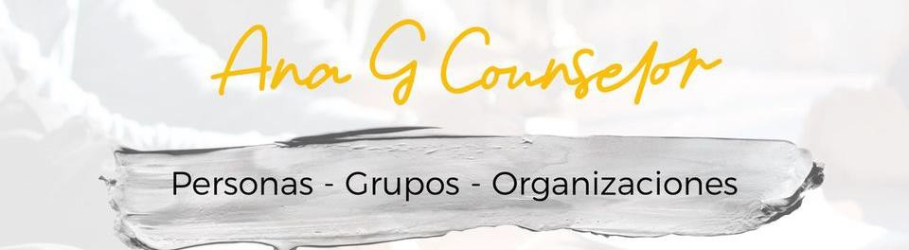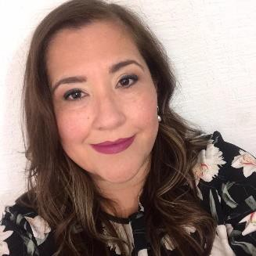Ana Laura
Garza García

@AnaGCounselor
+52 8112389333

Skills Mental Wellbeing
Influencer Counselor Focusing Trainer
Organizational Human Development Consultant

Humanist & Body
Therapist

Writer & Speaker

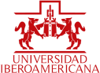

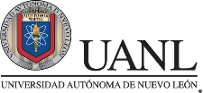

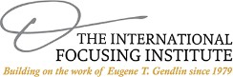
Person – Groups - Organizations

Living Tools´ Creator & Distributor
Positive leader, counselor and consultant with more than 30 experience years. Specialized in Mental and Emotional Health, Positive Psychology and Organizational Human Development. International author & speaker.

Education
Clinical Counseling and Mental Health M.D. St. Mary's University, USA. Human Development M. D. Universidad Iberoamericana, Mexico.
Public Accountant & Auditor, Univ. A. Nuevo León, Mexico.
Certifications
Trainer & Therapist, The International Focusing Institute of NY. Mindfulness, ITESM. Positive Psychology, TecMilenio. Coaching with NLP, J. Grinder. Heal Your Life® Teacher.
Ontological Coaching, Duhne. Organizational Dev. UDEM.
Professional profile
- EdD Institute founder, whose mission is to create spaces for the Mental Wellbeing development and the violence prevention.
- In 2020, Training PAE+ creator, Program for Emotional First Aid Brigadiers, with more than 3,800 people trained in Mexico, US, Caribbean, Central and South America.
- In 2020, director of www.buscayencuentra.com.mx, online store of mental wellbeing products & services.
- LifeCounseling Creator. A model of Counseling, Coaching, Focusing and Positive Psichology.
- Student counselor and Human Development professor.
- Diplomas designer and facilitator for national universities.
Publications
PAE+ Emotional First Aid Basic Mannual, 2021 From Violence to Love, Work Book.2021 Questions for Living, 2018 Ed. 2, 2021
Pandemic Notes. 2020

Volunteering and community support
In Mexico: Family Pastoral of Mexican Episcopate Conference, National APAC, Univ. of the Elders of Univ. A. Nuevo León.
In the US: Be Strong Families, Aurora Public Library, IncludeNYC.

