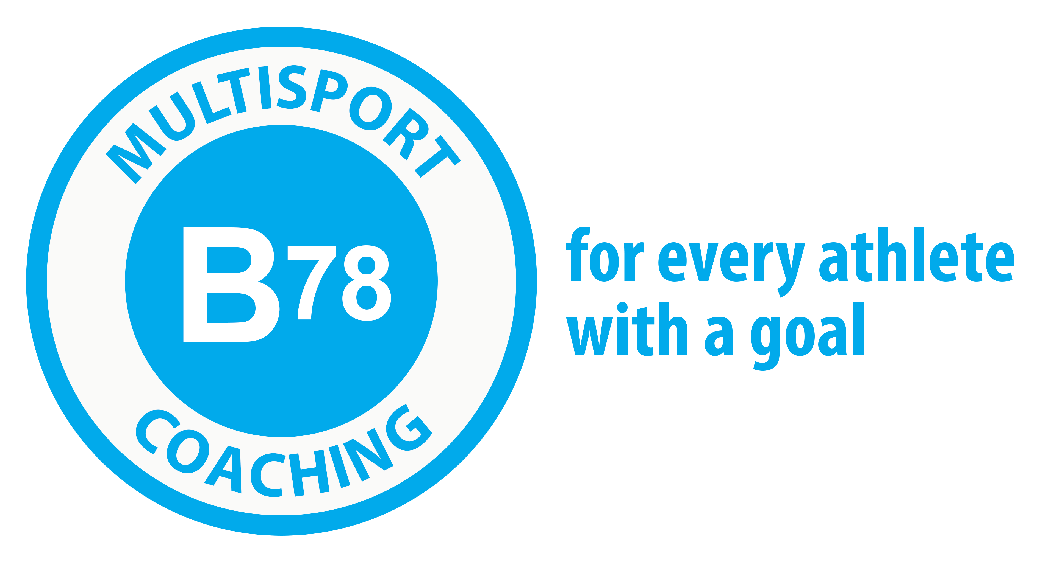

Ironman Canada Camp-Penticton
July 28-30th,2023

Thursday July 27th
Arrival in Penticton
Pick up camp welcome package

Friday July 28th
AM
Swim- 90min- Ironman course recon and pacing
Run – 1hr – Easy endurance Ironman course recon (first section of the course)

PM
Seminar covering nutrition, pacing and course details
Bike- 1hr Recovery Naramata
Team dinner at Hooded Merganzer- 5pm

Saturday July 29th
AM/PM
Bike – 180km – Ironman Canada Course Recon
Run – 15min- Off the bike
Swim- 20min- Recovery

Sunday July 30th
AM
Run – 2hrs 30min- Ironman Course Recon
Swim- 45min- Recovery/Light Endurance

PM
Travel Home

